**13.1 RNA** DATE:

NOTES:

**A. Genes**

* The _____________________________________ structure of DNA explains how it can be ________________________, but it does not explain how genes work.
* _________________ are molecular units of heredity. They are coded DNA instructions that control the production of _______________________ within the cell, and decide what the organism is like. Humans have roughly 22,000 genes
* The first step in __________________________these genetic messages is to copy part of the__________________________ sequence from DNA into ______ or ribonucleic acid. (using the sugar ribose)
* These RNA molecules contain _____________________ information for making proteins

**B. The Structure of RNA**

* RNA like DNA consists of a _____________________________ of nucleotides and is made up of the _______________________________ as DNA ( a 5-carbon sugar, a phosphate group and a nitrogenous base) _____________ for one small difference, the sugar group in RNA is _______________________
* RNA also differs from DNA in the fact that it is __________________________________ and has the base ____________ instead of thymine

(In RNA _____________________________________)

* The ability to copy a single DNA __________________ into RNA makes it possible for a single ___________________ to produce hundreds or even _________________ of RNA molecules

**C. Types of RNA**

RNA is involved in just one job: _______________________________

* There are _______ types of RNA

1. _____________________ RNA (mRNA)
2. Ribosomal RNA (rRNA)
3. ______________________ RNA (tRNA)

BIOLOGY CORNELL NOTES:

STUDY QUESTIONS

1. What is the difference between a gene and a chromosome?

__________________________________________________________________________________________________________________

2. What are 3 differences between DNA and RNA?

__________________________________________________________________________________________________________________________________________

3. What are the 3 types of RNA?

___________________________________________________________________________________________________________________

**13.1 RNA** DATE:

NOTES:

1. The job of the _______________________________ (mRNA) is to carry copies of ______________________________ for the assembly of ____________________ acids into proteins from DNA to the rest of the cell
2. The job of Ribosomal RNA (__________) is to make up the major part of _________________________. Proteins are assembled on ribosomes.
3. The job of the __________________________ RNA (tRNA) is to ______________________ or move amino acids to ribosomes during ______________________________________________

**D. Transcription**

* _________ molecules are produced by __________________ parts of the _______________________________ sequence of DNA into a complementary sequence in RNA. This process is called _________________________________.
* Transcription requires an ______________ known as RNA polymerase which is very similar to DNA polymerase in DNA replication
* During _____________________________ RNA polymerase binds to DNA and ________________________________ the DNA strands
* RNA polymerase then uses ________ strand of DNA as a __________________________ to assemble _____________________ into a strand of RNA

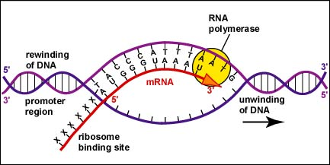

BIOLOGY CORNELL NOTES:

SUMMARY

______________________________________________________________________________________________________________________________________________________________________________________________________________________________________________________________________________________________________________________________________________________________________________________________________________________________________________________________________________________________________________________________________________________________________________________________________________________