**13.2 Ribosomes and Protein Synthesis**

**A.RNA EDITING**

1. RNA molecules are produced by _______________________________

2. Our DNA contains sequences of nucleotides called ____________________ that are NOT involved in coding for proteins

3. The DNA sequences that code for proteins are called ______________________

**B. THE GENETIC CODE**

1. _______________________________ are made by joining _____________ _________________ into long chains called polypeptides. Each combination is made by the ____ different ____________________________________________.

2. The _________________________ of proteins are determined by the _________ in which different amino acids are joined together to produce_________________

3. The ______________________________ is read ________ letters at a time. Each three-letter word in mRNA is known as a ________________________.

4. A codon consists of ________ consecutive nucleotides that specify a single _______________________ that is to be ________________ to the polypeptide

5. A codon wheel shows all _________ possible codons of the genetic code. Some amino acids can be specified by __________________________________________

6. The codon AUG can either specify the amino acid _______________________ or serve as the _______________ codon for protein synthesis. There are ___________ STOP codons that do not code for an amino acid but signify the ___________ of the polypeptide

**C. TRANSLATION**

1. The _______________ of an mRNA ______________ into a polypeptide chain ________________ is know as _____________. Translation takes place on _____________________

2. During __________________ the cell uses ___________________________ to produce ____________________

3. Before translation occurs _____________________________________ in the________________ and____________________ into the _________________

Study Questions : Develop 3 study questions from the material you learned today.

1.

____________________________________________________________________________________

2.

____________________________________________________________________________________

3.

____________________________________________________________________________________

4. Translation begins when the mRNA molecule in the cytoplasm ______________ to a _________________. As each ________________ of the mRNA molecule moves through the _________________, the proper ______________________ is brought into the ribosome by ____________. In the ribosome, the amino acid is ______________________ to the growing polypeptide chain.

5. Each _______ molecule carries only one kind of __________________________

6. In addition to an amino acid, each tRNA molecule has ____________________________________. These bases called ______________________ are complementary to one ______ codon

Like an assembly line worker who attaches one part to another, the ________________ form a _______________________ between the first two amino acid as well as _______________ the bond that held the first ___________ to its amino acid, which ___________________ the tRNA molecule.

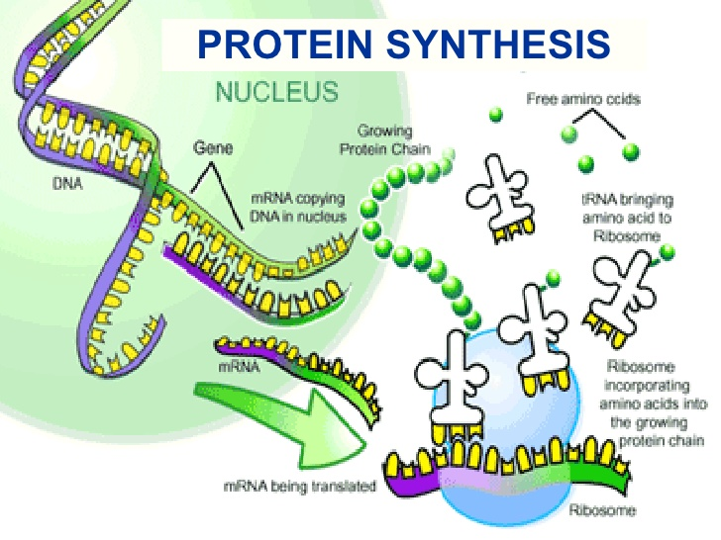

**D. REMINDER**

**DNA🡪 DNA is called REPLICATION**

**DNA🡪 mRNA is called TRANSCRIPTION**

**mRNA🡪 Protein is called TRANSLATION**

SUMMARY:

________________________________________________________________________________________________________________________________________________________________________________________________________________________________________________________________________________________________________________________________________________________