Intro. to DNA / worksheet

- What were the names of the people responsible for figuring out DNA’s structure?

1.

2.

3.

4.

- What happened between Watson & Crick and Rosalind Franklin?

- Write out the complete name for DNA:

- A nucleotide is made of three parts. List these parts below and label them on the picture:

1.
2.
3.

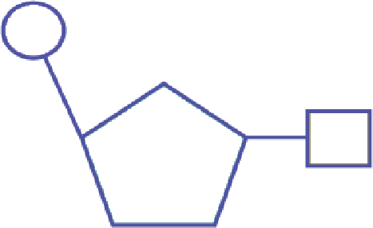

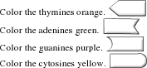
- On the diagram, color label the as indicated below:
To color :copy and paste the image into Paint
Then copy and paste it back onto this document.

