Atomic Structure Worksheet
Label the parts of an atom on the diagram below.

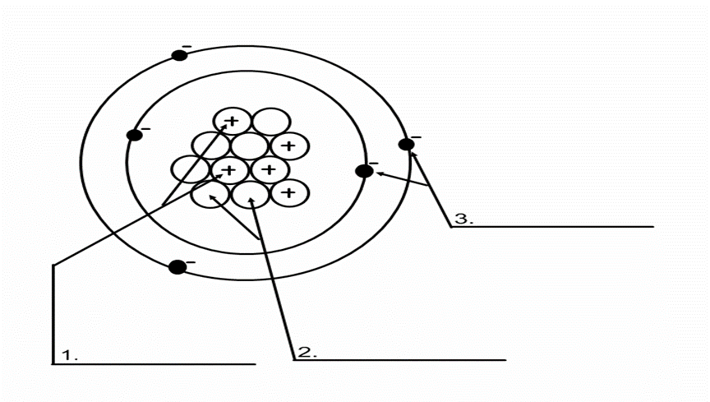

- What type of charge does a proton have?

- What type of charge does a neutron have?

- What type of charge does an electron have?

- Which two subatomic particles are located in the nucleus of an atom?

- If an atom has 35 protons in the nucleus, how many electrons will it have orbiting the nucleus?

- What is the atomic number of the atom in the diagram above?

- What is the atomic mass/mass number of the atom in the diagram above?

- How many protons are in the nucleus of an atom with an atomic number of 15?

- How many electrons are in the nucleus of an atom with an atomic number of 20?

- How many neutrons are in the nucleus of an atom with an atomic number of 25? (use Periodic Table for mass)

- What is the mass number of an atom with 3 protons, 4 neutrons, and 3 electrons?

- How many neutrons are in the nucleus of an atom that has an atomic mass of 36 and an atomic number of 25?

Bohr Model Drawing

Draw a Bohr model of an oxygen atom in the space below. Be sure to place the electrons in the correct orbitals and to fill out the key for the subatomic particles.
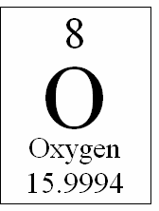
Key
13. Protons: 14. Neutrons: 15. Electrons:

Nucleus

The Atoms Family Atomic Math Challenge

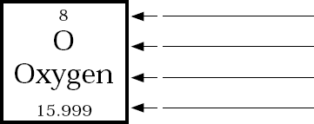
20. Atomic number equals the number of
17.
16.
or 21. Atomic mass equals
18.
the number of
19.

+

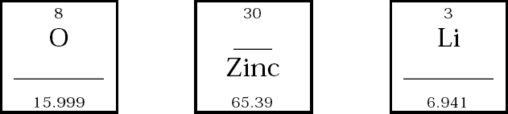

Atomic # = | Atomic # = | Atomic # =
Atomic Mass = | Atomic Mass = | Atomic Mass =
# of Protons = | # of Protons = | # of Protons =
# of Neutrons = | # of Neutrons = | # of Neutrons =
# of Electrons = | # of Electrons = | # of Electrons =
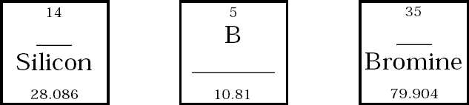

Atomic # = | Atomic # = | Atomic # =
Atomic Mass = | Atomic Mass = | Atomic Mass =
# of Protons = | # of Protons = | # of Protons =
# of Neutrons = | # of Neutrons = | # of Neutrons =
# of Electrons = | # of Electrons = | # of Electrons =

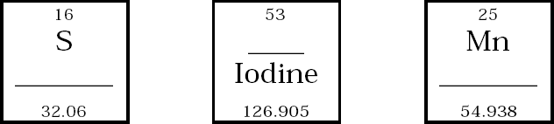

Atomic # = | Atomic # = | Atomic # =
Atomic Mass = | Atomic Mass = | Atomic Mass =
# of Protons = | # of Protons = | # of Protons =
# of Neutrons = | # of Neutrons = | # of Neutrons =
# of Electrons = | # of Electrons = | # of Electrons =
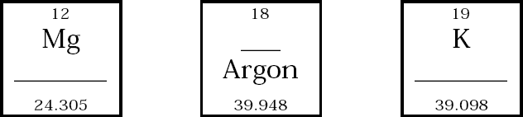

Atomic # = | Atomic # = | Atomic # =
Atomic Mass = | Atomic Mass = | Atomic Mass =
# of Protons = | # of Protons = | # of Protons =
# of Neutrons = | # of Neutrons = | # of Neutrons =
# of Electrons = | # of Electrons = | # of Electrons =
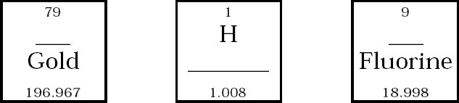

Atomic # = | Atomic # = | Atomic # =
Atomic Mass = | Atomic Mass = | Atomic Mass =
# of Protons = | # of Protons = | # of Protons =
# of Neutrons = | # of Neutrons = | # of Neutrons =
# of Electrons = | # of Electrons = | # of Electrons =

