Chapter 9 Review Worksheet – Cellular Respiration

Energy in General
Use the following diagram to answer questions
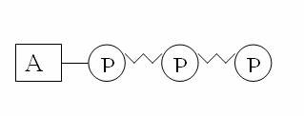
What is this molecule called?

Why is this molecule important to living things?

This molecule ______________ energy to release energy the _____________ between the last two phosphorus molecules are broken.

What is “left over” when energy is released from this molecule?

Energy is released from ATP when the bond is broken between
- two phosphate groups c. ribose and a phosphate group
- adenine and ribose d. adenine and a phosphate group

Cellular Respiration
Is cellular respiration aerobic or anaerobic? Explain.

When living cells break down the bonds holding molecules together, energy is
- stored as ADP. c. released
- stored as ATP. d. changed into glucose

In cellular respiration, the most energy is transferred during
- glycolysis. c. the Krebs cycle.
- lactic acid fermentation. d. the electron transport chain

Electrons are carried to the electron transport chain by
- ATP and NADH. c. ATP and NAD+.
- FADH₂ and NADH. d. NAD+ and ATP.

Glycolysis begins with glucose and produces
- Starch c. acetyl CoA
- lactic acid d. pyruvic acid (pyruvate)

What happens to electrons as they are transported along the electron transport chain and the H ion breaks off?
- They lose energy. c. They are moved out of the cell
- They gain energy. d. They combine with O2 and protons to form water.

Cellular respiration takes place in two stages:
- glycolysis and fermentation. c. glycolysis, then aerobic respiration.
- Stage 1 and Stage 2 of photosynthesis. d. anaerobic respiration, then glycolysis.

Which of the following is not formed during the Krebs cycle?
a. CO₂ b. NADH c. FADH₂ d. Lactic Acid

Which of the following is not part of cellular respiration?
- electron transport c. glycolysis
- the Krebs cycle d. the Calvin cycle

Glycolysis takes place
- in the cytoplasm c. only if oxygen is present
- in the mitochondria d. only if oxygen is absent

In cellular respiration, the most energy is created in which step?
- glycolysis c. Krebs cycle
- electron transport chain d. fermentation

C₆ H₁₂O₆ + 6O₂ 6CO₂ + 6 H₂O + MOLECULE A

The process shown in the equation above begins in the cytoplasm of a cell and ends in the
- cytoplasm. c. mitochondria.
- endoplasmic reticulum d. chloroplast.
The equation above summarizes the process known as
- photosynthesis. c. fermentation.
- protein breakdown. d. cellular respiration.
The molecule referred to as “molecule A” in the equation above is
- NADPH. c. NADH.
- ATP. d. ADP

Fermentation
Is fermentation a aerobic or anaerobic process? Explain.

Where does the pyruvic acid (pyruvate) come from that enters into the process of fermentation?

Compare and contrast the two types of fermentation.

Yeast produce alcohol and CO₂ in the process of
  - lactic acid fermentation c. alcoholic fermentation
  - aerobic respiration d. glycolysis

Both lactic acid and alcoholic fermentation produce
  - a 2-carbon molecule from a 6-carbon molecule c. ATP from ADP and phosphate
  - CO₂ from a three-carbon molecule d. NAD+ from NADH and H+

When muscles are exercised extensively in the absence of sufficient oxygen,
  - lactic acid is produced
  - a large amount of ATP is formed
  - NADH molecules split
  - the Kreb’s Cycle occurs

OPTIONAL CROSSWORD: You do not have to complete the crossword, however if you like a good challenge please feel free to do it!

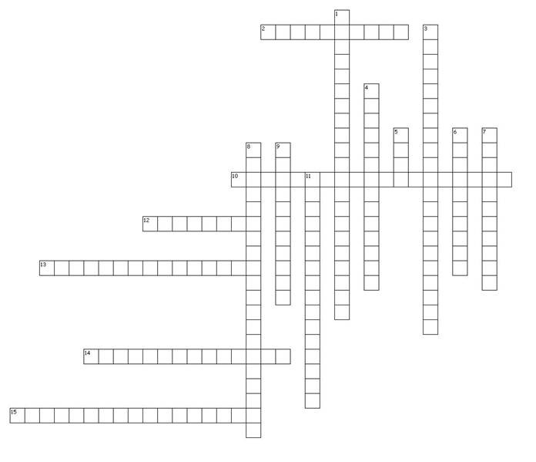
Across
2. In cellular respiration, series of anaerobic chemical reactions in the cytoplasm that break down glucose into pyruvic acid; forms a net profit of two ATP molecules.
10. Chemical process where mitochondria break down food molecules to produce ATP; the three stages are glycolysis, the citric acid cycle, and the electron transport chain.
- Molecules that absorb specific wavelength of sunlight.
- In cellular respiration, series of reactions that break down glucose and produce ATP; energizes electron carriers that pass energized electrons on to the electron transport chain.
- Process by which autotrophs, such as algae and plants, trap energy from sunlight with chlorophyll and us this energy to convert carbon dioxide and water into simple sugars.
- Series of proteins embedded in a membrane along which energized electrons are transported; as electrons are passed from molecule to molecule, energy is released.

Down
1. Anaerobic process where cells convert pyruvic acid into carbon dioxide and ethyl alcohol; carried out by many bacteria and fungi such as yeast.
- Energy-storing molecule in cells composed of an adenosine molecule, a ribose sugar and three phosphate groups; energy is stored in the molecules’ chemical bonds and can be used quickly and easily by cells.
- Phase of photosynthesis where light energy is converted to chemical energy in the form of ATP; results in the splitting of water and the release of oxygen.
- Electron carrier molecule; when carrying excited electrons, it becomes NADPH.
- Reaction taking place in the thylakoid membranes of a chloroplast during the light-dependent reactions where two molecules of water are split to form oxygen, hydrogen ions, and electrons.
- Light-absorbing pigment in plants and some protists that is required for photosynthesis; absorbs most wavelengths of light except green.
- Molecule formed from the breaking off of a phosphate group from ATP; results in a large release of energy that is used for biological reactions.
- Series of reactions during the light-independent phase of photosynthesis in which simple sugars are formed from carbon dioxide using ATP and hydrogen from the light-dependent reactions.
11. Phase of photosynthesis where energy from light-dependent reactions is used to produce glucose and additional ATP molecules.

