Name ___________________ Date ________ Period _______

***Animal Cell Coloring***

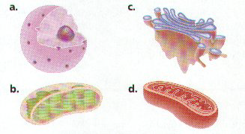

**Directions:** Give the function for each cell structure and then identify the ***color and label*** on the animal cell.

|  |
| --- |
| Plasma Membrane (Orange) - |
| Nucleus (Blue) - |
| Mitochondria (Gold) - |
| Lysosome (Dark Blue) - |
| Cytoplasm (Green) - |
| Cytoskeleton (Brown) - |
| Ribosome (Black) - |
| Nucleolus (Periwinkle) - |
| Golgi Apparatus (Dark Pink) - |
| Smooth Endoplasmic - Reticulum (Violet) - |
| Rough Endoplasmic Reticulum (Red orange) - |
| Chromatin (Sky Blue) - |

***Questions:***

1. Give the function of the nucleus.

2. What makes up the cell membrane?

3. Where does cellular respiration take place?

4. Where does protein synthesis take place?

5. Where are ribosomes made?

6. Give two ways that an animal cell differs from a plant cell.

7. Do plant cells contain mitochondria?

8. How can you tell rough ER from smooth ER?

9. Where are cell products modified and packaged in vesicles for transport?

10. Where is DNA found in a cell?

11. Where would old cell organelles be broken down (digested) to be recycled in the cell?

**Animal Cell**

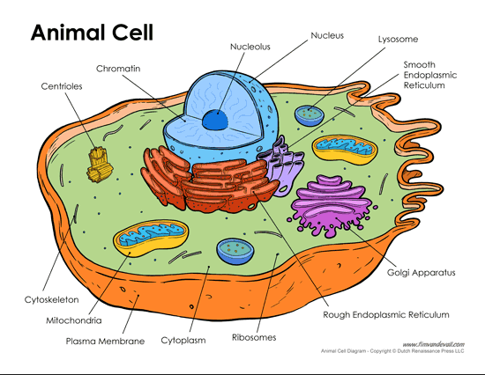

***Plant Cell Coloring***



***Directions:*** ***Define*** each of the parts of the plant cell and then find the ***label and color*** on the drawing of the plant cell.

|  |
| --- |
| Plasma Membrane (Yellow) - |
| Cell Wall (Dark green) - |
| Cytoplasm (Pale Yellow) - |
| Chloroplasts (Bright Green) - |
| Golgi Apparatus (Dark Pink) - |
| Mitochondria (Gold) - |
| Cytoskeleton (brown) - |
| Nucleus (Blue) - |
| Chromatin (Sky Blue) - |
| Nucleolus (Periwinkle) - |
| Ribosomes (Black) - |
| Rough Endoplasmic Reticulum (Red Orange) - |
| Smooth Endoplasmic Reticulum (violet) - |
| Vacuole (Pale Green) - |

**PLANT CELL**

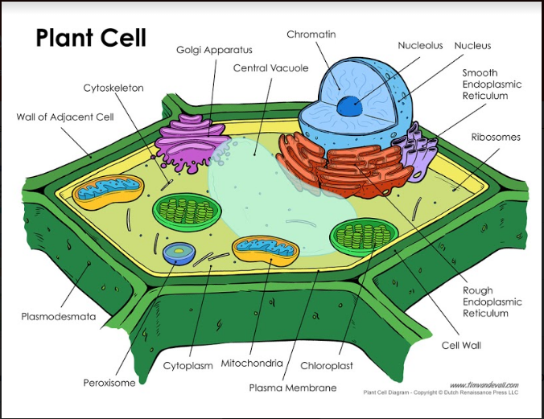

***Compare and Contrast*** the animal cell to the plant cell.

***Prokaryotes – Bacteria*** **Prokaryotes,** which includes, bacteria are the simplest of all the cells. All prokaryotes have a single, circular chromosome and lack a nucleus and membrane-bound organelles. There are two major groups of prokaryotic organisms --- the Kingdom **Eubacteria** and the Kingdom **Archaebacteria**. Eubacteria are known as true bacteria. They are the most common type of prokaryote. They are found everywhere, on surfaces and in the soil. **Archaebacteria or the ancient bacteria** are found in extreme environments, like hot sulfur springs and thermal vents in the ocean floor. They belong to the domain **Archaea**. Archaebacteria are thought to be some of the oldest life forms on earth.

1. What characteristics do all prokaryotes have in common?
2. What is the best known prokaryote and where can they be found?
3. Name the 2 kingdoms for prokaryotes.
4. Name the 2 bacterial domains.
5. Where are the bacterial members of the domain Archaea found?
6. What are thought to be the oldest organisms on Earth?

Most bacteria are **heterotrophic** and don't make their own food. That means they have to rely on other organisms to provide them with food. Some bacteria such as the **cyanobacteria** contain chlorophyll and can make their own food. These bacteria have to break down, or **decompose**, other living things to obtain energy. Very few bacteria cause illness. Some bacteria are used to make food, such as cheese and yogurt. Scientists have genetically engineered a type of bacteria that breaks down oil from oil spills. Some bacteria like ***E.coli***, live inside the guts of animals and help them to digest food.

1. Are all bacteria heterotrophic? Explain your answer.
2. What bacteria lives in our gut to help digest food?
3. What is the function for most bacteria and how is this helpful to them?

**CYANOBACTERIA**

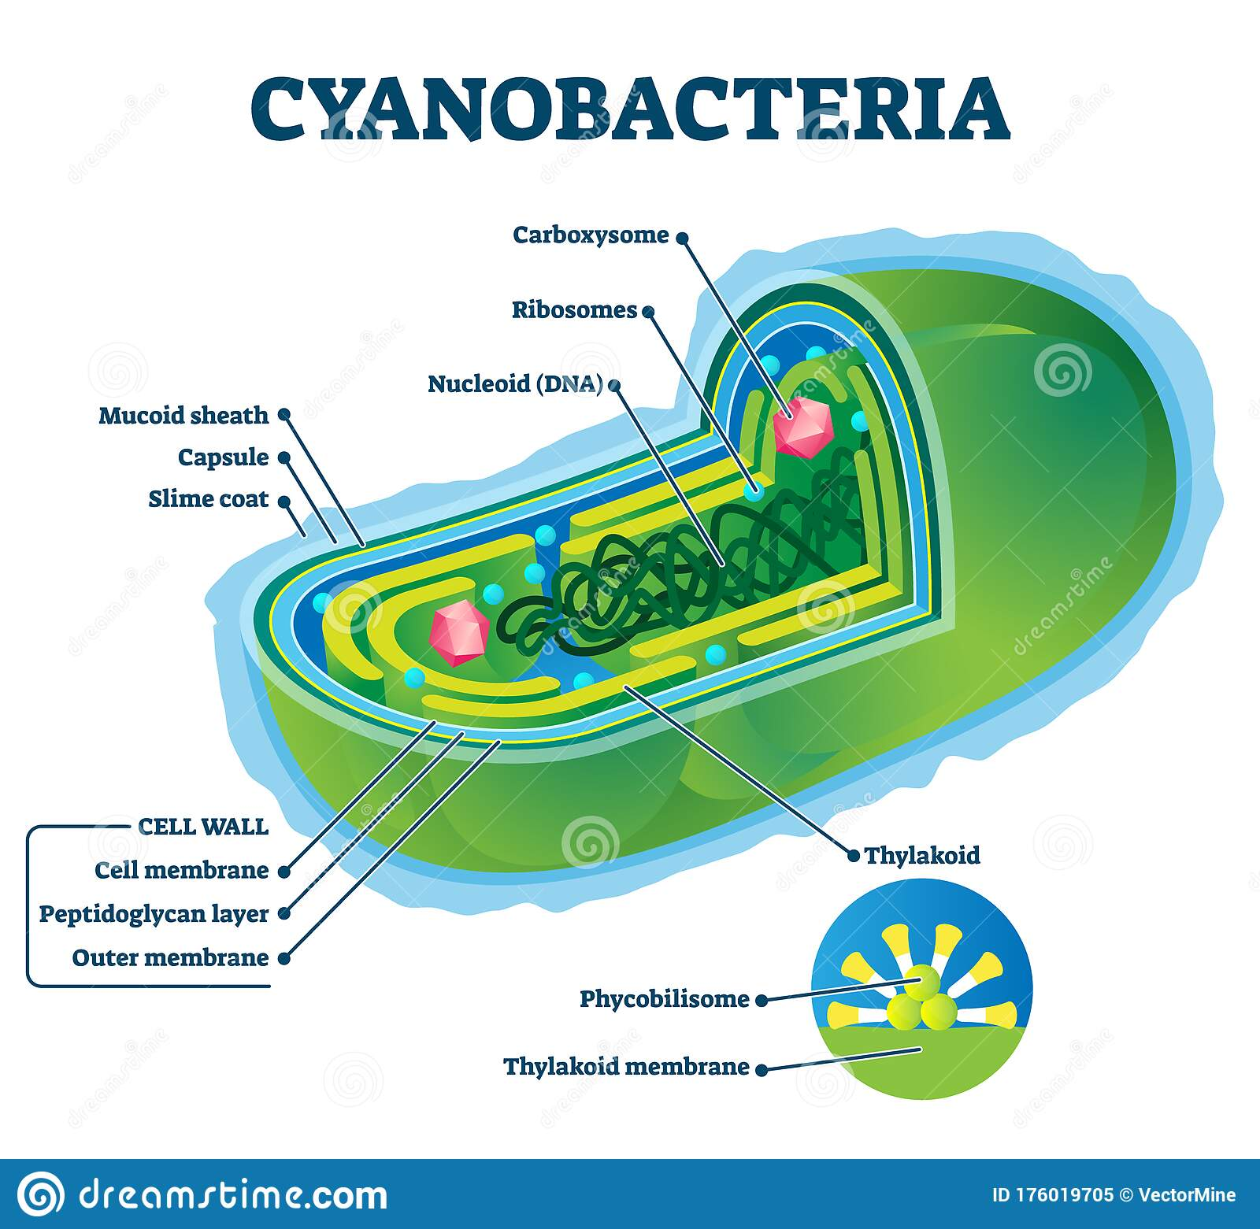

Most bacterial species are either **spherical**, called **cocci** (*sing*. **coccus**, from Greek *kókkos*, grain, and seed) or **rod-shaped**, called **bacilli** (*sing*. bacillus, from Latin *baculus*, stick). **Elongation is associated with swimming.**  Some rod-shaped bacteria, called **vibrio**, are slightly curved or **comma-shaped**; others, can be **spiral-shaped**, called **spirilla**, or **tightly coiled**, called **spirochaetes**. A small number of species even have tetrahedral or cuboidal shapes. More recently, bacteria were discovered deep under the Earth's crust that grow as long rods with a star-shaped cross-section. The **large surface area to volume ratio of this morphology may give these bacteria an advantage in nutrient-poor environments.** This wide variety of **shapes is determined by the bacterial cell wall and cytoskeleton**, and is important because it can influence the ability of bacteria to acquire nutrients, attach to surfaces, swim through liquids and escape predators.

**Name each of these bacterial shapes.**

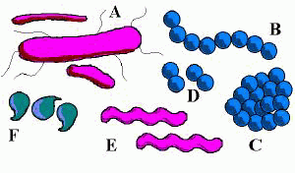

1. List and describe the 3 basic shapes for bacteria.

A.

B.

C.

1. What is the advantage of having an elongated shape?
2. Name and describe 3 variations of spiral shaped bacteria.

A.

B.

C.

1. What is the advantage to having a larger surface area to volume ratio?

Bacteria are unicellular and are covered with a thick outer **cell wall**. ***Color and label*** the **cell wall YELLOW**. Just within the cell wall is the cell membrane. ***Color*** ***and label*** the **plasma membrane GREEN**. Along the surface of some bacteria are structures called **pili** (**pilus**-singular) that help bacteria adhere to surfaces. ***Color and label*** all the **pili LIGHT GREEN.** Some bacteria are **motile** (can move). Many of these bacteria have long, whip like structures called **flagella** (**flagellum**-singular). ***Color and label*** the **flagella DARK GREEN**. Since bacteria are prokaryotes, they do **NOT** have a nucleus. They do have a single strand of **DNA** (double helix), their chromosome in the **nucleoid region** (center of the cell). This single strand of DNA contains all the instructions for making more bacterial cells. Locate the **DNA** and ***color and label*** it **RED**. Bacterial cells reproduce by a process called **binary fission**. The inside of the bacterial cell is filled with cytoplasm. ***Color and label*** the **cytoplasm LIGHT BLUE**. Sprinkled throughout the cytoplasm of the cell are small, round structures called **ribosomes.** Ribosomes make proteins for the cell. ***Label and Color*** all of the **ribosomes BLUE.**

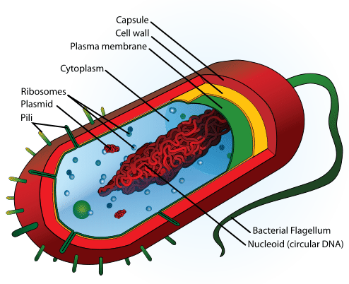

1. Name two structures that aid bacteria in movement.
2. What covers the outside of all prokaryotes?
3. What is the function of pili?
4. Describe the Chromosome (DNA) of bacteria & tell its location.