Elements & Macromolecules in Organisms

Most common elements in living things are carbon, hydrogen, nitrogen, and oxygen. These four elements constitute about 95% of your body weight. All compounds can be classified in two broad categories --- organic and inorganic compounds. Organic compounds are made primarily of carbon. Carbon has four outer electrons and can form four bonds. Carbon can form single bonds with another atom and also bond to other carbon molecules forming double, triple, or quadruple bonds. Organic compounds also contain hydrogen. Since hydrogen has only one electron, it can form only single bonds.
Each small organic molecule can be a unit of a large organic molecule called a macromolecule. There are four classes of macromolecules (carbohydrates, lipids, proteins, and nucleic acids). Carbohydrates and lipids are made of only carbon, hydrogen, and oxygen (CHO). Proteins are made of carbon, hydrogen, oxygen, and nitrogen (CHON). Nucleic acids such as DNA and RNA contain carbon, hydrogen, oxygen, nitrogen, and phosphorus (CHONP).
Protein
Carbohydrate Glucose
Lipid
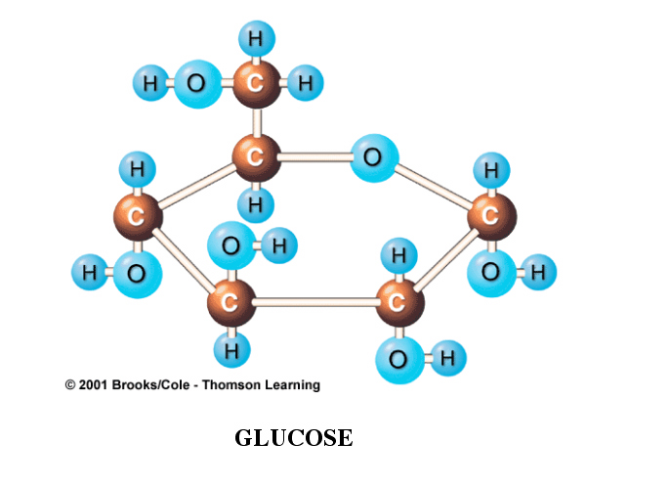

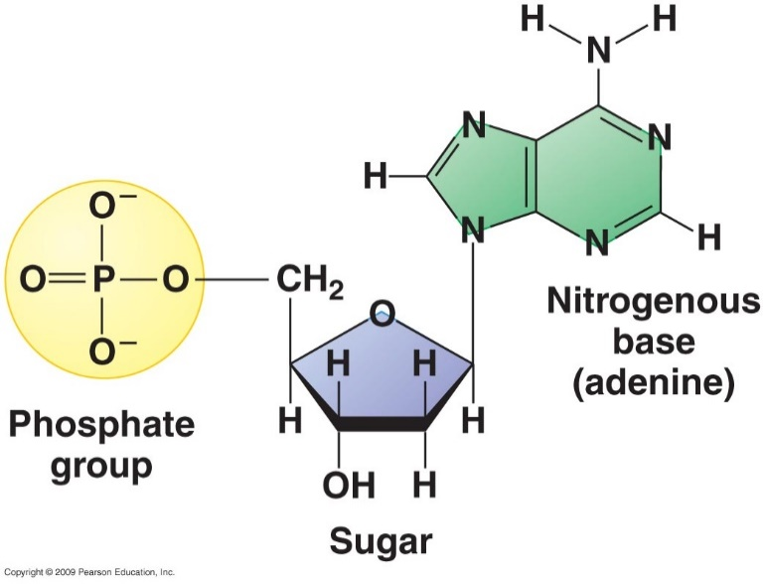
Nucleic Acid

The body also needs trace amounts of other elements such as calcium, potassium, and sulfur for proper functioning of muscles, nerves, etc.
USE THE DRAW FEATURE TO COLOR THE IMAGE APPROPRIATELY
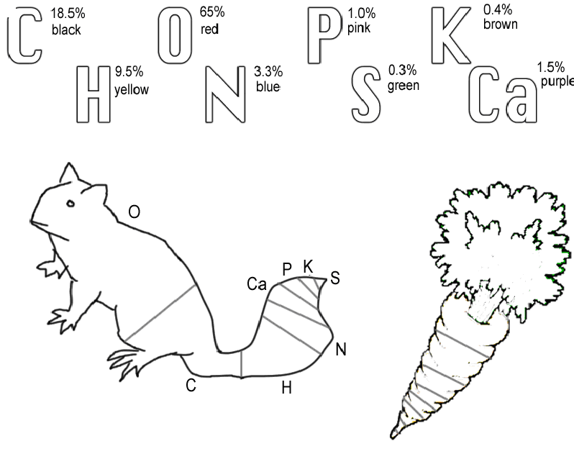
Questions:

1. Name the 4 main elements that make up 95% of an organism.

2. What are macromolecules?

3. Name the 4 classes of macromolecules.

4. What elements make up carbohydrates & lipids (symbols)?

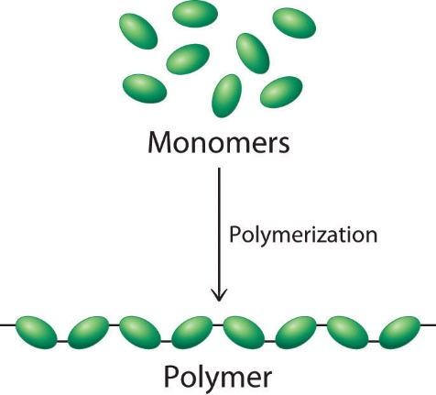
Organic Compounds

All organic compounds have molecules that contain carbon, the essential element for life. The four main classes of organic compounds (carbohydrates, lipids, proteins, and nucleic acids) that are essential to the proper functioning of all living things are known as polymers or macromolecules. Monomers are small molecules, which may be joined together in a repeating fashion to form more complex molecules called polymers. All of these compounds are built primarily of carbon, hydrogen, and oxygen but in different ratios. This gives each compound different properties.

Carbohydrates

Carbohydrates are used by the body for energy and structural support in cell walls of plants and exoskeletons of insects and crustaceans. Simple sugars (monosaccharides) include glucose, galactose, and fructose. These simple sugars combine to make disaccharides (double sugars like sucrose) and polysaccharides (long chains like cellulose, chitin, and glycogen).
USE THE DRAW FEATURE TO COLOR THE IMAGE APPROPRIATELY

Use the diagram of glucose and count how many carbons, hydrogens, and oxygens are in a single molecule. #C __________ # H __________ # O __________
O
C
C
C
C
C
O
H
H
C
H
H
O
H
H
H
O
H
H
O
H
H
O
H

Glucose Molecule

Questions:

5. What element do all organic compounds contain _____________.

6. Name 2 ways your body uses carbohydrates.

7. Name 3 simple sugars (monosaccharides).

Proteins

Proteins are made of subunits called amino acids and are used to build cells and do much of the work inside organisms. They also act as enzymes helping to control metabolic reactions in organisms. Amino acids contain two functional groups, the carboxyl group (-COOH) and the amino group (-NH₂).
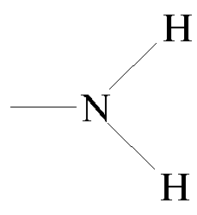
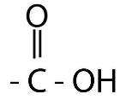

Amino group Carboxyl group
USE THE DRAW FEATURE TO COLOR THE IMAGE APPROPRIATELY

Basic Structure of Amino acid
N
H
H
C
C
O
H
H
R group

Questions:

8. What subunits make up proteins?

9. Proteins also act as in cells to control reactions.

10. Name the 2 functional groups in amino acids.

Lipids

Lipids are large, nonpolar (won't dissolve in water) molecules. Phospholipids make up cell membranes. Lipids also serve as waxy coverings (cuticle) on plants, pigments (chlorophyll), and steroids. Lipids have more carbon and hydrogen atoms than oxygen atoms. Fats are made of a glycerol (alcohol) and three fatty acid chains. This subunit is called a triglyceride.
USE THE DRAW FEATURE TO COLOR THE IMAGE APPROPRIATELY
C
C
C
H
H
H
H
H
O
O
O
H
H
H

Glycerol

The fatty acid chains may be saturated (only single bonds between carbons) or unsaturated (contain at least one double bond).

Saturated fatty Acid

Unsaturated Fatty Acid - Double Bond

Cell Membrane

A special type of lipid called phospholipids help make up the cell membrane. Two layers of these phospholipids make up the membrane. Phospholipids have a "water-loving" hydrophilic head and two "water-fearing" hydrophobic tails.

In the cell membrane below CIRCLE AND LABEL a phospholipid. Proteins are also embedded in the cell membrane. Color the two proteins in the cell membrane blue.

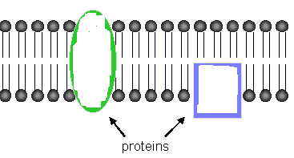
Cell Membrane

Questions:

11. Lipids are nonpolar. What does this mean?

12. makes up cell membranes.

13. Lipids have more and atoms than they do oxygen atoms.

14. If there are all SINGLE bonds between in the fatty acid chain, then it is said to be .

15. If there is a DOUBLE bond between in the fatty acid chain, then it is said to be .

16. The head of a phospholipid loves water and is said to be .

17. The 2 tails of a phospholipid are water-fearing and said to be .

Nucleic Acids

Nucleic acids carry the genetic information in a cell. DNA or deoxyribose nucleic acid contains all the instructions for making every protein needed by a living thing. RNA copies and transfers this genetic information so that proteins can be made. The subunits that make up nucleic acids are called nucleotides.
USE THE DRAW FEATURE TO COLOR THE IMAGE APPROPRIATELY : sugar (5-sided)-green, phosphate group (round)-yellow, and nitrogen base (6-sided)-blue. THEN PASTE YOUR COLORED MOLECULE BELOW. ATP used for cellular energy is a high energy nucleotide with three phosphate groups. Color code the ATP and LABEL THE PHOSPHATES.

Nucleotide

ATP
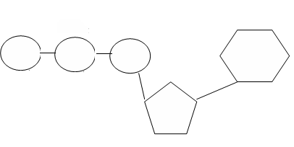

Questions:

18. Nucleic acids carry information in a molecule called DNA.

19. DNA stands for .

20. The nucleic acid _________ copies DNA so proteins can be made.

