Enzymatic: Virtual Enzyme Web quest
DIRECTIONS: Please click the link below to access the virtual web quest. Then follow all the prompts to complete the document.
https://biomanbio.com/HTML5GamesandLabs/LifeChemgames/enzymatichtml5page.html
- Click start New Game (Choose no for touchscreen)
- Read the Background and then proceed to the main menu.
- Double click the What are Enzymes button. Answer the following questions as you proceed through the web quest
  - Enzymes are ________________________ that speed up or ____________________ chemical reactions
  - These chemical reactions in living things are known as ________________________
  - In biology, two of the most important types of reactions are __________________________ and _______________________________________________ (aka Condensation)!
HYDROLYSIS
  - Hydrolysis is a type of reaction that involves the _________________________ of a large molecule called a Polymer into its building blocks (also known as monomers) Click replay on the web quest if you missed the animation.
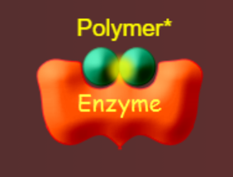
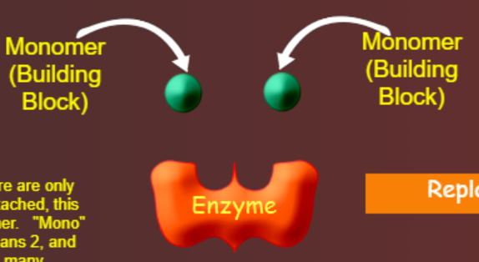
  - ____________________ is what enzymes in the body do when they ______________ down foods during digestions

DEHYDRATION SYNTHESIS

  - __________________________________is a type of reaction that involves __________________________ (synthesizing) large molecules called ______________________ by joining together building blocks (monomers) Click replay on the web quest if you missed the animation.
  - Dehydrations synthesis happens in your cells when you need to __________________ large complex molecules such as proteins, fats, nucleic acids or complex carbohydrates!
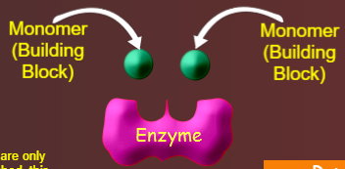

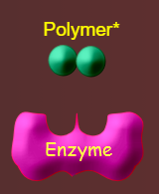

- PLAY THE GAME!! Your goal is to build brides to get all of the Snurfles to safety, but not allow the predators to cross the bridges. CHOOSE TO PLAY THE NEXT LEVEL OR JUMP TO MINI-QUIZ
MINI QUIZ: Please answer by writing the correct term
- What type of molecules are enzymes? _______________________________
- What do enzymes do? ___________________________________
- The chemical reactions done by living organisms are known as ___________________________
- Are enzymes needed for metabolism? ________________________
- What types of reactions are catalyzed by enzymes? ______________________________________
- Proteins are made of building blocks called amino acids. Based on this fact, what are enzymes made of? ____________________________________
- Type of reaction shown in the animation? _____________________________________
- Type of reaction shown in the animation? _____________________________________

- Double click the Specificity button. Answer the following questions as you proceed through the web quest
  - Usually, each enzyme can only ____________________________ a very specific chemical reaction!
  - This is because of the ___________________ if the enzyme.
  - Each enzymes has a unique shape that makes an ____________________________________! Each active site can only fit a specific _____________________________ or substrates
  - When the substrate (or substrates) enter the active site, the enzymes helpes a specific chemical reaction to occur! The end result of the chemical reaction is the ________________________ or products !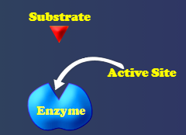 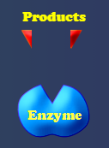

- PLAY THE GAME!! Your goal is to prevent the substrates from building up! (Click on the necessary enzyme, then use the arrow keys to move it so that it attaches to the substrate) CHOOSE TO PLAY THE NEXT LEVEL OR JUMP TO MINI-QUIZ
MINI QUIZ: Please answer by writing the correct term
- This is the part of the enzyme that binds the substrate and causes the reaction to occur. __________________________________________
- This is the substance that will enter the active site and undergo a chemical reaction. ___________________________________________
- This is a protein that catalyzes or speeds up a chemical reaction. _________________________
- These are what you end up with at the end of a chemical reaction. __________________________\
- We say that enzymes are specific. What does this mean? __________________
- What is the most important factor in determining the specificity of an enzyme? ____________________________________________
- Double click the Experiments button. Answer the following questions as you proceed through the web quest
TEMPERATURE
  - Several factors affect how well an enzyme is able to perform its job! For example, enzymes are affected by __________________, pH, and the concentration of substrates. All of these factors affect the rate at which an enzyme catalyzes a chemical reaction.
  - Read and click through until you start the lab.
  - Slide the temperature slide and carefully observe the enzyme and substrates.
  - What happened to the enzyme when the temperature got too high?

_____________________________
  - The temperature at which an enzyme works best is called the _________________ ________________! The optimal temperature in the temperature where the rate is the ____________________.
  - Looking at the graph, what is the optimal temperature for this enzyme? ___________
MINI QUIZ: Please answer by indicating A B C or D
- Based off your observations, which of the statements would be true? _________
- What is the optimal temperature for the enzyme shown below? _____________
- Why does the reaction rate slow down drastically when the temperature is too high? ___________
- Based off of your observations of the enzyme shown, which of the following is true? __________
ENSYMES AND pH
- The pH scale is a way to measure how _____________ or ______________ a solution is.
- Slide the pH slider and carefully observe the enzyme and substrates

- Enzymes are affected by pH. Click okay to see how the enzymes shown below is affect by _________
- Your Enzymes has ___________________ ! This means that is has lost its shape and DOES NOT WORK at this pH! Sometimes and enzyme can _______________ its shape after being denatured, if the pH returns to an optimal range. Experiment with the pH to see if this is the case for your enzyme!
- Click Next challenge
MINI QUIZ: Please answer by indicating A B C or D
- Based off your observations, which of the following statements would be true? __________
- What is the optimal pH for the enzyme shown below? __________
- Based off of your observations of the enzyme shown, which of the following is true? __________
- Pepsin is an enzyme found in your stomach. This is a very acidic environment! Which of the following would be the most reasonable inference for the optimal pH of pepsin?
ENZYME AND SUBSTRATE CONCENTATION
- Substrate concentration refers to the relative _______________ of a substrate present in a solution.
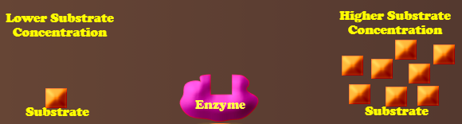
- In other words, a ______________ concentration means more substrate is available for the enzyume to act on! A lower substrate ____________________ means there is less substrate available for the enzyme to act on!

- Make a hypothesis about the effect of substrate concentration on enzyme activity. (MUST USE IF/THEN STATEMENT)
- Slide the substrate concentration slider slowly to see how the reaction rate of the enzyme is affected by changes in the substrate concentration.
- Click Next Challenge
MINI QUIZ: Please answer by indicating A B C or D
- Based on your observations, how does substrate concentration affect enzyme activity? ________________
- How is enzymes activity at varying substrate concentrations different from enzyme activity at carrying temperatures or pH levels? _______________
- Was your hypothesis on the relationship between substrate concertation and enzyme activity supported? _______________
RUN THE ENZYME MACHINE

