Biology Cornell Notes: Enzyme Notes Date:
Study Questions/ Vocabulary:  1. What are the two functions of enzymes?  _____________________________________________________________________________________  2. Define catalyst. ____________________________________________________________________3. Do enzymes raise or lower the energy needed to activate a reaction?  __________________________________  4. List three things that can affect an enzymes function  ________________________________________________________________________________________________________________________________________________________ | What are enzymes?  - Most enzymes are ___________________  - They act as a __________________ to accelerate (speed up) a reaction  - Enzymes are ____ __________ changed in the process  Two functions of enzymes  - ________________________ : to build (synthesis) a polymer you must first remove some water (Dehydrate)  - ________________________: to break (lysis) a polymer you must add water (Hydro)  Dehydration synthesis  - Dehydration synthesis: Removal of _________ to ___________ a bond  - This is how you make muscles in your body. Muscles are made by combining two amino acids together to make protein. Proteins make up your muscles.  Hydrolysis  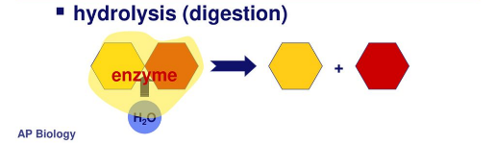  - Hydrolysis: Addition of _____________ to _____________ a bond  - This is how you digest your food. The polymers are broken down into their monomer groups. Thick of the cracker  Enzymes  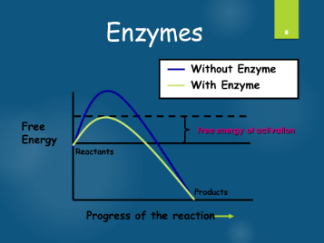  - Enzymes are specific for what they ___________________  - They are ________________  - All enzyme names end in ___________ ( Sucrase, Lactase, Maltase)  How do enzymes work?  - Enzymes work by _____________ _______________ which ________ activation energy  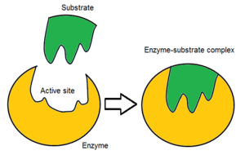  Active Site  - The active site is a ________________________ of an enzyme molecule where the substrate binds  Enzyme substrate complex  - The enzyme substrate complex is a _____________ molecule formed when an enzyme comes into _________________ _________________ with its substrate  What affects enzymes activity?  - Three different factors  - Temperature  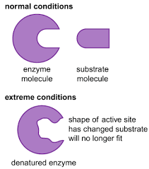  - pH  - Enzyme Inhibitors  - Temperature  - Extreme __________________ are the most dangerous  - ________________ _________________ may denature the enzyme  - When an enzyme is __________________ its active site is ______________  - pH  - Changes in ________ also ___________ the shape of an enzyme’s ___________ site  - Each enzyme works best at a specific pH value  - Enzyme inhibitors  - Enzyme inhibitors: are chemicals that __________ an enzyme’s normal substrate and _____________ with it for the active site  - If it fits….it sits…
SUMMARY : ________________________________________________________________________________________________________________________________________________________________________________________________________________________________________________________________________________________________________________________________________________________________________________________________________________________________________________________________________________________________________________________________________________________________________________________________

