Directions: The following cards are all out of order. Please rearrange the cards so that they go in order from smallest to largest. Be sure the function matches the vocabulary term as well as the picture.
VOCABULARY CARDS: | FUNCTION CARDS: | PICTURE CARDS:
 |  | 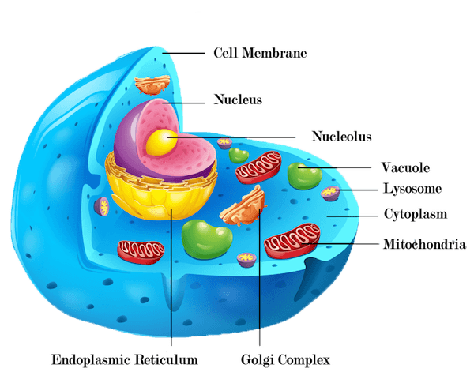
 |  | 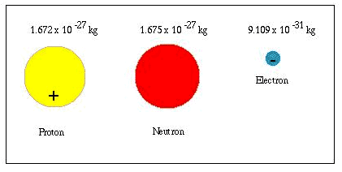
 |  | 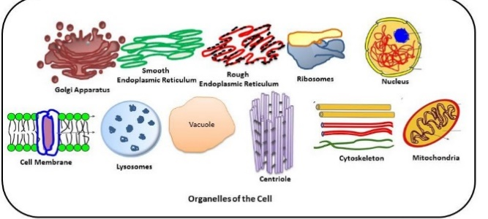
 |  | 