Photosynthesis, & Cell Respiration WebQuest

PHOTOSYNTHESIS & FOOD
Use the link to watch the “Simple Story of Photosynthesis & Food” video. As you watch, fill in the blanks below.
https://youtu.be/eo5XndJaz-Y

- What percentage of the food we eat comes from carbohydrates?

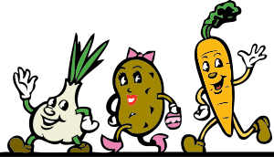
- What are carbohydrates made of:

- What are the pores in a plant’s skin called?

- What light absorbing pigment is found in chloroplasts?

- The sun helps covert carbon dioxide into a simple carbohydrate called:

- What is another name for cellulose?

- What does starch do for a plant?

- When we break down glucose, what energy molecule is produced?

- What are three ways we use ATP?

- How is ATP like dollars?

- Which organelle is responsible for breaking down carbohydrates into useable energy?

- Do plants have mitochondria?

GAME PLAY-PRACTICE

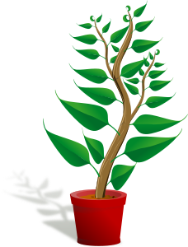
Use the link to access the Photosynthesis & Respiration Game. As you move through the game, answer the following questions.
https://www.biomanbio.com/HTML5GamesandLabs/PhotoRespgames/photoresphtml5page.html

- What molecule does the fruit represent?
- The molecules you use in a chemical reaction are called the:
- The molecules you produce in a chemical reaction are called the:
- How many ATP molecules are produced in one reaction during cell respiration?
- What are the reactants in respiration?
- What are the reactants in photosynthesis?
- What are the products in cellular respiration?
- What are the products in photosynthesis?

TASK SEVEN – GAME BOARD CHALLENGE
Use the link to access the Challenge Board Game. Choose 1-­‐PLAYER game. As you move through the game, write three questions/answers you encountered below. https://www.quia.com/cb/916146.html

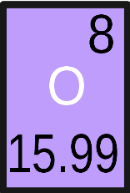
Q. A.
Q. A.
Q.

A.

