Respiration Card Sort

Procedure:
- Read the text below about respiration.
- Drag and drop the cards to sort them into two groups - find two sensible titles amongst the cards
- If you are unable to sort all the cards, please reread the text
- Sort any remaining cards.
- Have a partner check your work

Respiration Summary
Living organisms use energy released by respiration for their life processes. Respiration is the process by which energy is released from organic molecules such as glucose. There are two types of respiration – aerobic (which needs oxygen) and anaerobic (which doesn’t need oxygen).
Aerobic respiration (in cell mitochondria)
Aerobic respiration needs oxygen. It is the release of a relatively large amount of energy in cells by the breakdown of food substances in the presence of oxygen:
Glucose + Oxygen → Carbon Dioxide + Water
C₆H₁₂O₆ + 6O₂ → 6CO₂ + 6H₂O
Aerobic respiration happens all the time in animals and plants. Note that respiration is different to breathing (ventilation). Most of the reactions in aerobic respiration happen inside mitochondria in cells.
There aren’t any side effects of aerobic respiration because carbon dioxide and water are safe and easy for the body to get rid of. Aerobic respiration releases 19 times more energy than anaerobic respiration from the same amount of glucose.
Anaerobic respiration (in cell cytoplasm)
Unlike aerobic respiration, anaerobic respiration does not need oxygen. It is the release of a relatively small amount of energy in cells by the breakdown of food substances in the absence of oxygen. Unfortunately, the product of anaerobic respiration is toxic and so can cause problems.

Anaerobic respiration occurs in the cell cytoplasm. Glucose is not completely broken down, so much less energy is released than during aerobic respiration.
Glucose → Lactic acid
C₆H₁₂O₆ → 2C₃H₆O₃
Anaerobic respiration happens in muscles during hard exercise. There is a build-up of lactic acid in the muscles during vigorous exercise, this may cause pain. The lactic acid needs to be oxidized to carbon dioxide and water later.
This causes an oxygen debt - known as excess post-exercise oxygen consumption (EPOC) - that needs to be ‘repaid’ after the exercise stops. This is why we keep on breathing deeply for a few minutes after we have finished exercising.
Anaerobic respiration in plants and yeast
It’s not all bad though! Another type of anaerobic respiration, fermentation, also happens in plant cells and some microorganisms. Anaerobic respiration in yeast is used during brewing and bread-making:
Glucose → Ethanol + Carbon Dioxide
C₆H₁₂O₆ → 2C₂H₅OH + 2C0₂
Ethanol is the alcohol found in alcoholic drinks like beer and wine. In bread-making, bubbles of carbon dioxide gas expand the dough and help the bread rise.

Directions: Drag and drop the cards from below into two distinct groups- Find two sensible titles amongst the cards
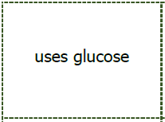 | 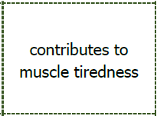 | 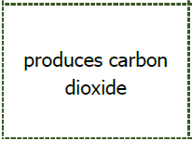
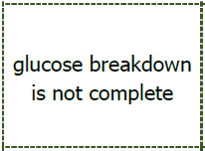 | 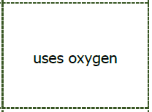 | 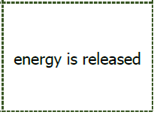
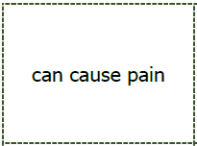 | 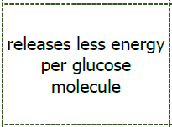 | 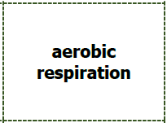
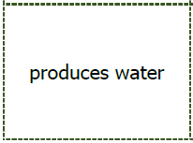 | 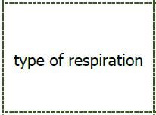 | 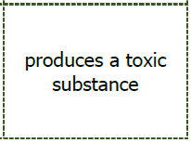
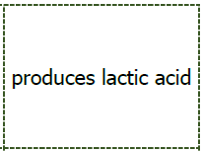 | 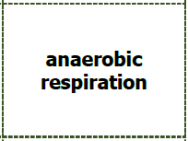 | 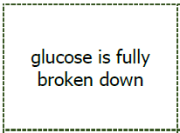
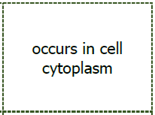
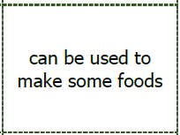 | 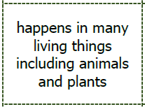 | 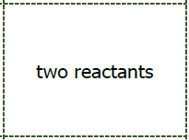
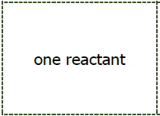 | 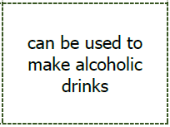
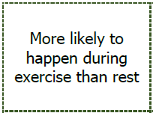 | 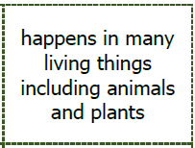 | 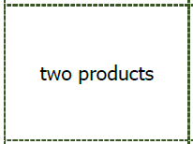
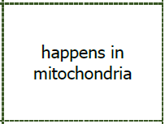 | 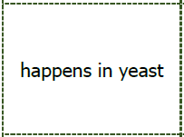 | 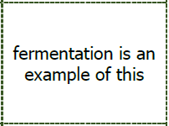
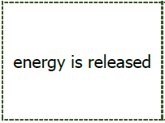 | 