Name: Period: Due:

CELL STRUCTURE STUDY GUIDE
- Identify the cell structures.
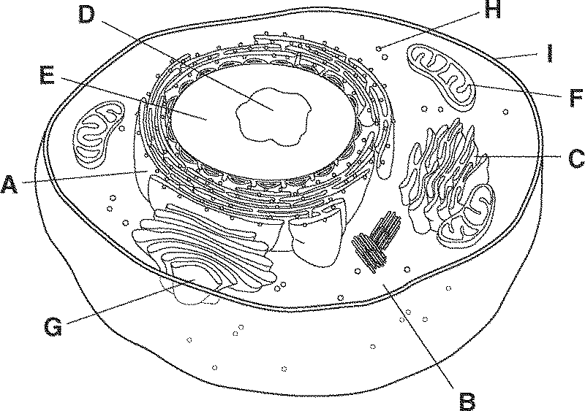
- Describe two ways you can tell this cell is NOT a plant cell.
- Describe two ways you can tell this cell is NOT a bacterial cell.
- What are cells called that have no nucleus and no organelles?
- What are cells called that have a nucleus and organelles?
- What kinds of cells are eukaryotes?
- What kinds of cells are prokaryotes?
- A structure surrounded by a membrane that performs a specialized function within a cell is known as?
- List 3 ways in which a plant cell differs from an animal cell. Be sure to indicate what belongs to the plant and what belongs to the animal cell.
- Describe the differences between the structure and functions of the rough and the smooth ER.
- What organelle is responsible for modifying and packaging proteins for distribution?
- What organelle is responsible for storing water inside a plant cell?
- List the organelles involved in the process of protein production.
- What is the gel-like material inside the cell and inside organelles called?
- Where does photosynthesis occur in a cell?
- What is the dark spot in the nucleus called?
1.
A:
B:
C:
D:
E:
F:
G:
H:
I:

2.

3.

4.

5.

6.
7.
8.

9.

10.

11.

12.

13.

14.

15.
16.

- If a cell is very active, like muscle cells and needs more energy, what type of organelle will it need more of?
- What is the purpose of DNA inside the nucleus?
- What structure surrounds the DNA and controls what enters and leaves the nucleus?
- What is the job of the nucleolus?
- How do materials get to & from the Golgi?
- Centrioles are found ONLY in which kind of cells?
- What is the function of centrioles?
- Where are ribosomes found?
- What is the function of ribosomes?
- What do lysosomes do?
- Which organelle manufactures ATP in the cell?
- What is the only kind of cells that have chloroplasts?
- Where is the cell wall located?
- What kinds of cells have cell walls?
- What is the function of cell walls?
- Which structure is most directly responsible for maintaining homeostasis (balance) in all cells?
- 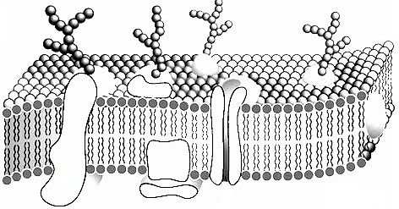Identify the parts of the cell membrane.
B
A
C
D
17.

18.
19.

20.
21.
22.
23.
24.
25.
26.
27.
28.

29.
30.
31.
32.

33.
A:
B:
C:
D:

- What is the function of the cell membrane?

- Define homeostasis and give an example.

- Why is the cell membrane said to be “semi- permeable”?

- Define “concentration gradient”.
34.

35.

36.

37.

- What kind of transport DOES NOT require energy?
- During diffusion molecules tend to move from to .
- When the concentration of a solute is the same throughout a system, the system has reached?
- Which kinds of transport are passive?

- Facilitated diffusion with aquaporins is also called?
- In a solution, the such as sugar, dissolves into the , like water.
- tonic means there is a GREATER concentration of solute molecules OUTSIDE the cell than inside. Draw a picture to the right and label the movement of water.

- tonic means there is a LOWER concentration of solute molecules OUTSIDE the cell than inside. Draw a picture to the right and label the movement of water.

- tonic means there is the SAME concentration of solute molecules outside the cell as inside. Draw a picture to the right and label the movement of water.

- Active transport requires?
- Which kinds of transport are active? (Hint: There are 3!)

- Diagram exocytosis and endocytosis to the right and label which is which.

- Small membrane sacs used for transport of large substances are called?
38.

39.

40.

41.

42.
43. 44.

45.

46.

47.
48.

49.

50.

- What are the parts of the Cell Theory 51. ___________________________
__________________________________________________________

- Name the scientist
  - ____________________________________came up with the name cells (looked at cork)
  - _______________________________________ determined all animals are made of cells
  - ___________________________________ looked at pond water, father of microbiology
  - ________________________________________determined all plants are made of cells
  - ________________________________________determined cells come from other cells

