Cell Membrane Worksheet

*Directions: Read the passage about cell membranes below and then answer the questions that follow.*

The membranes found in the cells of all living organisms have two main functions: 1) to protect the cell, and 2) to let materials enter and exit the cell. The cell membrane is **semi-permeable** which means that it allows some materials to pass through and not others. This allows the cell to maintain a stable internal environment known as **homeostasis.** The cell membrane, also called the **plasma membrane,** is made mostly of **lipids.** The lipids found in cell membranes are specifically called **phospholipids**. These lipids are arranged in a double lipid layer known as the **phospholipid bilayer**. Each phospholipid has a **hydrophilic** (water-attracting) head and two **hydrophobic** (water-repelling) tails. Because water is polar, this means that the phospholipid heads are also polar, while the phospholipid tails are nonpolar. The head of a phospholipid is made of an alcohol and **phosphate** group, while the tails are chains of **fatty acids**.

The multiple different structures that make up the cell membrane can freely move horizontally through the membrane which is why it is called a **fluid mosaic.** When phospholipids move, they allow water and other molecules to pass through into or out of the cell. This is known as **simple** **diffusion** because it does not require **energy,** and the water and/or molecules are moving **down** the concentration gradient. **Cholesterol** molecules, located in between many of the phospholipids, help to make the membrane stronger and more flexible.Cell membranes also contain **proteins.** Some proteins span across the whole membrane. These proteins, called **transport proteins**, help to move substances or wastes across the membrane. Other proteins can be found on the outer surface of the cell membrane. These proteins, called **receptor proteins**, transmit signals to the inside of the cell. **Carbohydrate chains** are attached to the outside of the membrane. These chains help cells to signal and recognize other cells.

1. What are the two main functions of cell membranes?
   1. __________________________________________________________________________
   2. __________________________________________________________________________
2. Why is the cell membrane semi-permeable? _______________________________________________
3. How does the cell membrane help the cell to maintain homeostasis? _____________________________

________________________________________________________________________________

1. What is another name for the cell membrane? _________ _________________
2. What type of molecule makes up the majority of the cell membrane? ____________________________
3. Lipids found in the cell membrane are specifically called _____________________________________.
4. Why is the membrane called a phospholipid bilayer? _________________________________________

________________________________________________________________________________

1. *Fill-in-the-blanks in the statements below about phospholipids.*

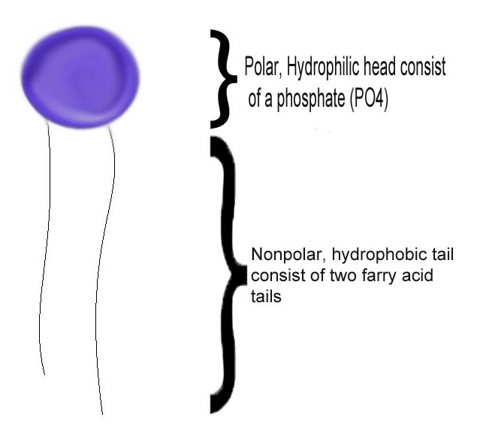

* 1. Phospholipid heads are ___________ which means they are water-______________ and _______________ like water.
  2. Phospholipid tails are ___________ which means they are water-______________ and _______________ unlike water.

1. Why is the cell membrane called a fluid mosaic? ____________________________________________

________________________________________________________________________________

1. How does simple diffusion occur across the cell membrane? ___________________________________

________________________________________________________________________________

________________________________________________________________________________

1. What is the role of **cholesterol** in the cell membrane? _______________________________________
2. Where are **transport proteins** located in the cell membrane? __________________________________
3. What is the function of transport proteins? ______________________________________________
4. Where are **receptor proteins** located in the cell membrane? ___________________________________
5. What is the function of receptor proteins? _______________________________________________
6. Where are **carbohydrate chains** located in the cell membrane? _________________________________
7. What is the function of carbohydrate chains? _____________________________________________

*Directions: Color each part of the cell membrane listed in the table below.*  Please Copy and paste the image into paint 3D. Proceed to color the image. Then copy and paste it back onto this document.

|  |  |  |  |
| --- | --- | --- | --- |
| **Letter** | **Name/Color** | **Letter** | **Name/Color** |
| A | Phospholipid bilayer (no color) | H | Receptor protein (red) |
| B | Transport protein (pink) | G | Phospholipid heads (yellow) |
| F | Phospholipid tails (orange) | C | Cholesterol (blue) |
| E | Carbohydrate chains (green) |  |  |

