ATP, Photosynthesis, & Cell Respiration WebQuest
TASK ONE – INTRODUCTION TO ATP
Use the link to watch the “What is ATP & How It Works” video. As you watch, fill in the section below. https://www.youtube.com/watch?v=bbtqF9q_pFw
1. The full name of ATP is:
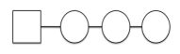
2. Label the ATP Diagram with what each shape represents.

3. ATP is a molecule in the cell that allows for quick and easy __________________ when needed by the cells organelles.
4. ATP is a type of ____________________ that __________________energy when the chemical bonds are _________________ between two ______________ groups.
5. The abbreviation for Adenosine Diphosphate is _____________________________
6. The ADP enters the cell’s _________________________ and is recharged when the mitochondria adds another ______________________ to the molecule. The molecule becomes _____________________again.
TASK TWO – CELL RESPIRATION & PHOTOSYNTHESIS
Use the link to access the “Photosynthesis and Cell Respiration” article. As you watch/ read, fill in the blanks below.
https://biologywise.com/photosynthesis-cellular-respiration
7. Photosynthesis is the process used by plant cells to convert ______________ from the sun into ________________________ , so as to create energy-rich ____________________molecules like glucose.
8. Cellular respiration is the process of ____________________________food molecules to obtain energy and ________________________ it in the form of______________________ ATP molecules.
9. Photosynthesis takes place in the cells of plant leaves in structures called _________________________, which contain ________________________. The plant cells absorb light from the sun through the chlorophyll ______________and using ____________________and _________________ obtained from the environment, undergo a series of chemical reactions to produce_______________________________________ molecules.
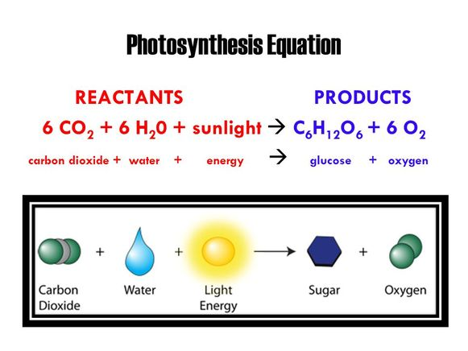
10. Look at the picture. Copy the chemical reaction for photosynthesis below in symbols and words. BE SURE TO USE PROPER SUBSCRIPTS!!!!

Chemical Reaction SYMBOLS
Chemical Reaction WORDS

11. Cellular respiration takes place in the _______________________ way in both ________________ and _____________________________
12. Living cells obtain the_____________________________ of photosynthesis (sugar molecules) and undergo cellular respiration to produce ____________________ molecules.
13. Some cells respire _____________________________, using _____________________ , while others undergo ____________________________ respiration, _____________________ using oxygen.
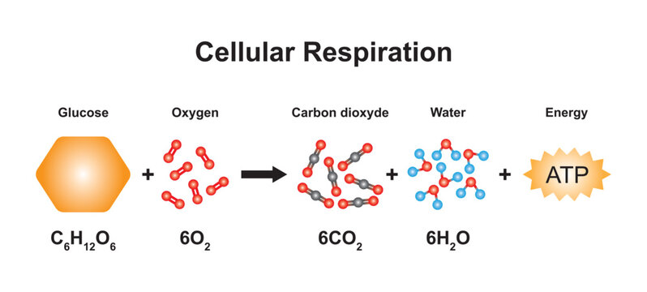
14. Look at the picture. Copy the chemical reaction for cellular respiration below in symbols and words. BE SURE TO USE PROPER SUBSCRIPTS!!!

Chemical Reaction SYMBOLS
Chemical Reaction WORDS

15. Read the last section “Differences Between Cell Respiration & Photosynthesis. Use the details in this section to fill in the table below to compare and contrast these processes.
3 Details about Photosynthesis | 2 Ways They Are Alike | 3 Details About Cellular Respiration
1. | 1. | 1.
2. | 2. | 2.
3. |  | 3.

TASK THREE – PHOTOSYNTHESIS & FOOD
Use the link to watch the “Simple Story of Photosynthesis & Food” video. As you watch, fill in the blanks below.
https://www.youtube.com/watch?v=eo5XndJaz-Y
16. What percentage of the food we eat comes from carbohydrates?
17. What are carbohydrates made of:
18. What are the pores in a plant’s skin called?
19. What light absorbing pigment is found in chloroplasts?
20. The sun helps covert carbon dioxide into a simple carbohydrate called:
21. What is another name for cellulose?
22. What does starch do for a plant?
23. When we break down glucose, what energy molecule is produced?
24. What are three ways we use ATP?
25. How is ATP like dollars?
26. Which organelle is responsible for breaking down carbohydrates into useable energy?
27. Do plants have mitochondria?
TASK FOUR – GAME PLAY PRACTICE
Use the link to access the Photosynthesis & Respiration Game. As you move through the game, answer the following questions. https://biomanbio.com/HTML5GamesandLabs/PhotoRespgames/photoresphtml5page.html
28. What molecule does the fruit represent?
29. The molecules you use in a chemical reaction are called the:
30. The molecules you produce in a chemical reaction are called the:
31. How many ATP molecules are produced in one reaction during cell respiration?
32. What are the reactants in respiration?
33. What are the reactants in photosynthesis?
34. What are the products in cellular respiration?
35. What are the products in photosynthesis?
TASK FIVE – ANAEROBIC & AEROBIC RESPIRATION
Use the link to watch the “Respiration” video. As you watch, fill in the blanks below. https://www.youtube.com/watch?v=Xp0o19gWX7E
36. What is the difference between respiration and breathing?
37. What is more efficient? - Anaerobic or Aerobic Respiration?
38. What compound is responsible for the cramps that we feel when we run out of oxygen? 39. The build up of lactic acid causes:
40. What is the name of the length of time needed for us to pay back our oxygen debt?

TASK SIX – FERMENTATION
Use the link to watch the “Fermentation Of Yeast & Sugar” video. As you watch, fill in the blanks below.
https://www.youtube.com/watch?v=FYClCHVT00M
41. Fermentation is a metabolic process that coverts _________________ into ________________
42. Fermentation occurs in _________________________, bacteria, and other microorganisms, as well as _______________________________________________________
43. The bottle with the MOST sugar grew to a ___________________________size.
44. Yeast is a type of ___________________________
45. When the yeast digests sugar and starches, it produces the waste products of_____________________ and ____________________________.
46. Write the fermentation equation shown in the video in the space below. Write the symbols and words.

47. Is yeast fermentation an anaerobic or aerobic form of cellular respiration?
Why?

TASK SEVEN – GAME BOARD CHALLENGE
Use the link to access the Challenge Board Game. Choose 1-PLAYER game. As you move through the game, write three questions/answers you encountered below.
https://www.quia.com/cb/916146.html
Question | Answer
1. | 1.
2. | 2.
3. | 3.

