Macromolecule | Function | Monomer (subunit) | Examples | Elements

Cut out the boxes below and paste in the table above.

Storage, Transport, Regulatory Movement, Structure, Enzymes | Glucose (sugar), Starch, Glycogen, Cellulose | Keratin (hair) , Muscles, Silk, Nuts, Beans, Hemoglobin, Insulin | CHO | Nucleic Acids
CHO | Fats, Oils, Waxes, Cholesterol, Phospholipids | Lipids (Fats) | 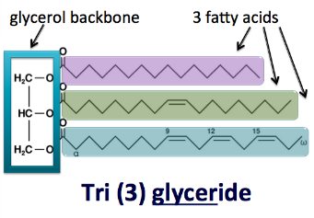 | Energy Storage
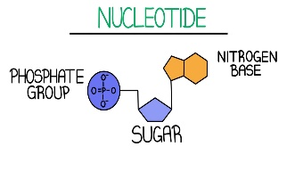 | Energy Storage, Forms Cell membrane, Chemical Messengers, Protection, Insulation | CHON | Proteins | 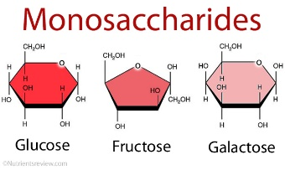
DNA, RNA | Carbohydrates | Carries genetic information to make proteins | 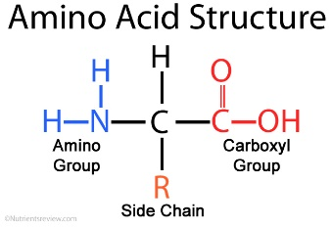 | CHONP

