ATP/ADP Energy Cycle Name __________________________________

Directions: Read and mark up the text. (Aka close read)

**Essential Question: What is ATP and how is it used by living cells?**

ATP or adenosine triphosphate, is the main energy-carrying or energy-transferring molecule of all living things. In cellular respiration, the energy in the food you eat is released and used to power the cell and its’ functions. ATP is the molecule that accepts the energy from digested food and transfers that energy to where it is needed in the cell. In photosynthesis, light energy is first captured by chlorophyll and transferred to ATP. The ATP then goes to power the process of making glucose. ATP is the energy “currency” of the cell. When a cell needs work to be done it must spend its ATP.

Your cells require energy to carry out many different functions (active transport across the membrane, protein synthesis, and cell division). The fuel for these functions comes from a molecule called adenosine triphosphate (ATP). ATP stores energy until a cell needs it. When a cell requires energy, it breaks part of the ATP molecule apart which releases energy.

ATP is made up of three subunits: an adenine molecule, a ribose sugar and 3 phosphate groups (adenosine triphosphate). “Adenosine” is the term used for the molecule formed when adenine is bonded to ribose. When only two phosphate groups are attached it is called ADP (adenosine diphosphate).

The useable energy in ATP is stored in the last “high-energy” bond holding on the third phosphate group. When a cell needs energy to perform a function, it breaks the last phosphate off of an ATP molecule and the energy is released. ADP does not have enough energy to perform cellular work so it must be converted back into ATP by adding another phosphate group. The energy needed to “reenergize” ATP by adding a phosphate group comes from the chemical breakdown of the food we eat (cellular respiration) or from light energy (photosynthesis).

It is estimated that humans use almost their body weight in ATP each day to keep their cells functioning. In fact, a cell can use about 2 trillion molecules of ATP per second!! Where does all of the ATP come from? You guessed it; it is recycled over and over again from ADP. Just like rechargeable batteries.

**Part 1: The structure of ATP**

ATP consists of 3 parts: 1 adenine molecule, 1 ribose sugar molecule, and 3 phosphate molecules. Energy is stored in the bond that is found between the 2nd and 3rd phosphate groups.

* COLOR & LABEL the following in the ATP molecules below: adenine – red, ribose – orange, 3 phosphate groups – yellow.
* 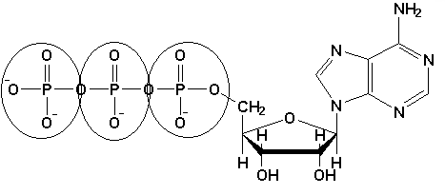Circle the area that represents the HIGH ENERGY bond.

**3**

**2**

**1**

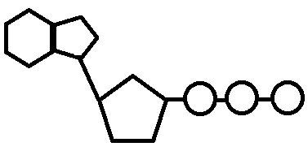

**1**

**2**

**3**

**Part 2: ATP Decomposition**

When a cell requires energy, it breaks off the last (3rd) phosphate group from the ATP molecule, which releases energy. The molecule that is left over is called adenosine diphosphate (ADP) which consists of adenine, ribose sugar, and **TWO** phosphate groups. ADP contains less energy than ATP.

* COLOR & LABEL the following in the energy molecule below: adenine – red, ribose – orange, first two phosphate groups – yellow, lone phosphate group – purple. COLOR the energy released – green.
* Circle the part of the image that makes up one molecule of ADP.

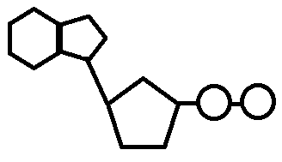

**ENERGY**

**RELEASED!**

**Part 3: ATP Synthesis**

ATP molecules are constantly being rebuilt from ADP and lone phosphate groups. This ensures that cells always have a source of energy. However, it takes energy to make ATP. The energy to make ATP comes from a carbohydrate called GLUCOSE. Glucose is a monosaccharide, or simple sugar. Its chemical formula is C6H12O6. Plants produce glucose during photosynthesis.

* COLOR & LABEL the following in the energy molecule below: adenine – red, ribose – orange, first two phosphate groups – yellow, lone phosphate group – purple. COLOR the energy absorbed – blue.
* Is the ENTIRE energy molecule called ATP or ADP? Be sure to LABEL the name below!

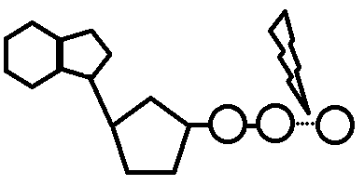

ENERGY Absorbed

**Use your resources to answer the following questions:**

1. What is energy?
2. (T/F) Organisms need a constant supply of energy to survive.
3. What is the structural difference between ATP and ADP? Compare/contrast structure of ATP & ADP.
4. Which structure, ATP or ADP, contains more stored energy? Where is the energy stored?
5. Which type of macromolecule (protein, carb, nucleic acid, or lipid) is ATP & ADP?

**Part 4: ATP/ADP Cycle** 🡪 SEE CUT OUTS

* Label ATP and ADP molecules
* Label Adenine, Ribose, Phosphate Groups (1, 2, 3) 🡪 both on the ATP & ADP molecule
* Color entire ATP 🡪 GREEN
* Color Energy Released 🡪 ORANGE
* Color Lightning Bolt 🡪 PURPLE
* Color Lone Phosphate in ADP 🡪 YELLOW
* Color entire ADP 🡪 BLUE
* Color Energy Absorbed 🡪 RED
* Cut all 4 images and rearrange them showing the ATP/ADP cycle. Start with ATP on the top. Glue the images and then ADD ARROWS to show that this process is a continuous cycle. Give the cycle a title: **ATP/ADP Cycle**

