Module 1 Virology
Directions:
- Please follow this link https://www.covid19.csats.psu.edu/
- Register for the course
- On the left side of the page, click Lesson 1 a new virus. Read through the pages.
- Then, from the drop down menu select Activity 1: Identifying a virus in the drop down menu
- Proceed through the website and answering the following questions.

Part 1 Virology – How do scientists identify new viruses?
Picture this: You are a virologist. You have extracted the viral nucleic acid from the unknown virus and used a sequencer to obtain the sequence of nucleotide bases of the unknown virus. Using the data, how will you go about studying the virus that has been isolated from Mr. Li’s respiratory tract cells?

Sequence of the unknown virus:
AUGUUUGUUUUUCUUGUUUUAUUGCCACUA

Sequences of known viruses:
GGAAAACAAAAGCAACAAAAAUGAAGGCAA
Sequence of the HA protein from Influenza A

ATGCGCCAGGGCGCCCCCGCGCGGGGGCGC
Sequence of Herpes glycoprotein B

GUUCCUGUGUGGAAAGAUGCAGAGACCACC
Sequence of the HIV gp120 protein

AUGUUUAUUUUCUUAUUAUUUCUUACUCUC
Sequence of the SARS-CoV S protein

Think Like a Scientist:
- How would you go about identifying the virus that has been isolated from Mr. Li’s respiratory tract cells? (High light the best option)

- View the virus with the naked eye and decide to which virus it looks the most similar.
- Compare the unknown virus nucleotide sequence to other various viruses to find which have the most similar sequences.
- Find other scientists that also study viruses and ask them what virus they think it is.
Bioinformatics - Think Like a Scientist

- What is the match score for HA of the Influenza A virus to the unknown virus?

- What is the match score for glycoprotein B of the Herpes virus to the unknown virus?

- What is the match score for Env of the HIV virus to the unknown virus?

- What is the match score for S protein of the SARS-CoV to the unknown virus?

- Were any of the known viral protein sequences exactly the same as the viral protein of the unknown virus?
- Yes
- No

- Which sequence of the known viral protein was most closely related to the sequence of the unknown viral protein?
- Influenza A
- Herpes
- HIV
- SARS-CoV

- What does this tell us?
- We cannot identify anything about the virus because it is not the same sequence as a known virus.
- The unknown virus may have similar characteristics to the known virus we identified as being the most similar to the unknown virus.
- Scientists are able to classify the virus based on its similarity to a known sequence.
- The unknown virus is SARS-CoV.
- Answers A, B, C, and D are correct.
- Answers B and C are correct.

Electron micrograph analysis
- How will you confirm your conclusions made from comparing the sequencing data of the unknown virus to the known viruses?
  - View viruses growing in a petri dish with a light microscope to compare their structure to the unknown virus’s structure.
  - Assume that the unknown virus is the same as SARS-CoV because the sequences are somewhat similar.
  - Compare the electron micrographs of the unknown virus to micrographs of known viruses to compare their structures.
  - Count the number of viruses on the electron micrograph and determine which electron micrographs of known viruses have the same number of viruses as the unknown virus micrograph.

Picture this: You are a virologist studying the electron micrograph of the unknown virus.
Compare the electron micrograph of the unknown virus to the known viruses. Be sure to pay attention to our structures and the general structure of each virus.
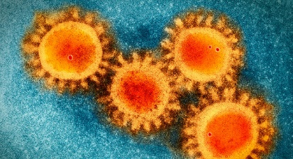
Unknown virus

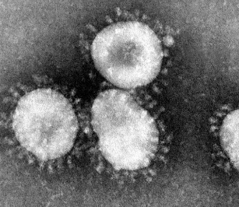
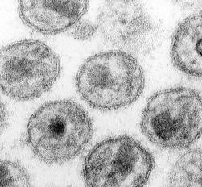
Influenza A
SARS-CoV
HIV
Herpes

Think like a scientist:
- Using the electron micrograph data to compare the appearances of the viruses, which type of virus is the unknown virus most likely related to?
  - Influenza A
  - SARS-CoV
  - HIV
  - Herpes
- Do the results of this part of the activity confirm your conclusions from Part 1?
  - Yes
  - No

Final confirmation
- What does the acronym BLAST stand for?
**Please be sure to read this page in its entirety, it is very interesting!
Think Like a Scientist:
- According to the BLAST search, which virus do you have?
  - SARS-CoV
  - SARS-CoV-2
  - HIV
  - Influenza
- What is the Percent (%) Identity? (Per. Ident)
  - 70%-79%
  - 80% - 89%
  - 90% - 99%
  - 100%
- At the beginning of the module, we mentioned that viral genetic material can either be RNA or DNA. Looking at the sequence above, is SARS-CoV-2 a RNA virus or a DNA virus?
  - RNA
  - DNA
- What have you learned about SARS-CoV-2 so far?
  - SARS-CoV-2 is an RNA virus.
  - SARS-CoV-2 is a DNA virus.
  - SARS-CoV-2 has proteins on its surface.
  - SARS-CoV-2 is a new virus that hasn’t been seen before.
  - A, C, and D are correct.
  - B, C, and D are correct.
Part 2: How do scientists characterize novel viruses?
Think like a scientist
- What are the viral particles shown in the electron micrographs made of?
  - Surface spike (S) proteins
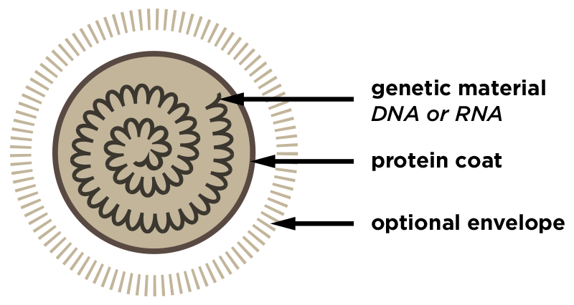
  - Cell membrane
  - Viral envelope
  - RNA
  - DNA
  - A and B are correct
  - A and C are correct
  - A, C, E are correct
Inactivating SARS-CoV-2 with Soap
- Why does washing your hands with soap for a sufficient amount of time help decrease your chances of getting infected with the virus?
  - The soap molecules interact with the nucleic acids (RNA) of the virus.
  - The soap molecules are completely hydrophilic, so they are attracted to the virus.
  - The hydrophobic portions of the soap molecules associate with the hydrophobic portions of the virus particle causing it to fall apart.
  - Soap is not an effective way to eliminate the virus because virus particles are non-polar and hydrophobic, while soap is polar and hydrophilic.
- The Mayo Clinic infographic above has great information, but how could it be improved?
  - Show the hydrophobic tails of the virus lipid bilayer interacting with the hydrophobic tails of the soap molecules in the micelles instead of the soap just interacting with the heads of the lipid bilayer molecule.
  - Show the hydrophilic portions of the soap molecules interacting with the hydrophobic portions of the virus lipid bilayer in the micelles instead of the soap just interacting with the heads of the lipid bilayer molecule.
  - Take away the surface proteins because the soap molecules cannot interact with the hydrophobic proteins of the SARS-CoV-2 virus.
  - The MayoClinic infographic has nothing that could be changed about it.
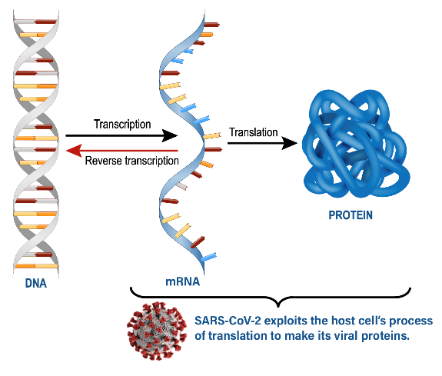
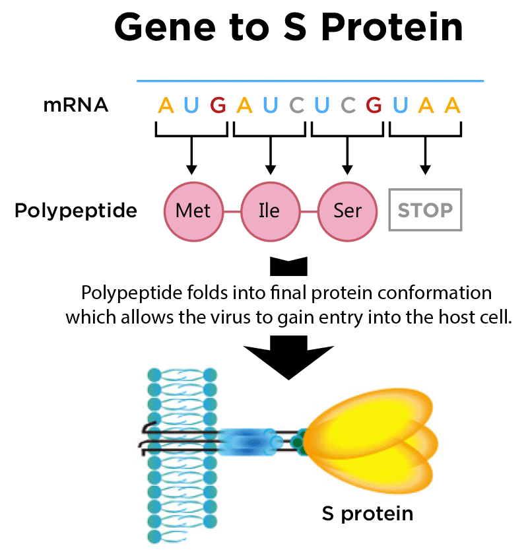
How is the S protein created for the virus?

** At this time, you may continue through the tutorial but you are no longer being assessed.

