***Structure of DNA and Replication***

Directions: Label the diagram below with the following choices:

|  |  |  |
| --- | --- | --- |
| * Nucleotide | * Deoxyribose | * Phosphate group |
| * Base pair | * Hydrogen bond | * Nitrogenous base |

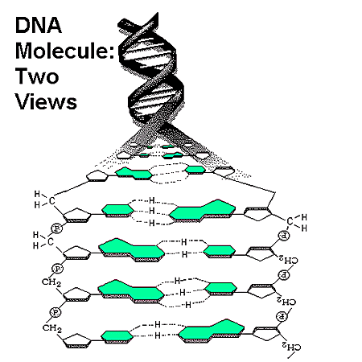

**2. ____________________**

**4. ____________________**

**6. ____________________**

**5. __________________**

**3. ____________________**

**1. ____________________**

Directions: Complete each sentence.

1. Guanine, cytosine, thymine, and __________________ are the four __________________ in DNA.
2. In DNA, guanine always forms hydrogen bonds with __________________.
3. The process of __________________ produces a new copy of an organism’s genetic information, which is passed on to a new cell.
4. The double coiled, “staircase” shape of DNA is called a __________________.

Directions: Answer each question in complete sentences.

1. What do the letters DNA stand for?

_________________________________________________________________________

1. Where is DNA found? ____________________________________________________
2. Label the **nucleotides** (A, T, G, C) in the DNA molecule below:



1. What is the first step in the process of DNA replication?
2. What is the first step in the process of DNA replication?

_________________________________________________________________________

_________________________________________________________________________

1. Which enzyme is responsible for “unzipping” the DNA double helix?

_________________________________________________________________________

1. Which enzyme is responsible for facilitating the hydrogen bonding between nucleotides in a new DNA molecule?

_________________________________________________________________________

_________________________________________________________________________

1. Which enzyme is responsible for creating the covalent bonds that connect the sugar-phosphate backbone of the new DNA molecules?

_________________________________________________________________________

1. If the sequence of one single strand of DNA is C-A-A-G-T-A-G-G-C-T, what is the sequence of the complementary strand?

_________________________________________________________________________

1. Describe the origin of each strand of the new double helices created after DNA replication.

_________________________________________________________________________

_________________________________________________________________________

1. Why is DNA replication important to the growth and development of a multi-cellular organism?

_________________________________________________________________________

_________________________________________________________________________

1. Place the following terms in the correct order from smallest to largest: **Nucleosome, supercoils, coils, chromosome, DNA double helix**

_________________________________________________________________________

_________________________________________________________________________

1. List the 3 basic steps of DNA replication:
   1. _________________________________________________________________
   2. _________________________________________________________________
   3. _________________________________________________________________
2. The model of DNA below is ready to be copied. Compared to the **original** double helix, evaluate the copies made during three attempts of DNA replication. List any errors with the replication if they occurred: ORIGINAL

|  |  |
| --- | --- |
| A | T |
| T | A |
| C | G |
| C | G |
| G | C |
| T | A |
| G | C |

Replication #1

List problems if any:

_______________________

_______________________

_______________________

_______________________

_______________________

_______________________

|  |  |  |  |  |
| --- | --- | --- | --- | --- |
| A | T |  | A | T |
| T | A |  | T | A |
| C | G |  | C | G |
| C | G | AND | A | G |
| G | C |  | G | C |
| T | A |  | T | A |
| G | C |  | G | C |

List problems if any:

_______________________

_______________________

_______________________

_______________________

_______________________

_______________________

Replication #2

|  |  |  |  |  |
| --- | --- | --- | --- | --- |
| A | T |  | A | T |
| T | A |  | T | A |
| C | G |  | C | G |
| C | G | AND | C | G |
| G | C |  | G | C |
| T | A |  | T | A |
| G | C |  | G | C |

1. Complete the diagram below. The blue columns represent the original DNA. The blank columns represent the daughter strands.

Original DNA

|  |  |
| --- | --- |
| A |  |
| G |  |
| C |  |
| T |  |
| A |  |
| T |  |
| A |  |

|  |  |
| --- | --- |
|  |  |
|  |  |
|  |  |
|  |  |
|  |  |
|  |  |
|  |  |

|  |  |
| --- | --- |
|  |  |
|  |  |
|  |  |
|  |  |
|  |  |
|  |  |
|  |  |

1. DNA Incorrectly copied, compare the original DNA to the copies. Circle the areas in the diagram on the right that show a genetic mutation.

|  |  |
| --- | --- |
| A |  |
| G |  |
| C |  |
| T |  |
| A |  |
| T |  |
| A |  |

|  |  |
| --- | --- |
| A | T |
| G | C |
| C | G |
| T | A |
| A | T |
| T | G |
| A | T |

|  |  |
| --- | --- |
| G | T |
| G | C |
| C | G |
| T | A |
| A | T |
| C | A |
| A | T |

1. Explain how the mutations might have been caused in the diagram above.

_________________________________________________________________________

_________________________________________________________________________

_________________________________________________________________________

1. In what way is DNA like a book?  
   ________________________________________________________________________________________
2. What was Rosalind Franklin’s contribution to DNA? ________________________________________________________________________________________
3. Who discovered the shape of DNA? ________________________________________________________________________________________
4. What is the role of DNA in heredity? ________________________________________________________________________________________________________________________________________________________________________________________________________________________________________________________________________