Name: Date:

Background Information

Owl Pellet Dissection

They are produced and regurgitated by owls, hawks, and eagles. Enzymes and strong acids in the stomach of the bird dissolve the soft parts of the prey. Bones, feathers and fur are not digested and they are formed into a slimy pellet that the owl will regurgitate.

Objectives
Through a study of owl pellets, student will be able to do the following:
- Dissect one complete pellet of a barn owl.
- Identify the animal(s) whose bones are found in the pellets.
- Identify individual bones of animal(s) and show where they belong in the skeleton.
- Explore a real-life example of food webs and chains.

Materials
- Bone Sorting Chart
- Owl pellet
- Ruler
- Paper Towel
- Dissection tools

Procedure
- Place a pellet on a paper towel.
- Make observations about the owl pellet – record the length and width
- Using dissection needle and forceps, separate the bones of the animals from the fur and/or feathers.
- Clean the bones of debris and sort them according to type. Skulls are the best bones for identifying.
- Using the Bone Sorting Chart, record the kinds and numbers of prey you find in your pellet on your data sheet.
- Answer the questions on the data sheet about the ecology of owls.

Data Sheet

- Measure and give the length and width of the owl pellet:
Length:
Width:

Describe, and record the characteristics of the barn owl pellet, please use complete sentences.

Include a small labelled sketch below.

Sketch:

Describe, using complete sentences, what the owl pellet feels like.

- What do you predict you will find in your owl pellet?

Use the Bone Sorting Chart to identify the animals and body parts found in your owl pellet.
Animal Name of Bone

BONE SORTING CHART
DIRECTIONS: As you dissect your owl pellet, use the bone chart to help you sort the bones based on the type (skull, lower jaw, scapula, pelvis, rib, vertebrae, etc.). In the column on the right, indicate how many bones you found of each type.
 | Rodent | Bird | Shrew | Mole | Total Number of Bones:
Skull | 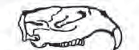 | 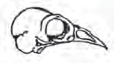 | 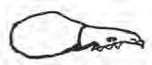 | 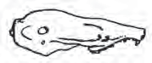
Jaw | 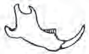 | 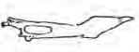 | 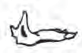 | 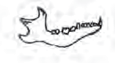
Front Leg or Wing (humerus, radius, ulna) | 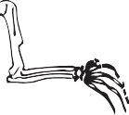 | 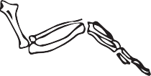 | 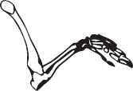 | 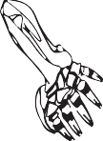
Hind Leg (femur, tibia, fibula)
Pelvis | 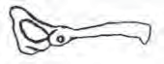 | 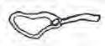 |  | 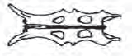
Rib | 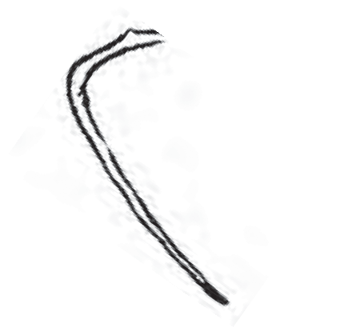 | 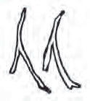 | 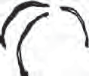 | 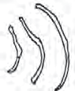
Scapula | 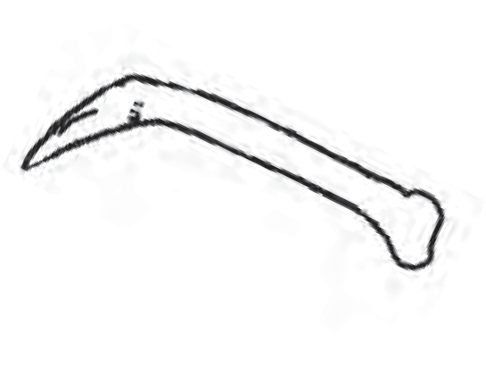  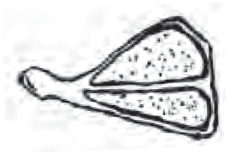 |  | 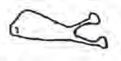 | 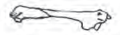
Vertebrae | 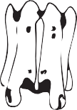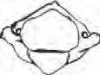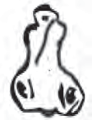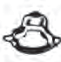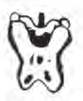
How many different animal bones did you find? _____________

OWL FOOD WEB 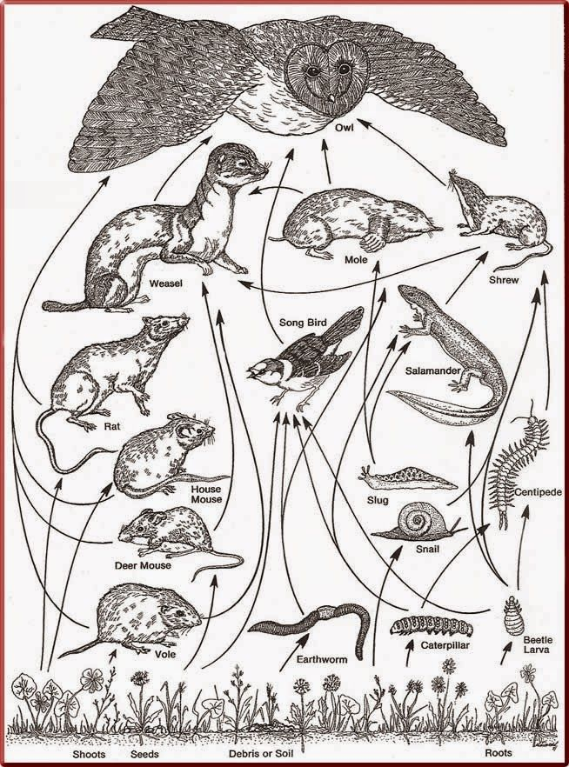

- What do the contents of this pellet tell you about this owl’s diet? (Please use complete sentences)

What type of habitat do you think this owl would be hunting in?

According to the food web provided, name five animals that an owl eats?

