Biology Cornell Notes | Speciation Notes DATE
Study Questions  1. How do new species form?  ___________________________________________________________________________________________________________________________________________________________________________  2. Distinguish between convergent and divergent evolution. ________________________________________________________________________________________________________________________________________________________  3. Identify the types of isolation that can lead to the formation of new species.  _________________________________________________________________________________________________________________________________________________________________________________________________________________  SUMMARY: | A. Types of Natural Selection  1._________________________________  2. ________________________________  3. _________________________________  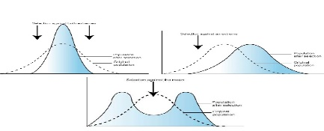  Key Concept: New species can arise when populations are isolated.  A. The Isolation of Population - Can lead to ________________________  - Populations become isolated when there is no gene flow.  - Isolated populations adapt to their own environments  - Genetic differences can add up over generations  - ________________________ is the rise of two or more species from one existing species  B. ___________________________ - can occur between isolated populations  - Members of different populations cannot mate successfully  - Final step to becoming separate species  C. Populations can become isolated  - Behavioral barriers can cause isolation called _________________________________________________________  - Includes differences in _______________________ or mating  - Example _________________________________  - Geographic barriers cause isolation – called _________________________________________________  - Physical barriers ___________________ populations  - Example _____________________________  - Temporal Barriers can cause isolation - called ____________________________________________________  - ___________________ of _________________ prevents mating  Key Concept: Evolution occurs in patterns  - Evolution through natural selection is - _____ ___________________  - Natural selection can have direction  - The effects of natural selection add up over time  - __________________________ evolution - describes evolution toward similar traits in ___________________________ species  - Example – ______________________________________________ ________________________________________________________  - __________________________ evolution – describes evolution toward different species in closely related species  - Example- ______________________________________________ ________________________________________________________  - Species can shape each other over time  - Two or more species can evolve together through ____________________________________________  - Evolutionary paths become connected  - Species evolve in response to changes in each other  - Coevolution can occur in beneficial relationships  - Example ___________________________________________  - Coevolution can occur in competitive relationships – evolutionary arms race  - Example___________________________________________  - Species can become extinct  - __________________________ = the elimination of a species from Earth  - __________________________________________ occurs continuously at a very low rate  - Occur at roughly the same rate as speciation  - Usually affects a few species in a small area  - Caused by local changes in environment  - ____________________________________ : are rare by much more intense  - Destroys many species at global level  - Thought to be cause by catastrophic events  - At least 5 mass extinctions in the last 600 million years  - Speciation often occurs in patterns  - A pattern of _____________________________________________ exists in the fossil record  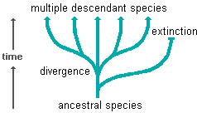  - Burst of speciation occur suddenly in geologic time followed by long periods of little evolutionary change  - Many species evolve from one species during _______________________________________________________  - Ancestral species diversifies into many descendants

