Name: Date: Block:

BIOLOGY 621 Identification of the Snorks
INTRODUCTION:
In this simulation activity, you will examine the DNA sequence of a fictitious organism - the Snork. Snorks were discovered on the planet Dee Enae in a distant solar system. Snorks only have one chromosome with eight genes on it. Your job is to analyze the genes of its DNA and determine what traits the organism has and then sketch the organism.

For simplicity, the gene sequences are much smaller than real gene sequences found in living organisms. Each gene has two versions that result in a different trait being expressed in the snork. The genes are listed in the chart below.

Genes | Protein (Amino Acid Sequence) | Phenotype
#1: Body Covering | val - ser - leu | Hairless
 | val - ser - lys | Hairy
#2: Body Style | tyr - pro - gln - gln - lys | Plump
 | val - pro - thr - pro - lys | Skinny
#3: Legs | leu - leu - leu - pro | 3 legged
 | leu - leu - ser - ala | 2 legged
#4: Head Shape | ala - val - val | Round head
 | val - ala - ala | Square head
#5: Tails | his - ile | Tail
 | his - his | No tail
#6: Body Pigment | ser - pro - val | Blue pigment (hair/skin)
 | val - phe - tyr | Red pigment (hair/skin)
#7: Eyes | asn - ile - leu - leu - pro - thr | Small slanted eyes
 | asn - iso - pro - pro - pro - thr | Large round eyes
#8: Mouth | val - asn - asn - ala | Circular mouth
 | asn - asn - asn - ala | Rectangular mouth
#9: Ears | phe - ser - his | Pointed standing-up ears
 | phe - phe - his | Rounded floppy ears
#10: Arms | arg - tyr - cys - lys | Long spaghetti-like arms
 | arg - arg - asn - thr | Short stumpy arms

PROCEDURE:
- Each of the following DNA samples was taken from volunteer snorks. Your job is to first transcribe the complementary mRNA of all DNA sample(s). (DNA to mRNA)
- Using the amino acid chart translate the genes in the mRNA into proteins.
- Remember that AUG is the "start" codon, and it signifies the beginning of a gene. The end of a gene will be signaled with one of the three "stop" codons. There may be some "junk" in between genes - Watch out!
- After you have finished translating your mRNA strand into proteins, determine the organism's phenotype (how the organism looks).
- Sketch a picture of one of the snorks (hard copy or virtual is acceptable)

Use either of the following amino acid charts to translate your mRNA into a protein.
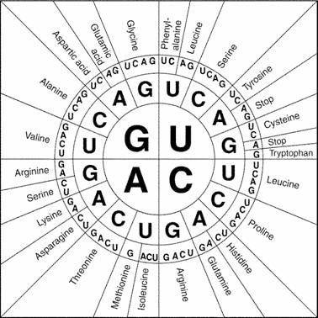

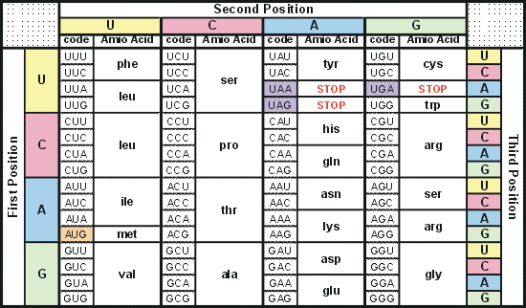

SNICKER SNORK
TAC CAG TCG TTT ATT CGC TAC ATG GGG GTT GTC TTT

ATC AAT TAC GAG AAT TCA CGC ATT GGA CGA TAC CGA

CAA CAC ATT TAC GTA GTA ATC CCT TAC CAA AAA ATG

ACT GCG TAC TTA TAG AAT GAC GGG TGG ACT TAC TTA

TTG TTA CGG ATT TAT TAC AAA AGA GTG ATT TAC TCC

ATG ACG TTC ATT

SNUFFLE SNORK
TAC CAT AGA TTT ATT CGC TAC CAA GGA TGA GGT TTC

ATC AAT TAC GAA GAG GAG GGG ATT GGA CGA TAC CAA

CGC CGA ATT TAC GTA GTG ATC CCT TAC CAT AAA ATA

ACT GCG TAC TTA TAA GAA GAC GGG TGT ACT TAC TTA

TTA TTA CGT ATT TAT TAC AAG AGC GTG ATT TAC TCC

TCT TTA TGT ATT

SNAPPLE SNORK
TAC CAG TCG TTT ATT CGC TAC ATG GGG GTT GTC TTT

ATC AAT TAC GAG AAT TCA CGC ATT GGA CGA TAC CAA

CGC CGA ATT TAC GTG TAA ATC CCT TAC AGA GGG CAT

ACT GCG TAC TTA TAA GAG GAG GGG TGG ACT TAC CAA

TTA TTA CGT ATT TAT TAC AAG AAA GTA ATT TAC GCA

GCC TTG TGG ATT

SNOOPY SNORK
TAC CAT AGG GAG ATT CGC TAC ATG GGG GTT GTC TTT

ATC AAT TAC AAT GAG GAC GGG ATT GGA CGA TAC CAC

CGT CGA ATT TAC GTA TAA ATC CCT TAC AGA GGG CAT

ACT GCG TAC TTG TAA GAA GAC GGG TGT ACT TAC TTA

TTG TTA CGG ATT TAT TAC AAA AGA GTG ATT TAC TCT

ATA ACA TTT ATT

Name of Snork:

Picture of Snork:

