Atoms and Elements Webquest
Read and explore the following sites to understand more about what makes up our world.
SITE 1 : http://education.jlab.org/atomtour/index.html

- What are atoms?

- How many atoms have scientists been able to create in a lab?

- Fill in the following table with information on the three types of particles. (be sure to click on the fun facts button)
Name of  Particle | Charge | Location | Fun Facts
 |  |  | Adding a proton makes a ______________ kind of atom!
 |  |  | Adding a neutron makes an ______________________ of that atom, a heavier version of that atom.
 |  |  | Atoms usually have about as many _________________ as protons

SITE 2 : http://elements.wlonk.com/ElementsTable.htm

Use the above link to discover more about each element. Be sure to click each element and look at the symbols to discover more information
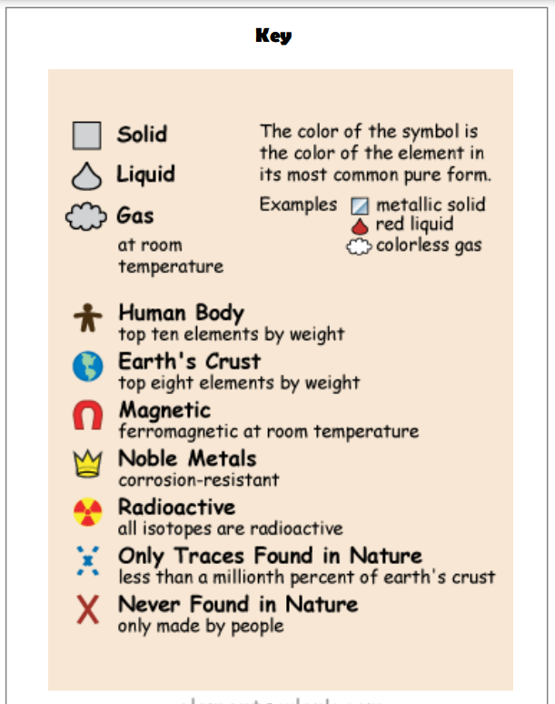
1. Find the 8 elements that make up most of the Earth’s crust (use the key to figure out how!)

2. There are several elements that are never found in nature and only made by people. (Use the key!). Name 4

- Name 4 elements that are solids at room temperature.

- Name 4 elements that are gases at room temperature.

- Find 2 element that is a liquid at room temperature.

SITE 2: https://www.thoughtco.com/elements-in-the-human-body-p2-602188

Pick a color (use the draw feature) for each element and color the body according to how much of that element is found in the body (like a pie chart!)
Nitrogen

__________ % of body

Color on body

2 Facts:

Oxygen

__________ % of body

Color on body

2 Facts:

Calcium

__________ % of body

Color on body

2 Facts:

Phosphorus

__________ % of body

Color on body

2 Facts:

Carbon

__________ % of body

Color on body

- Facts:

Hydrogen

__________ % of body

Color on body

- Facts:

