Bonding Basics

Complete the chart using a periodic table to help you.
Element | Atomic Symbol | Total # of Electrons | # of Valence Electrons
Chlorine
Potassium
Magnesium
Fluorine
Aluminum
Sodium
Nitrogen
Oxygen
Hydrogen
Carbon
Iodine

Ionic Bonds
- Atoms will transfer on or more _____________________ to another to form a bond
- Each atom is left with a _______________________ outer shell
- An ionic bond forms between a _____________________ and a _____________________

Use the following image as an example to complete all other ionic bonds on your own. You may either use the draw feature or insert shapes.
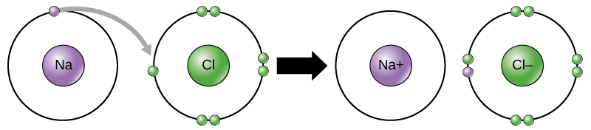
- Potassium + Iodine

- Magnesium + Oxygen

- Lithium + Florine

Covalent Bonds
- Atoms __________________ one or more electrons with each other to form the bond
- Each atom is left with a ________________________ outer shell
- A covalent bond forms between two ______________________________

Use the following image as an example to complete all other covalent bonds on your own. You may either use the draw feature or insert shapes.
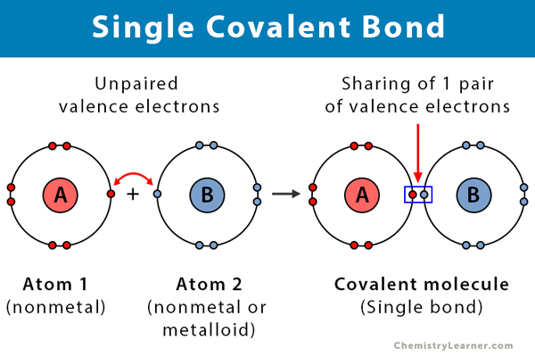
- Chlorine + Chlorine

- Oxygen + Oxygen

- Hydrogen + Oxygen + Hydrogen

