Cells and the Cell Theory – Scavenger Hunt

Instructions:
- Pages 2-7 contain the QR codes for the six different Locations. They should be placed around the room. Students can access them by using any QR code reader. This reader needs to be installed prior to starting the activity. A shortened website URL has also been provided if needed on the Location cards.
- Pages 8-9 contain the student submission form that can be printed and filled in as an alternative to the online submission.
- Pages 10-11 is the Teacher Reference and Answer Key and contains the same information found on the website accessed by the QR codes as well as the answers.
- If you choose to have your students enter their answers through Location #6, they must enter your email address in the last field. Once they submit, their answers will automatically be emailed to you.

Note: It doesn’t matter the order the students access the Locations except for #6. Location #6 should be placed somewhere so that it is only be accessed once all the others have been completed. Location #6 links to the online form where your students will enter their answers and send them to you. Alternatively, you could let them access Location #6 at the start and let them fill in the form as they move through the activity. If you’d rather they simply submit their paper copy, then simply omit Location #6 as it is optional.

Location #1
https://goo.gl/1ddgFt
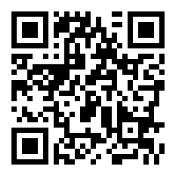

Location #2
https://goo.gl/jj8E0g
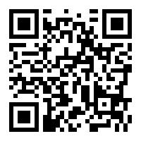

Location #3
https://goo.gl/pmCPgW
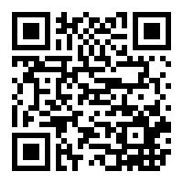

Location #4
https://goo.gl/887zqT
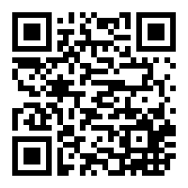

Location #5
https://goo.gl/H9A0hb
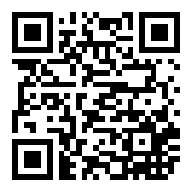

Location #6
https://goo.gl/dkObZR
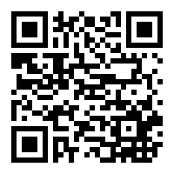

Student Submission Form
Group Members Names: _________________________________________
Location #1

1. Question

1. Answer

2. Question

2. Answer

3. Question

3. Answer

Location #2

Submit your “Seek Out” image. If you’re not submitting online, make sure you show your teacher at this point.

Location #3

Location #4
1.

2.

3.

4.

Location #5
1.

2.

3.

