Sort each of the following characteristics as either DNA, RNA, or Both.

Deoxyribonucleic Acid
double stranded
Makes up chromosomes
A, G, C
Ribonucleic Acid
Uracil (U)
Read by ribosome
Deoxyribose Sugar
Ribose Sugar
Stays in the nucleus
leaves the nucleus
Thymine (T)
single stranded
Made of nucleotides

DNA | Both | RNA

DNA to mRNA
You are mRNA. Your task is to enter the nucleus and copy the code into RNA so that it can be understood by the ribosome. For each example write the letter of the mRNA nitrogen base that would compliment the DNA base.
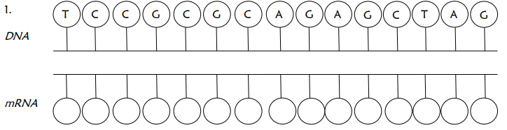

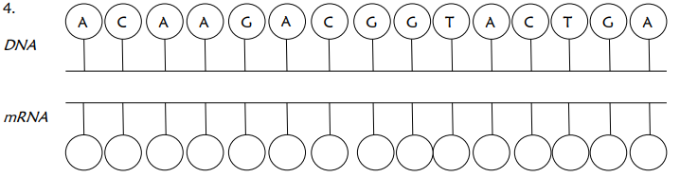

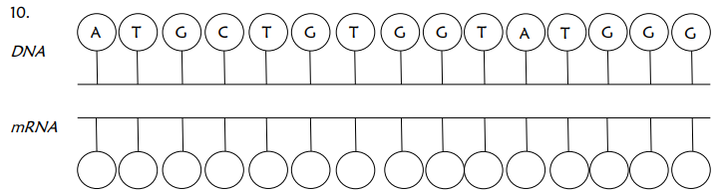

Completes each statement.
1. DNA is found in the of eukaryotes and the of prokaryotes.
2. DNA has the base while RNA uses .
3. DNA is stranded in a helix while RNA is stranded.
4. mRNA enters the nucleus to create an copy of DNA.
5. is used to carry the genetic code from DNA to the ribosomes
6. rRNA makes up the .
7. is read by the ribosome.
8. brings amino acids to matching sections of mRNA called .
9. make up a protein.
10. Chains of proteins make up a .

