MACROMOLECULE FOLDABLE
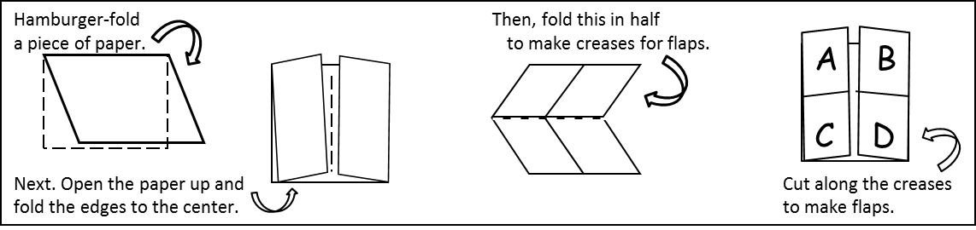
Fold and cut a piece of paper as shown below to make 4 tabs.

FRONT SIDE OF TABS:
TAB A
- Label the tab CARBOHYDRATE using a blue color.
- List the elements carbohydrates include
- Sketch and color a GLUCOSE molecule blue
TAB B
- Label the tab LIPID using a green color
- List what elements lipids include
- Sketch and label a TRIGLYCERIDE molecule green
TAB C
- Label the tab PROTEIN using a red color
- List what elements proteins include
- Sketch and color an AMINO ACID molecule red
TAB D
- Label the tab NUCLEIC ACID using a purple color
- List what elements nucleic acids include
- Sketch and color a NUCLEOTIDE purple

BACK SIDE OF TABS:
TAB A
- Give 1 FUNCTION OF CARBOHYDRATES
- List 4 EXAMPLES OF CARBOHYDRATES
TAB B
1. Give 2 FUNCTIONS OF LIPID
2. List 3 EXAMPLES OF LIPIDS
TAB C
- Give 3 FUNCTIONS OF PROTEIN
- List 2 EXAMPLES OF PROTEINS
TAB D
  - Give 2 FUNCTIONS OF NUCLEIC ACIDS
  - List 2 EXAMPLES OF NUCLEIC ACIDS

ON THE INSIDE CENTER SECTION
- write this heading at the top of the page: “COMPOUNDS IN A PERSON”.
- Draw a human, and show where/how the 4 macromolecules are used in the body.
ON THE BACK OF THE FOLDABLE
- Write your name and class period.
- Below that, define the following terms
A. POLYMER
B. MONOMER
- Draw and label a diagram that includes each term

