Periodic Table Coloring Activity
You have been given a black and white periodic table that needs some color according to the following directions. You will find the following page in your text book helpful: Appendix E. Back of book page A-24
You may use any colors you like unless specified. Like the diagrams in your book, make a color key so your periodic table may be accurately read. Some boxes may be shaded multiple colors – just make sure you can see them all! Have fun and make them pretty. You don’t want to stare at an ugly periodic table
1. State of Matter at Room Temperature (solid, liquid, or gas)
• There are two elements that are liquid at room temperature: Hg and Br. Using a blue color, outline the symbols.
• 11 elements exist as gases at room temperature. Outline their symbols using a red color
H, He, N, O, F, Ne Cl, Ar, Kr, Xe, Rn
• The remaining elements are solid at room temperature – leave those alone.
2. Metals vs. Nonmetals (Page A-24)
• With a dark color, add the “stair step” pattern that starts under Boron and extends down to Po and At. This is the division line between metals and nonmetals.
• Choose any color and outline the area where nonmetals are found (don’t forget about Hydrogen!)
• Choose a different color and outline the area in the periodic table where the metals are found.
3. Metalloids
• Choose any color of a color pencil or crayon and shade in the following elements: B, Si, Ge, As, Sb, Te, Po, and At (for At only color half the box). These elements are called metalloids and exhibit both metallic and nonmetallic properties.
4. Specific Families and Blocks (use pg A-24 to help)
• Using color pencils or crayons color each of the following a different color
- Alkali Metals
- Alkaline Earth Metals
- Transition Metals
- Other metals or Inner Transition Metals
- Halogens
- Noble Gases
- All the rest of the nonmetals (other nonmetals) not in a named family (don’t forget about Hydrogen!)
*Should have 12 different color types and items in your Key
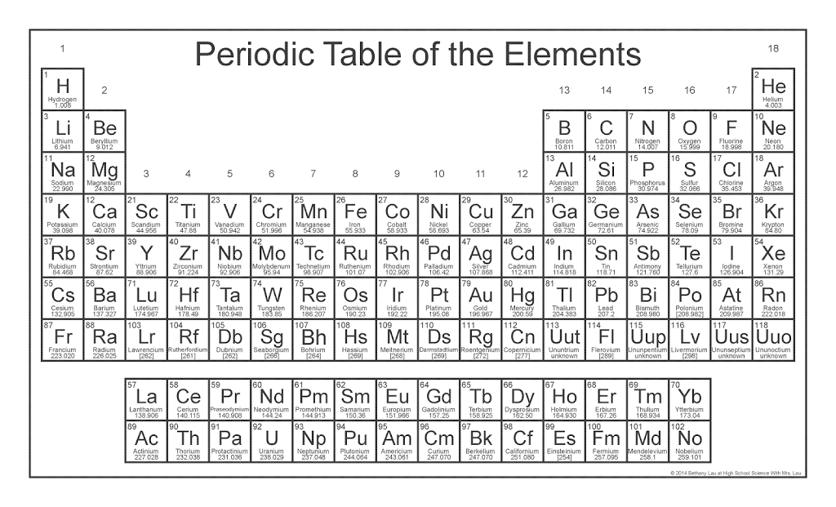
COLOR KEY:

- Liquid at room temperature
- Gas at room temperature
- Nonmetals (outline)
- Metals (outline)
- Metalloids
- Alkali Metals
- Alkaline Earth Metals
- Transition Metals
- Other metals or Inner Transition Metals
- Halogens
- Noble Gases
- All the rest of the nonmetals (other nonmetals) not in a named family (don’t forget about Hydrogen!)

