Periodic Table Practice
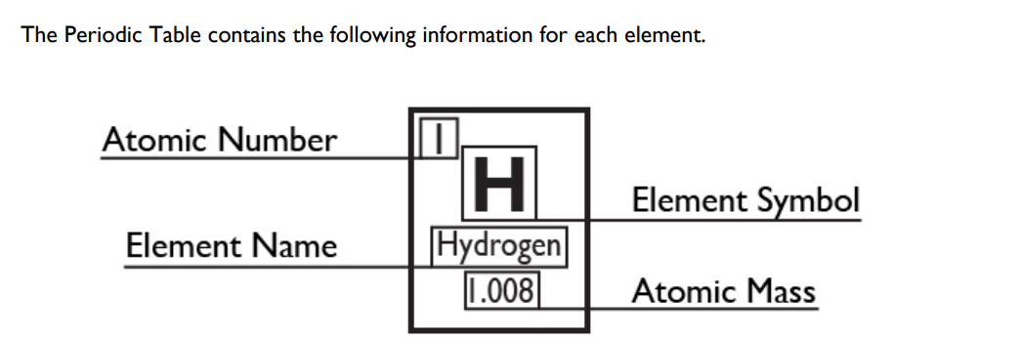
Directions: Please use the periodic table to fill in the missing information for each element.
Be | 76 | Radon | 65.38 | Silver
23 | Nd | 98.907 | Am | Mercury
Antimony | 54.938 | Mg | 186.207 | 46
20.180 | Platinum | 100 | Nb | 17
2 | Ta | 83.80 | Americium | 54

Protons, Neutrons, and Electrons Practice
How to calculate the number of each particle in an atom:
# Protons = Atomic Number
# Neutrons = Atomic Mass (rounded) – Atomic Number OR Big # - Small #
# Electrons = Protons
Use the periodic table to fill in the chart below.
Element Symbol | Atomic Number | Atomic Mass | Protons | Neutrons | Electrons
H | 1 |  | 1
 | 2 |  |  | 2 | 2
 | 3 | 7 | 3
 | 4 |  |  | 5 | 4
 | 5 |  | 5 |  | 5
C | 6 | 12
N | 7 |  |  | 7
O | 8 |  | 8 | 8
 | 9 | 19 |  |  | 9
 | 10 | 20 | 10
 | 11 |  |  | 12 | 11
 | 12 |  | 12
Al | 13 |  |  |  | 13
 | 14 |  | 14 | 14
P | 15 |  |  |  | 15
S | 16 |  | 16
 | 17 | 35 |  |  | 17
 | 18 |  | 18 | 22
 | 19 | 39 |  |  | 19
Ca | 20 |  | 20

