1. THE GENETIC CODE
Polypeptide:
Genetic Code:
What is the genetic code and how is it read?
Draw the mRNA and codons below
- How to Read Codons: (take notes on this section)
__________________________________________________________________________________________________________________________________________________________________________________________________________________________________________________________________________________________________________________________________________________________________
Summarize steps 1-4
____________________________________________________________________________________________________________________________________________________________________________________________________________________________________________________________________________________________________________________________________________________________________________________________________________________________________________________________________________________
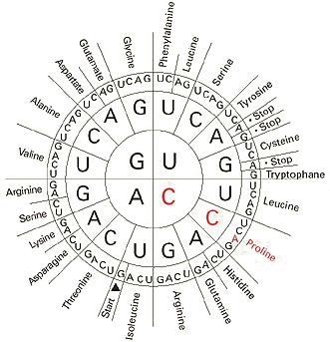
This Photo by Unknown Author is licensed under CC BY-SA
B. Start and Stop Codons (take notes on this section) ______________________________________________________________________________________________________________________________________________________________________________________________________________________________________________________________________________
QUICK LAB (complete on this piece of paper)

Analyze and Conclude:

TRANSLATION
What role does the ribosome play in assembling proteins?

Define: Translation –

- Steps in translation (take notes on this section)
_____________________________________________________________________________________________________________________________________________________________________________________________________________________________________________________________________________________________________________________________________________________________________________________________________________________
Define: Anti codon-

Summarize the three steps in translation below
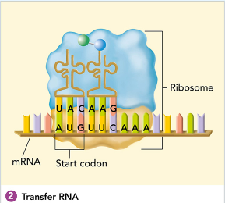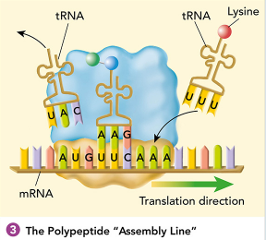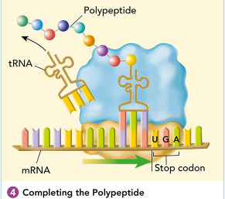

- The roles of tRNA and rRNA in translation (take notes on this section)
__________________________________________________________________________________________________________________________________________________________________
THE MOLECULAR BASIS OF HEREDITY (take notes on this section)
______________________________________________________________________________________________________________________________________________________________________________________________________________________________________________________________________________
What is the Central Dogma of molecule biology?

[-Define: Gene expression: -

