**What is the ideal cell size?**

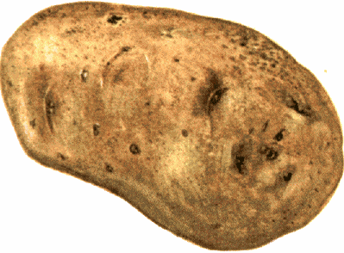

As you have observed, cells are small. Consider your little toe: it is made of about 2-3 billion cells! A newly-made cell will grow, but once it reaches a certain size it will divide to form two new cells rather than growing bigger. Why is this? Why aren’t you made of a few dozen, or a few hundred cells, instead of trillions? Why don’t single-celled organisms like amoebas and paramecia grow as big as a human? In this lab, we will investigate this question using model cells.

Gathering Data

|  |  |  |  |
| --- | --- | --- | --- |
| **Cube Data** | | | |
| **Cube Size (cm)** | **Surface area (cm2)**  **(length x width x number of sides)** | **Volume (cm3)**  **(length x width x height)** | **Surface Area: Volume Ratio (reduced)** |
| **.5** |  |  |  |
| **1** |  |  |  |
| **2** |  |  |  |

|  |  |  |  |
| --- | --- | --- | --- |
| **Diffusion of Iodine** | | | |
| **Cube Size (cm)** | **Depth of Diffusion (cm)** | **Time (min)** | **Rate of Diffusion (cm/min)** |
| **.5** |  |  |  |
| **1** |  |  |  |
| **2** |  |  |  |

1. What do the cubes represent?
2. What does the iodine represent?

* All team members help with the following calculations:

**Percent Volume of Cube (total cube volume) – (volume of cube that has not changed color)**

**X 100%**

=

**That Received Iodine** **(total cube volume)**

|  |  |  |  |
| --- | --- | --- | --- |
| **Total Volume**  **of Original Cube (cm3)** | **“Unchanged” Cube Side Length: Subtract depth of diffusion (both sides) from original cube dimensions (cm)** | **Volume of unchanged cube (that has *not* changed color) (cm3)** | **Percent of total volume of cube that *received* iodine (see formula above)** |
|  |  |  |  |
|  |  |  |  |
|  |  |  |  |

Discussion Questions: Please use complete sentences

1. What is a potato?
2. Why did the diffusion of iodine into the potato cube cause the color change from white to black?
3. If each cube represented a living cell, and the iodine solution was a substance needed within the cell, what problem might the largest cell have?
4. Examine your data in table 2. What pattern do you notice in the relationship between cube size and the rate of diffusion?
5. Examine your data in table 1. Describe what happens to the surface area and the volume as the cell grows larger.
6. Still considering table 1, what happens to the ***ratio*** between surface area and volume as the cell grows larger?
7. According to your data, which cell was most successful at receiving the needed nutrient (iodine solution) in the allowed time?
8. What can you say about the surface area to volume ratio that will best meet the needs of living cells?
9. Why is surface area significant in this situation?
10. Use what you learned in this lab to answer the research question.
11. Evaluate your initial prediction (as stated in the Pre-Lab).
12. Graph the Percent Volume of Cube Changed by cell size (0.5, 1 and 2 cm), then use your graph to predict the Percent Volume of Cube Changed for a hypothetical cube of .25 cm, and one of 4 cm.

TITLE_______________________________________________________

Percent Volume of Cell Changed



Cell Size