Directions: please use the Molymod biochemistry set to recreate each of the 4 monomer groups. Use the images as reference.
Carbohydrate  - Monomer = Glucose  - Contains – Carbon, Hydrogen and Oxygen | 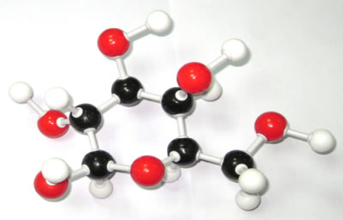
Lipid  - Monomer = Glycerol + fatty acid tail  - Contains – Carbon, Hydrogen and Oxygen | 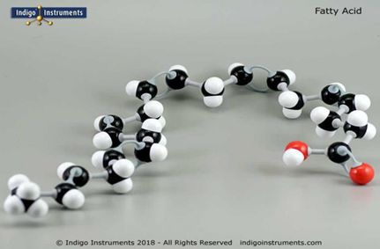
Protein  - Monomer= Amino Acid  - Contains – Carbon, Hydrogen, Oxygen, Nitrogen | 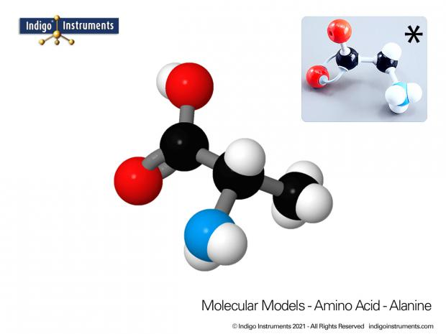
Nucleic Acid (DNA and RNA)  - Monomer = Nucleotide  - Contains - Carbon, Hydrogen, Oxygen, Nitrogen, Phosphorous | 