Open-Ended Inquiry
Unique Amino Acids – the Monomers of Proteins
Ask Questions
In what way does controlling the proteins in an organism control the organism’s characteristics?
Introduction
Molecular biology seeks to explain living organisms by studying them at the molecular level using molecules like DNA and RNA. DNA carries information for specifying the traits of an organisms. The cell uses the sequence of bases in DNA as a template for making mRNA. The codons of mRNA specify the sequence of amino acids in a protein. Proteins play a key role in producing an organism’s traits.
One of the most interesting discoveries of molecular biology is the near-universal nature of the genetic code. Despite their enormous diversity in form and function, living organisms display remarkable unity at life’s most basic level, the molecular biology of the gene. How are species are related to one another? Your goal is to determine the species with the most common amino acid sequences.
Procedure
Part A: Plan Your Investigation
You will be figuring out how four different species are related through amino acids. One of the species will be humans. You will choose the other three species from this list:

- Brown bear
- Chimpanzee
- gibbon
- gorilla
- spider monkey
- mouse
- shrew

1. | I will be investigating humans and these three species:  a. humans c. ______________  b. _____________ d. ______________
2. | Think about what you already know about each species that you chose. Then make a prediction by ranking the species in order from most recent common ancestor with humans (most closely related) to least recent common ancestor with humans (least closely related).  1. _____________  2. ______________  3. ____________
Part B: Comparing Amino Acid Sequences in Hemoglobin
Hemoglobin is the molecule in blood that carries oxygen. This complex molecule contains four protein chains.
Figure 1 shows the amino acid sequence for one of those chains in eight mammals. Each letter stands for a different amino acid. Each column is a location on the protein chain. note: Not shown are the locations where the amino acids are identical in all eight mammals.
Figure 1 Comparison of amino acid sequences in hemoglobin from eight mammals
 | 4 | 5 | 6 | 9 | 10 | 12 | 13 | 20 | 25 | 33 | 41 | 43 | 50 | 51 | 52
Human | T | P | E | S | A | T | A | V | G | V | F | E | T | P | D
Brown Bear | T | G | E | S | L | T | G | V | G | V | F | D | S | A | D
Chimpanzee | T | P | E | S | A | T | A | V | G | V | F | E | T | P | D
Gibbon | T | P | E | S | A | T | A | V | G | V | F | E | T | P | D
Gorilla | T | P | E | S | A | T | A | V | G | V | F | E | T | P | D
Spider Monkey | T | P | E | N | A | T | T | V | G | L | F | E | S | P | D
Mouse | T | D | A | A | A | S | C | S | G | V | Y | D | S | A | S
Shrew | S | G | E | A | C | T | G | E | A | V | F | D | S | A | S

 | 54 | 56 | 58 | 68 | 69 | 70 | 71 | 72 | 73 | 75 | 76 | 77 | 80 | 87 | 104
Human | V | G | P | L | G | A | F | S | D | L | A | H | N | T | R
Brown Bear | I | N | P | L | N | S | F | S | D | L | K | N | N | K | K
Chimpanzee | V | G | P | L | G | A | F | S | D | L | A | H | N | T | R
Gibbon | V | G | P | L | G | A | F | S | D | L | A | H | N | Q | R
Gorilla | V | G | P | L | G | A | F | S | D | L | A | H | N | T | K
Spider  Monkey | V | G | P | L | G | A | F | S | D | L | N | H | N | Q | K
Mouse | I | G | A | I | T | A | F | N | D | L | N | H | S | S | R
Shrew | V | G | P | L | H | S | L | G | E | V | A | N | N | K | R

 | 109 | 110 | 112 | 115 | 116 | 117 | 118 | 121 | 125 | 126 | 130 | 139
Human | V | L | C | A | H | H | F | E | P | V | Y | N
Brown Bear | V | L | C | A | H | H | F | E | Q | V | Y | N
Chimpanzee | V | L | C | A | H | H | F | E | P | V | Y | N
Gibbon | V | L | C | A | H | H | F | E | Q | V | Y | N
Gorilla | V | L | C | A | H | H | F | E | P | V | Y | N
Spider  Monkey | V | L | C | A | H | H | F | E | Q | V | Y | N
Mouse | M | I | I | G | H | H | L | D | A | A | F | T
Shrew | V | L | V | A | S | K | F | E | P | V | F | N

PROCEDURE
1. | Use the row labelled Human as the control. Compare the sequence for the first species that you selected to the sequence for humans. Highlight the differences you find.  For example, in spot 4, the human has “T” while the shrew has “S”. If you selected the shrew, highlight “S”.
2. | Repeat Step 3 for the other two mammals that you selected. Make sure to compare each sequence with the sequence for humans.
3. | Use the data table to record the number of differences you found for each species compared with humans.  Data Table  Mammal Number of Differences in Hemoglobin  - Human 0
Part C: Biogeography
4. | For each species that you picked (except humans), look online to learn where the species lives. For humans, find out where modern humans evolved and lived, to the best of our knowledge.
5. | On the world map, use colored pencils to show the places you identified. Add a key to show the meaning of each color.
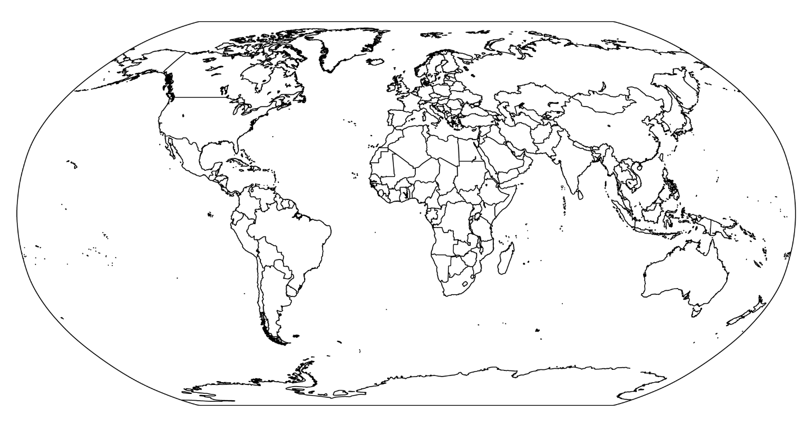
Color Key
PLEASE USE COMPLETE SENTENCES FOR ALL ANSWERS

Interpret Diagrams - Based on your map and research, which species may be close relatives? Which species may not be closely related? Explain.
Part D: Anatomical Comparison
1. | Compare Describe how the skeletal structures are similar to each other. Pick one area of the body to focus on. For example, compare the skulls or the hands/paws of all four species.
2. | Contrast Describe how the skeletal structures are different from each other
Part E: Embryonic Development Comparison
1. | Find pictures or diagrams of the embryos of each species.
2. | Compare - Describe how the embryos are similar to each other.
3. | Contrast - Describe how the embryos are different from each other.
Analyze and Interpret Data
1. | Draw Conclusions: Review the evidence you obtained. Then rank each of the three species in order from most recent common ancestor with humans to least recent common ancestor with humans.  1. ________________________  2. ________________________  3. ________________________
2. | Support Your Explanation with Evidence: How did you determine which species is most closely related to humans? Cite evidence from the lab to support your explanation.

