Name:

Ecology Lab - Predator Prey Interactions *home edition
In any ecosystem, there are interactions between predators and prey, and herbivores, carnivores, and omnivores. The population numbers of each group depend on those interactions. Too many predators might cause the loss of a prey species. Not enough prey could eliminate the predators because they won’t have enough to eat. This simulation will explore interactions of organisms that live in a forest ecosystem.

Process

1. Open the simulator: https://www.learner.org/wp-content/interactive/envsci/ecology/ecology.html
*You may want to split your screen so you can look at this document while running the simulation.

2. The simulation will start with two plants highlighted. What do you think will happen to these plants in this ecosystem? Can they both survive together? Why or Why not.

3. Run the simulation until it stops at Day 100. . Observe the population in the graph.
4. Describe what happened to Plant A and to Plant B:

5. The competitive exclusion principle states that two species in the same environment will compete for resources. In those cases, one species will be the winner and one will be the loser. Consider the two plants. What resources are they competing for, and why would one of them be the winner? Your answer requires you to make some assumptions about how these plants live.

What happens when a herbivore is added?
6. RESET the simulation. Choose the rabbit and then determine what happens when it eats plant A and then plant B and when it eats both types of plants. Enter the final totals in the data table by estimating from the graph. Run the simulation until it reaches 100 days. Reset between each test. Note: You can roll your mouse over the line on the graph to get the population number.

 | Plant A final population | Plant B final population | Rabbit final population
Rabbit (eats only plant A)
Rabbit (eats only plant B)
Rabbit (eats both Plant A & B)

7. In which scenario is the ecosystem the most stable? Suggest a reason for this and use the word COMPETITION in this explanation.

8. Most herbivores are GENERALISTS, and will eat almost any plant available to them as food. It is unrealistic to have a herbivore that only eats plant A. Though some animals are SPECIALISTS and only eat one type of food. - Reset the simulation and activate all 3 herbivores and set them to eat both plant A and plant B.

What happened to plants A and B when all three herbivores were present and ate both types of plants?
9. This scenario is different from when there was just a rabbit present. Some generalists also have a preference for certain food types. Suggest a reason for the outcome when all three herbivores were present.
10. Add a squirrel to the ecosystem that also eats both plant A and Plant B. Describe what happens to the squirrel in this setting.
11. Why do you think this outcome occurs in this setting? (Why did the squirrel do so poorly?)
12. Squirrels are omnivores. Rest the simulation and change the squirrels’ food source to include snails and a tree (plant C).
What happens to the squirrels now?
What happens to the herbivores?

13. Suggest a reason that added a food source that only the squirrels ate impacted the ecosystem so much:
14. CHALLENGE: How can you get the herbivores and plants and the squirrel to coexist in this ecosystem? You will need to adjust what each one eats until you can create a graph where they all survive.
 | Rabbit | Snail | Deer | Squirrel
What each eats:

15. Describe the populations of each of the organisms in this food web. *Answers may vary on this one?>
Which plant has the largest population size?
Which type of animal has the smallest population size (herbivores or omnivores)?

16. Another aspect of the competitive exclusion principle is that animals that compete within the same environment may eventually come to occupy their own NICHE. A niche is a way of life, and includes how the animal lives, what it eats, reproduction strategies and more. For example, a hawk and owl both eat the same kinds of food, but the owl hunts at night and the hawk during the day.
How did your final ecosystem (The Challenge from #14) illustrate this aspect of the competitive exclusion principle?

Part 2: Explore Predator and Prey Interactions

Predators and prey populations often cycle. For example, if there are more rabbits in an ecosystem, there can be more wolves. As the wolves increase in number, the number of rabbits will begin to decline. This is called a PREDATOR PREY CYCLE.

Process: Click the green button that says “presets” to clear your other data and start fresh.

In this simulation, we are going to simplify things. You will have a rabbit, plant A, and a wolf.

- Set the simulation to run with these plant A, a rabbit, and a wolf.
- This time, use the “STEP” button to run the simulation to year 30.

17. Complete the table below. ( - Scroll over the lines to determine the population size at each time period.)

 | Day 0 | Day 5 | Day 10 | Day 15 | Day 20 | Day 25 | Day 30
Plant A
Rabbit
Wolf

18. What happened to the plant population between day2 and day 10? Explain why this occurred.

19. What happened to the rabbit population between day 5 and day 10? Explain why this occurred.

20. What happened to the plant population between day 10 and day 20? Explain why this occurred.

21. At 30 days, compare the wolf population to the rabbit population:

20 Click the run button to take the simulation to day 200. What ultimately happens to all three populations?
23. Predict what would happen if we added another herbivore to the system. *You can run this sim if you want*
Would the number of wolves increase? Why or why not
Would the number of rabbits increase? Why or why not?

Assessment *These answers are not in the simulation, APPLY what you have learned.

24. Pandas are animals that are SPECIALISTS and only eat one type of food (bamboo) in the forest where they live. If another animal moves into the forest and also eats that type of food. What will likely happen to the panda?

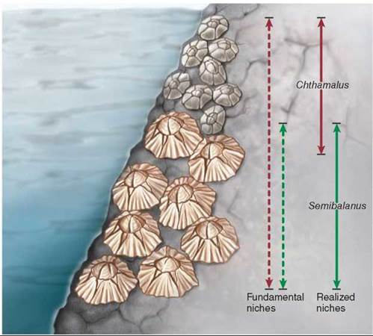
25. Two species of barnacles live in shallow areas of the ocean. One species tends to live at the top of rocks and the other lives in the lower areas. Explain how this illustrates the COMPETITIVE EXCLUSION PRINCIPLE?

24. A wolf is a KEYSTONE species. Explain how the wolf indirectly affects the population numbers of plants.

