Name Period Date

DNA: The Molecule of Heredity Worksheet

DNA Structure
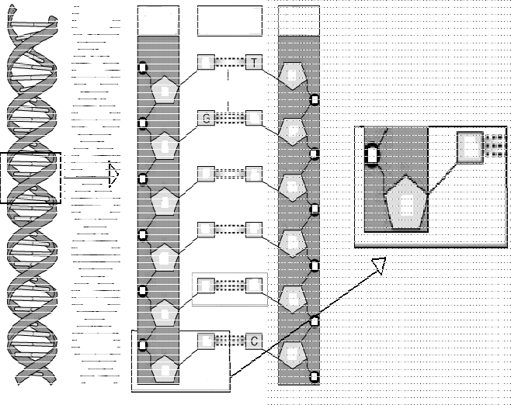
- Use the draw feature to label the following
  - Circle and label a nucleotide.
  - Label the sugar and phosphate molecules.
  - Label the bases that are not already labeled.
  - Label a base pair.
  - Label the sugar-­ phosphate backbones.
  - Label the hydrogen bonds.

- A nucleotide is made of three parts: a group, a five carbon
, and a base.

- In a single strand of DNA, the phosphate group binds to the of the next group.

- Chargaff's rule states that the DNA of any species contains equal amounts of
& and also equal amounts of
& .

- In DNA, thymine is complementary to (or pairs with) ;; cytosine is complementary to .

- In a strand of DNA, if the percentage of thymine is 30%, what would the percentage of cytosine in the same DNA strand be? .

- James Watson and Francis Crick with, the help of Rosalind Franklin and others, determined that the shape of the DNA molecule was a .

- Why do purines pair with pyrimidines?

- What type of bonds connect the deoxyribose sugars to the phosphate groups?

- What type of bonds connect the bases to each other?

DNA Replication
- Number the steps of DNA replication in the correct order (1, 2, 3):
Daughter strands are formed using complementary base pairing.
DNA unwinds
The DNA of the daughter strands winds with together with its parent strand.
- Why is DNA replication called “semi-­conservative”?
- What enzyme unwinds or unzips the parent strand?
- What enzyme connects the new bases to the old bases in the DNA template?

- What enzyme connects the new nucleotides together and proofreads them?

- Show the complimentary base pairing that would occur in the replication of the short DNA molecule below. Use two different colors to show which strands are the original and which are newly synthesized. (NEW STRANDS SHOULD BE A DIFFERENT COLOR THAN ORIGINAL STRANDS)

Original DNA  Strand 1 | Original DNA  Strand 2 | -- | Original DNA Strand 1 (copy from left) | New DNA Strand | + | New DNA Strand | Original DNA Strand 2 (copy from left)
A - | T |  |  |  | +
C - | G |  |  |  | +
T - | A |  |  |  | +
T - | A |  |  |  | +
A - | T |  |  |  | +
C - | G |  |  |  | +
G - | C |  |  |  | +
C - | G |  |  |  | +
C - | G |  |  |  | +
G - | C |  |  |  | +
A - | T |  |  |  | +
T - | A |  |  |  | +

