Steps of Transcription
TRANSCRIPTION
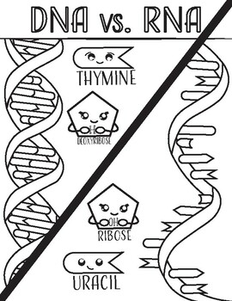
- DNA unwinds and unzips
- RNA polymerase binds
- mRNA bases (AUGC) match up with the correct DNA bases
- mRNA breaks off into codons
- mRNA EXONS exit the nucleus
- DNA winds back up and remains in the nucleus

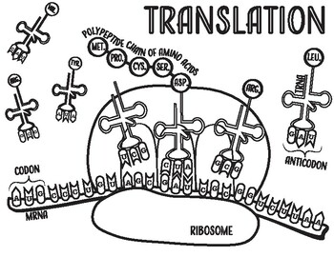
Steps of Translation
- mRNA Exons bind to the ribosome
- tRNA binds to the mRNA using its anti-codon (proofreader)
- tRNA drops the correct amino acid
- A peptide bond forms between the amino acids to create a polypeptide
- Once a stop codon is reached, the protein is released

