Terms: Please define the following terms.
Protein Synthesis & Amino Acid
Worksheet
DNA | DNA & RNA | RNA | Protein Synthesis
deoxyribonucleic acid | base | ribonucleic acid | amino acid
deoxyribose | nucleotide | ribose | codon
hydrogen bond | pentose sugar | introns | anticodon
thymine | phosphate | exons | transcription
 | backbone | messenger RNA | translation
 | rungs | transfer RNA | polypeptide
 | cytosine | mRNA | protein
 | guanine | tRNA
 | adenine | ribosome
Label the Diagrams: Color and label the parts listed below on the diagram
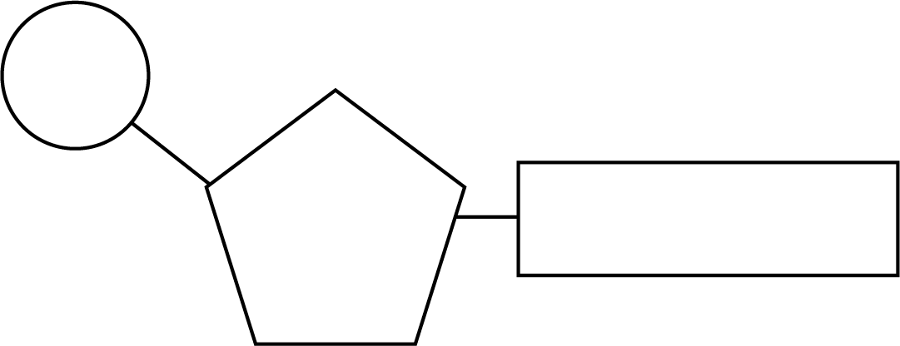
Nucleotide Structure
phosphate group
five-carbon sugar nitrogen(ous) base

DNA Structure – Color and draw arrows to label the parts listed below on the diagram
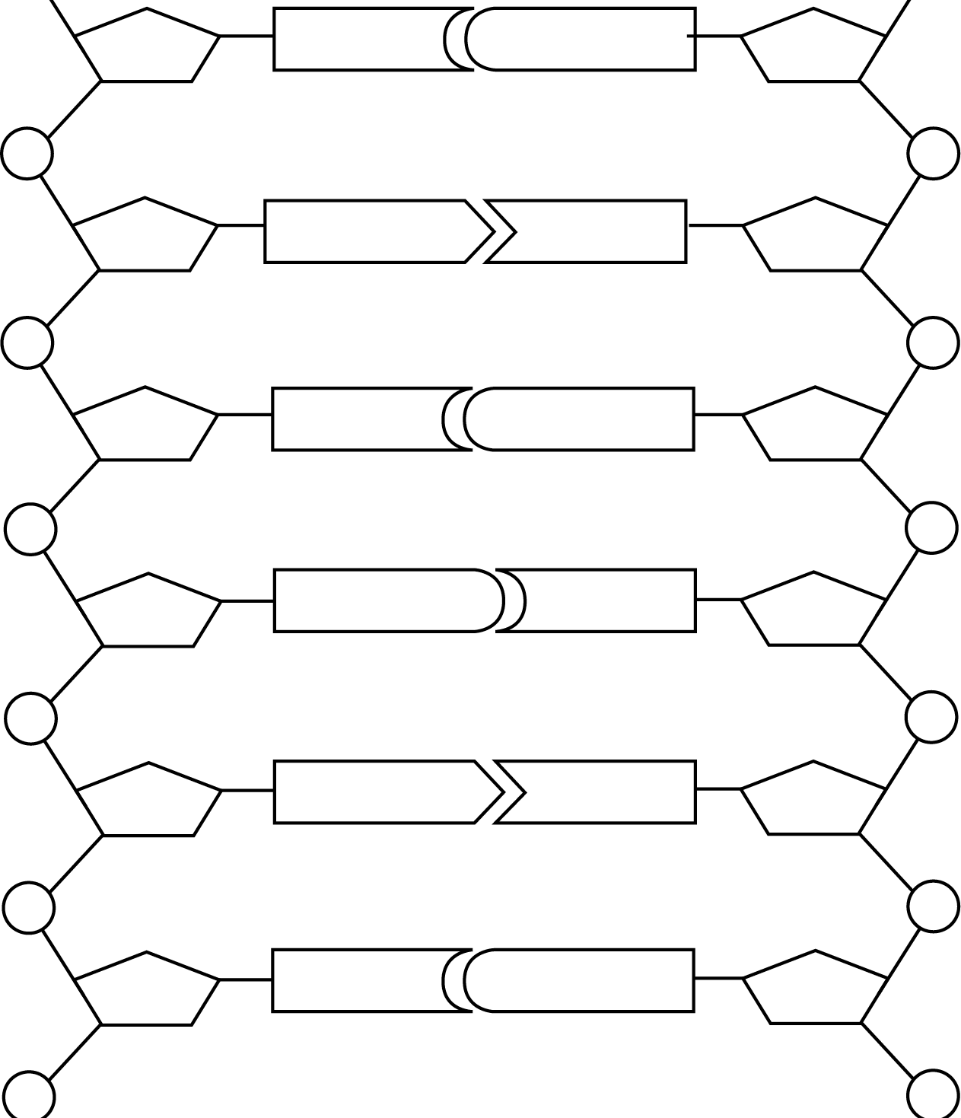
sugar-phosphate backbone

adenine

thymine

cytosine

guanine

hydrogen bond

- Fill in the complimentary DNA strand using DNA base paring rules.
- Fill in the correct mRNA bases by transcribing the bottom DNA code.
- Translate the mRNA codons and find the correct amino acid using the Codon Circular Table.
- Write in the amino acid and the correct ant-codon, the tRNA molecule.
- Then answer the questions about protein synthesis below the amino acids.
Original  DNA | Complementary  DNA | Codon  mRNA | Anti-Codon  tRNA | Amino Acid  Use the mRNA Codons!
A | T | A | U | Met., Methionine The start codon
T | A | U | A
G | C | G | C
G
T
A
G
C
T
A
A
C
C
T
T
Circle the most correct answer.

1. Which of the following is attached to the transfer RNA (tRNA)?
A. DNA B. ribosome C. amino acid D. nucleic acid
2. Which of the following is not part of protein synthesis?
A. replication B. translation C. transcription
3. The codon is located on the
A. mRNA. B. tRNA. C. rRNA. D. DNA.
4. In the RNA molecule, which nitrogen base is found in place of thymine?
A. guanine B. cytosine C. thymine D. uracil
5. During the process of transcription, which of the following is produced?
A. H2O B. ATP C. mRNA D. DNA
6. The actual site of protein synthesis is the
A. nucleus. B. mitochondrion. C. chloroplast. D. ribosome.
7. If the DNA template reads “ATA”, then which of the following would be the corresponding sequence on the mRNA?
A. UAU B. ATA C. TUT D. UCU

8. The genetic code is based upon the reading of how many bases at a time?
A. one B. two C. three D. four
9. Amino acids are held together by __?__ bonds.
A. hydrogen B. peptide C. ionic D. high energy

Here’s another way to look at the same process. Fill in all the circles and ovals. Remember, when finding the Amino Acids, you must use the mRNA codons!
Original Strand
C
A G G A
A
T
T
G C
T
C G A
T
DNA

mRNA

Use your Textbook (CHAPTER 13) to answer the following questions. MUST USE COMPLETE SENTENCES
Amino Acids
tRNA
- Describe 3 main differences between RNA and DNA
- Why is it important for a single gene to be able to produce hundreds or thousands of the same RNA molecule?
- What do you think would happen if introns were not removed from pre-mRNA?
- How is protein synthesis different from DNA Replication?
- Why is the genetic code considered universal?
- In what way does controlling the protein in an organism control the organism’s characteristics?

Transcribe and Translate a Gene- CLICK THE LINK https://learn.genetics.utah.edu/content/basics/transcribe/
- Choose one gene to transcribe. List the correct mRNA sequence of your gene.

- Please list the sequence of amino acids you chose to create your protein. (use your codon wheel)

- What protein did you code for? (LISTEN!)

- 4. What is the function of your protein?

If you have time remaining, transcribe and translate the other two genes.

