Biology Cornell Notes: ATP and Cellular Respiration Notes Date:
Study Questions/ Vocabulary:  1.How do we get energy from ATP?  _________________________________________________________________________________________________________________________________________________________  2. When is ATP made in the body? _________________________________________________________________________________________________________________________________________________________3. What is cellular respiration? Why isn’t it breathing? _________________________________________________________________________________________________________________________________________________________  4. Where does each step of Cellular Respiration take place?  ________________________________________________________________________________________________________________________________________________________  5. Which step produced the most ATP? ________________________________________________________________________________________________________________________________________________________ | - Organisms that use ________________________ from the sun to produce food are ______________________ (Auto = self) Ex._______________________  - Organisms that ______________ use the sun’s energy to make food are ______________________ Ex. ________________________  A. ATP=ENERGY!!!  - Cell Energy  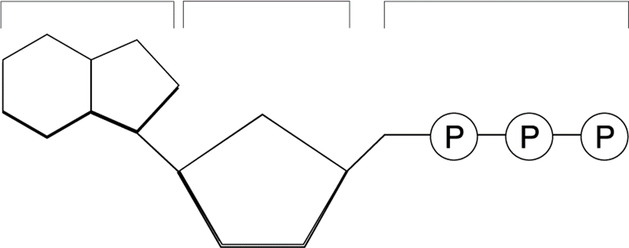  - Cells usable source of ______________ is called _________  - ATP stands for _______________________________________  - All energy is stored in the _____________ of compounds - ____________ the bond _____________ the energy  - When the cell has energy available it can store this energy by adding a ______________________ to ADP, producing ________________  B. Energy from ATP  - Energy from ATP is obtained by _______________ the high energy bond between the __________________________________________________  - ATP is made in the body during a process called _____________________ that takes place in both __________________& _____________________  C. Cellular Respiration  1. Respiration is _________ the same as what we call breathing! Reparation is a chemical reaction!  * Please write out what you think the equation for respiration looks like.  Overall Equation for Cellular Respiration  - Respiration (2 Kinds – Aerobic and Anaerobic)  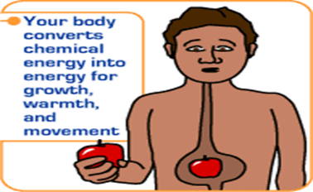  - Cellular Respiration is the process by which the energy of _____________ is ________________ in the cell to be used for life processes (__________________________________________ ___________________________________________ ___________________________________________)  - Anaerobic Respiration: Occurs when ___________________________ is available to the cell (2 kinds; Alcoholic and Lactic Acid Fermentation)  - ______________________________________________________  - ______________________________________ than in aerobic respiration  - Aerobic Respiration: __________________________________________  - Occurs in the ____________________________ of the cell  - Total of ________________ molecules produced  - General Formula for Cellular Respiration:  C₆H₁₂O₆ + 6O₂ 6 CO₂ + 6H₂O + 36 ATP  D. Where does Cellular Respiration Occur?  - Cellular Respiration takes place in two parts of the cell.  - _______________________ Occurs in the ___________________________  - __________________________ and ________________ Take place in the mitochondria  Cell Respiration Summary  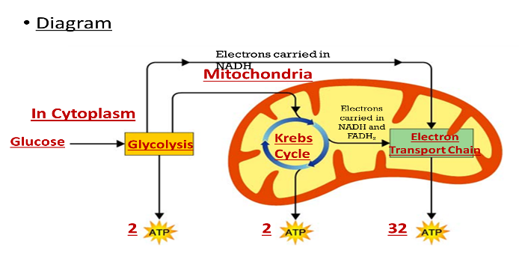  3 Steps:  1st ___________________(Anaerobic)  2nd ____________________ (Aerobic)  3rd __________________________  (ETC- Aerobic)  E. Glycolysis Summary  1. Takes place in the ____________________________________  2. _____________________________________ (doesn’t use Oxygen)  3. Requires input of 2 _________________  4. Produces _______________ (Electron Carriers) and ________________  5. Glucose is split into two molecules of _____________________  F. Krebs Cycle Summary  1. _________________________________________ (_________________)  2. Uses the ___________________ from _____________________  3. Circular reactions that give off ______________ (Carbon Dioxide) and produces ________________________ per glucose molecule  4. Takes place in the ______________________________________________  5. For ___________________________ molecules, the Krebs Cycle produces _______________, _______________, ________________. ____________  G. Electron Transport Chain Summary  1. ____________________ Produced  2. __________________ Produced  3. Occurs across ________________________________________________  4. Uses coenzymes NAD+ and FAD+ to accept e- from glucose  5. ___________________________________________  6. ___________________________________________
SUMMARY : ________________________________________________________________________________________________________________________________________________________________________________________________________________________________________________________________________________________________________________________________________________________________________________________________________________________________________________________________________________________________________________________________________________________________________________________________

