***Cell Analogy Infographic Project***

***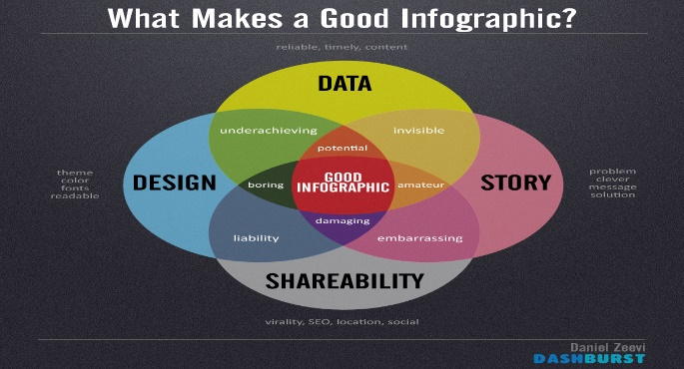*Introduction:** Often times it is difficult for a student to understand all of the intricate details of cells and their organelles. To combat this, we are going to relate the cell processes and organelles to something in our everyday lives. For example, the nucleus is the control center of the cell similarly to the principal’s office being the control center of the school.

***Procedure:***

1. **Research each cell organelle to determine its function.** Choose an appropriate analogy that has a similar function in life. Remember, be creative when making your analogies. Your analogies can be futuristic, historic, modern or fantasy as long as your analogies are similar to a cell. BE CREATIVE! THINK OUTSIDE THE BOX!!!!

|  |  |  |  |
| --- | --- | --- | --- |
| **Organelle** | **Function** | **Analogy** | **Reason** |
| Vacuole |  |  |  |
| Nucleus |  |  |  |
| Nucleolus |  |  |  |
| Smooth  Endoplasmic reticulum |  |  |  |
| Rough Endoplasmic Reticulum |  |  |  |
| Ribosome |  |  |  |
| Cell membrane |  |  |  |
| Golgi apparatus |  |  |  |
| Lysosomes |  |  |  |
| Mitochondria |  |  |  |
| Chloroplast |  |  |  |
| Cell Wall |  |  |  |

1. **Make a rough draft blueprint of your cell.** Be sure to include labels for all cell organelles and their corresponding structure. Structures should be labeled Cell Organelle / Analogy name. Example: Nucleus / Principal’s office.
2. **Create a virtual cell analogy.** Use an online resource such as Microsoft Sway, 3D Paint, prezi.com or PowerPoint to create a virtual reality cell analogy. Be sure to label all cell organelles and corresponding analogy structures.
3. **Choose one of the following careers and complete the “Job” associated with that career.**
   1. Travel Agent
   2. Newspaper Journalist/ Newscaster
   3. Musician/ Poet

**Career Job Descriptions**

**Travel Agent –** Create a brochure. A brochure is a type of small magazine that contains pictures and information on a product or a company.

Requirements.

1. Cell analogy title
2. Use of a brochure template/ typed
3. Descriptions of the attractions of your cell analogy. These would be the organelles that people could explore.
4. Explanation of structure and function of at least 4 organelles
5. Colorful illustrations of the attractions of your analogy
6. Record a commercial and submit with your electronic brochure
7. Submitted electronically

**Newspaper Journalist/ Newscaster -** Create a newspaper. A newspaper is a paper that is printed and distributed usually daily or weekly and that contains news, articles of opinion, features, and advertising

Requirements.

1. Typed article
2. Name your newspaper or TV station
3. Create stories about what is happening in and around your analogy. Be creative. Try an eye catching headline or idea.
4. Describe the structure and function of at least 4 organelles in your article or news story.
5. Record a newscast and submit with your electronic newspaper
6. Submitted electronically.

**Musician-** Create a song. A song is a short poem or lyrics set to music that is meant to be sung.

Requirements

1. Typed Lyrics that correspond to a familiar tune
2. Describe the structure and function of at least 4 organelles in your song
3. You will record, or perform your song and submit it electronically
4. Submitted electronically

***Cell Analogy Rubric Infographic***

|  |  |  |  |  |  |
| --- | --- | --- | --- | --- | --- |
| **Required element** | 10 | 8 | 5 | 3 | 0 |
| Organelles Represented | All 11 Organelles are labeled | 8-10 Organelles are labeled | 5-7 Organelles are labeled | 1-4 Organelles are labeled | 0 Organelles labeled |
| Analogies | 11 Analogies make sense and are labeled | 8-10 Analogies make sense and are labeled | 5-7 Analogies make sense and are labeled | 1-4 Analogies make sense and are labeled | 0 Analogies make sense or are labeled |
| Visual Appeal | At least 4 colors  Extremely neat  Excellent use of space | 3 colors used  Very neat  Some space is unused | 2 colors used  Fairly neat  Large areas unused | 1 color used  Disorderly  Mostly vacant | 0 colors used  No visual appeal |
| Quality | Great deal of time and effort shown | Time and effort shown | Some time and effort shown | Little time and effort shown | No effort shown |

***Cell Analogy Rubric Job***

|  |  |  |  |  |  |
| --- | --- | --- | --- | --- | --- |
| **Required element** | 10 | 8 | 5 | 3 | 0 |
| Organelles Represented | 4 organelles described | 3 organelles described | 2 organelles described | 1 organelle described | 0 organelles |
| Visual Appeal | At least 4 colors  Extremely neat  Excellent use of space | 3 colors used  Very neat  Some space is unused | 2 colors used  Fairly neat  Large areas unused | 1 color used  Disorderly  Mostly vacant | 0 colors used  No visual appeal |
| Quality | Great deal of time and effort shown | Time and effort shown | Some time and effort shown | Little time and effort shown | No effort shown |

***Cell Analogy Rubric Video***

|  |  |  |  |  |  |
| --- | --- | --- | --- | --- | --- |
| **Required element** | 10 | 8 | 5 | 3 | 0 |
| Organelles Represented | 4 organelles described | 3 organelles described | 2 organelles described | 1 organelle described | 0 organelles |
| Performance | Interesting, well-rehearsed,  with smooth delivery that  holds audience attention. | Relatively interesting,  rehearsed, with a fairly  smooth delivery that mostly  holds audience attention. | Delivery not smooth, but  able to hold audience  attention most of the time. | Delivery not smooth,  audience attention lost. | Chose not to present |
| Quality | Great deal of time and effort shown | Time and effort shown | Some time and effort shown | Little time and effort shown | No effort shown |

***Cell Analogy Rubric Peer Score***

|  |  |  |  |
| --- | --- | --- | --- |
| **Required element** | 10 | 5 | 0 |
| Teamwork | The team worked well  together to achieve  objectives. Each member  contributed in a valuable  way to the project. All data  sources indicated a high  level of mutual respect and  collaboration. | The team worked well together  most of the time, with only a few  occurrences of communication  breakdown or failure to  collaborate when appropriate.  Members were mostly respectful  of each other. | Team did not collaborate  or communicate well.  Some members would  work independently,  without regard to  objectives or priorities. A  lack of respect and regard  was frequently noted. |
| On Time | Project is completed on time. | Project was turned in 1 day late. | Project was turned in more than 1 day past the due date. |

***Cell Analogy /120***