Cell Membrane and Cell Transport WebQuest
Part I: Cell Membranes
Go to the following website: www.biology4kids.com/files/cell_membrane.html
1. How is the cell membrane similar to a plastic bag with tiny holes? __________________________________ __________________________________________________________________________________________
2. What two components make up the cell membrane? _____________________________________________
a. What are their functions? _____________________________________________________
3. What is the fluid mosaic model? _____________________________________________________________________ __________________________________________________________________________________________
4. Sketch a section of the cell membrane, showing both phospholipids and proteins.
Label your drawing.

5. Label the diagram of the phospholipid molecule below with the following terms:
hydrophilic head, hydrophobic tail
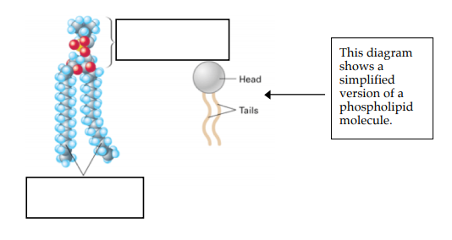

Lipids have long hydrocarbon tails (made of carbon and hydrogen). Water does not like to associate with these tails, so the tails in a phospholipid are hydrophobic (=water-fearing). The phospholipid heads have some charge, so they are polar. Water is also polar and likes to associate with other polar molecules. Thus, the heads are hydrophilic (=water-loving).
6. Given the information above, why does the arrangement of the phospholipid bilayer make sense? (The tails are facing inwards and the heads are facing the watery area surrounding the cell).
______________________________________________________________________________________________________________________________________________________________________________________________________________________________________________________________________________
Part II: Membrane Transport
On the right side of the webpage under Cell Structure, click on “Function.” (Right after it says Cell Structure & Function) > Click on “Passive Transport” on the right hand side. If you cannot find it, the URL is: www.biology4kids.com/files/cell2_main.html
1. How does passive transport differ from active transport? ________________________________________ __________________________________________________________________________________________
2. Two types of passive transport (movement of molecules across a membrane that does not require energy) include ___________________ and _______________________.
3. What do some proteins act as to aid in moving molecules across a membrane? __________________________________________________________________________________________
4. What do you think semi-permeable means? (Permeable means to pass into or through). __________________________________________________________________________________________
5. What is facilitated diffusion? Does it require energy to occur? _____________________________ __________________________________________________________________________________________
a. What is an example of a molecule that cannot cross the membrane by simple diffusion? _________________
6. Molecules that move from high to low concentration are said to be moving down a _________________________ ___________________.
7. Make a sketch showing molecules in high concentration on one side of the membrane, and in low concentration on the other side of the membrane and the movement of molecules down a concentration gradient.

8. How are small molecules able to freely cross the membrane without an input of energy?
_______________________________________________________________________________
9. What is osmosis? ________________________________________________________________
10. In terms of ion concentration, what type of homeostasis needs to be established for a cell to survive? __________________________________________________________________________________________
11. What will happen if red blood cells are placed in water? Why does this happen? __________________________________________________________________________________________
On the right side of the webpage under Cell Function, click on “Active Transport.”
12. What is active transport? __________________________________________________________________________
13. Why does the cell sometimes have to expend energy to move individual molecules across the cell membrane?________________________________________________________________________________
14. Which membrane molecules do most of the work in active transport? ______________________________
15. Membrane proteins are very __________________, meaning that they are designed to move only one or two types of molecules or ions across the membrane.
16. What does it mean by proteins working against a concentration gradient? ______________________ __________________________________________________________________________________________
17. Sketch a diagram of active transport, showing the phospholipids and the proteins in the membrane. Also make sure to represent that the molecule is moving from low to high concentration.

Part III: A Closer Look at Membrane Structure and Transport
Go to http://www.phschool.com/science/biology_place/biocoach/biomembrane1/intro.html
Concept 1: Membrane Structure
Membranes consist of a ________________________ _________________ combined with a variety of __________________ in a fluid __________________ arrangement. The surfaces of cell membranes are ________________________ (water-loving); the interiors are ______________________ (water-fearing). Hydrophilic molecules tend to interact with ______________ and each other. Hydrophobic molecules _________________ interaction with water and tend to interact with other _______________________ molecules.
Concept 2: Osmosis
Osmosis (movement of ______________ across membranes) depends on the relative ____________________________ of solute molecules on either side of the ________________________. The presence or absence of cell ______________ influences how cells respond to osmotic fluctuations in their environment.
Click on “Review” in the upper right hand corner. It will open up a new screen.
Concept 2 Review: Isotonic, Hypotonic, and Hypertonic Solutions
Water moves readily across cell membranes through special protein-lined ____________________, and if the total concentration of all dissolved solutes is not ________________ on both sides, there will be net ____________________ of water molecules into or out of the cell. Whether there is net movement of water into or out of the cell and which _____________________ it moves depends on whether the cell’s environment is isotonic, hypotonic, or hypertonic.
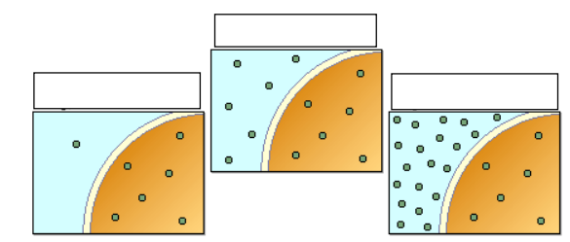
Label the three illustrations below as isotonic, hypotonic, or hypertonic.

Click “Next” on the bottom left side of the screen.
Concept 2 Review: Cells in Isotonic Solutions
When two environments are isotonic, the total concentration of dissolved solutes is the_________________ in both of them. When cells are in isotonic solution, movement of water out of the cell is exactly ____________________ by movement of water into the cell. A _____________ solution of NaCl (saline) is isotonic to __________________ cells.
Select “animate” to watch the movement of water molecules through protein channels in the cell membrane in an isotonic solution.
Make your own sketch of a cell in an isotonic solution:
Click “Next” on the bottom left side of the screen.
Concept 2 Review: Cells in Hypotonic Solutions
Hypotonic comes from the Greek “hypo,” meaning ______________ and “tonos” meaning ___________________. In a hypotonic solution, the total concentration of all dissolved solute particles is ______________ than that of another solution or less than that of a ________________.
If concentrations of dissolved solutes are less ________________ the cell than ________________, the concentration of water outside is correspondingly greater. When a cell is exposed to such hypotonic solutions, there is net movement of water _______________ the cell. Cells without cell ______________ will swell and may ______________(lyse) if excess water is not removed from the cell. Cells with cell walls often benefit from the _______________ pressure that develops in hypotonic environments.
Select “animate” to watch the movement of water molecules across the cell in a hypotonic solution.
Make your own sketch of a cell in a hypotonic solution:

Select “A Closer Look” to see plant and animal cells in hypotonic environments on the bottom of the page.
Compare and contrast what happens when a plant cell and animal cell are placed in a hypotonic solution.
____________________________________________________________________________________________________________________________________________________________________________________
Click “Back to Review” and then select “Next” to view cells in hypertonic solutions.
Concept 2 Review: Cells in Hypertonic Solutions
Hypertonic comes from the Greek “hyper,” meaning _____________, and “tonos,” meaning stretching. In a hypertonic solution, the total concentration of all dissolved solute particles is __________________ than that of another solution, or greater than the concentration in a ______________.
If concentrations of dissolved solutes are greater _________________ the cell, the concentration of water outside is correspondingly _______________. As a result, water inside the cell will flow __________________ to attain equilibrium, causing the cell to _______________. As cells lose water, they lose the ability to __________________ or __________________. Hypertonic environments, such as concentrated brines or _________________, have been used for food preservation because microbial cells that would otherwise cause spoilage are _____________________ in these very hypertonic environments and are unable to function.
Select “animate” to watch the movement of water molecules across the cell in a hypertonic solution.
Make your own sketch of a cell in a hypertonic solution:

Select “A Closer Look” to see plant and animal cells in hypertonic environments on the bottom of the page.
Compare and contrast what happens when a plant cell and animal cell are placed in a hypertonic solution. ____________________________________________________________________________________________________________________________________________________________________________________
Close the review screen you are on to go back to the BioCoach Activity. You should still be on Concept 2: Osmosis. Click “Next Concept.”
Concept 3: Selective Permeability of Membranes
Cell membranes are selectively permeable. Some solutes can cross the membrane ______________, some cross with ____________________, and others do not cross at all. A few lipophilic (lipid-loving) substances move freely across the cell membrane by _________________ __________________. Most small molecules or ions require the assistance of specific ________________ ____________________ to transport them across the membrane. _______________ molecules do not cross intact cell membranes, except in certain special cases.

