Organelle | Function/ Description | How can I remember it?
Cell Membrane
Cell Wall
Cytoplasm
Mitochondria
Lysosomes
Vacuoles
Golgi Bodies
Chloroplasts
Endoplasmic Reticulum
Ribosomes
Nucleus
Nucleolus
Chromatin

FUNCTION CARDS: Please drag and drop the function card to the appropriate organelle | MEMORY ITEMS: Please drag and drop the memory item to the appropriate “how can I remember it” column
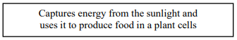  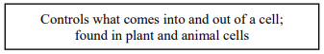  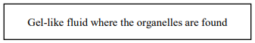  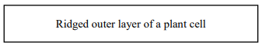  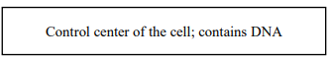  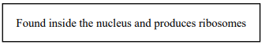  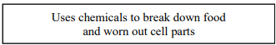  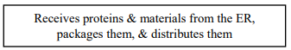  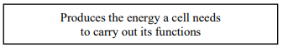  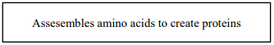  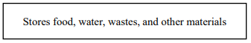  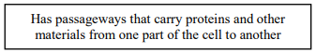  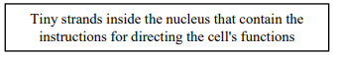 | 