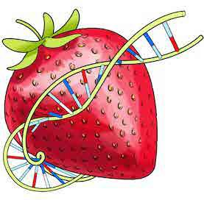
DNA

Name: Period: Date:

Extraction: Strawberries

Essential Question:
Targets:
- Exhibit proper lab procedures.
- Demonstrate ability to mass an object.
- Show understanding of dependent and independent variables.
- Apply knowledge to correctly fill out a data table following established criteria.
- Analyze and interpret collected data.
- Create a graph following established criteria.
- Exhibit ability to follow directions.
- Demonstrate knowledge of DNA’s role in living and once living organisms.
- Extract DNA from Strawberries.
- Apply knowledge of DNA to everyday situations.
What is the percent of DNA you are able to extract from a strawberry?

- What do you think the DNA will look like when you extract it from the plant cell?

- Where is the DNA found that you will extract? Draw a sketch of where DNA is found:
Sketch DNA Location

Don’t forget to label.

Follow Part 1 Procedure of the found at lab station.

Put Goggles On

Record the Initial Mass of Strawberry(ies) here:

Part 1 Questions:
Remember to answer in complete sentences
- What was the purpose of mashing up the strawberry?

- What does the extraction buffer do? Hint: Extraction buffer contains dish soap.
What does soap do to fats (grease)?

No Goggles = No Grade

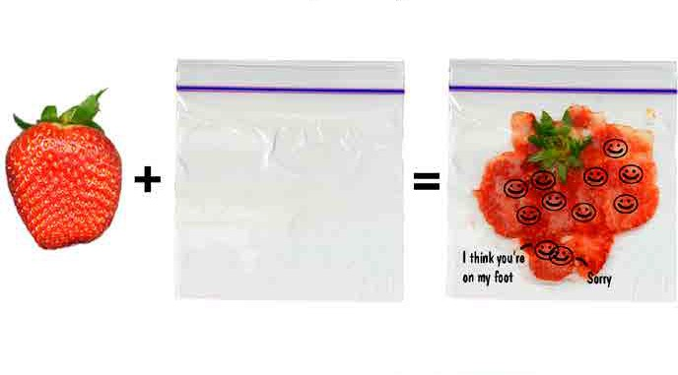

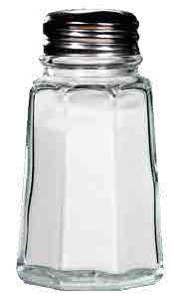
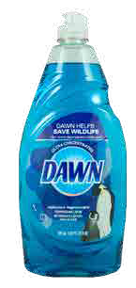
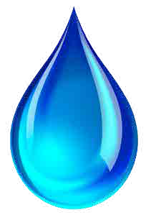
+ +

Part 1 Questions (cont.): Remember to answer in complete sentences
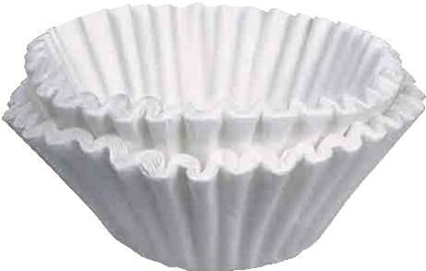
- What is the purpose of the filter? What parts of the strawberry do we not want in our liquid?

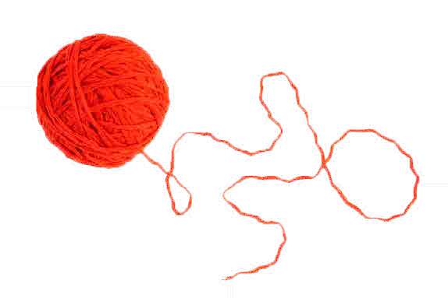
- A person cannot see a single cotton thread four classrooms away. But if you wound thousands of threads into a rope, it would be visible at the same distance. How is this statement an analogy of our DNA extraction lab?

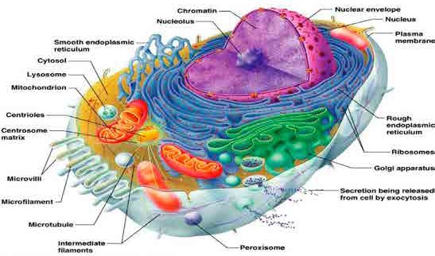
- Is DNA found in all living or once living cells? Explain.

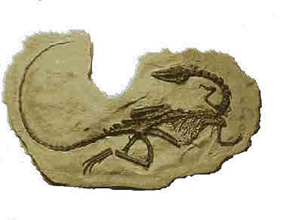
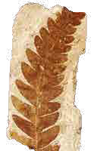
- If DNA is found in all living or once living cells, what does this mean for scientists studying the fossils of ancient organisms? What could they learn from studying the DNA of ancient organisms?

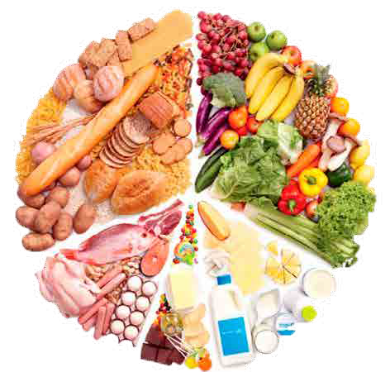
- Since the strawberries were once living and we can extract DNA from them, what does this mean about the foods you eat? Is there DNA in your foods? How do you know?

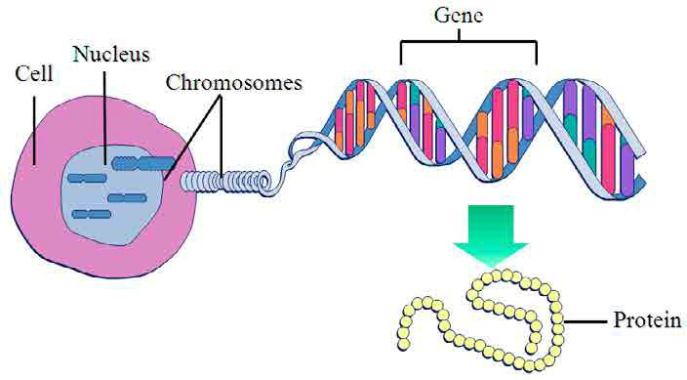
- Remember genes are found in DNA, and genes control traits. Give at least 3 examples of traits (characteristics) expressed in a strawberry.

Part 2: Remember to answer in complete sentences

Put Goggles On — No Goggles = No Grade

→ Follow Part 2 of the procedure found at your lab station. ←
- Observations: What do you see appearing?
Sketch observations here

Don’t forget to label.

- Write detailed observations below of what you saw appearing:

Your Data Mass Unit
Pre-mass of the skewer
Post-mass of the skewer
Final yield of the DNA extracted*
*To obtain the final yield of DNA extracted subtract the post-mass from the pre-mass of the skewer.

Mass of Strawberry vs. Mass of Strawberry DNA Extraction Yield

 | Initial mass of strawberry(ies) (g) | Final yield of DNA (g) | DNA % of strawberry mass *
Group 1 Data (Your group)
Group 2 Data
Group 3 Data
* Final Yield of DNA / Initial mass of Strawberry = DNA % of strawberry mass

Title:

Part 1 Questions:

Can you tell if there is a correlation between the initial mass of the strawberry and the final yield of DNA extracted? If so, what is the correlation?

- What other variables could affect how much DNA you were able to extract from the strawberry? (List at least 3.) What do you think you could change in order to increase your final yield?

What happened when you added the alcohol to the extract?

- Why is it important for scientists to remove DNA from an organism? List and describe to reasons/ applications of this technology.

If you extracted DNA from a human, what could this tell you about the person? How could their DNA be useful to: A. The individual, B. The individual’s doctor, C. A police officer or court, D. The individual’s family

Data and Graphs Checklist (to be filled out by instructor)
Data Table |  | Graph
Data Table   Present   Missing | Title   Present   Missing | Graph (data transformed into)   Present   Missing | Key or legend   Present   Missing | Data Accuracy   complete,   incomplete,   incorrect | Visuals   cluttered,   disorganized   messy   easily interpreted enhancing data understanding.   accurately represent data collected.
Rows & columns clearly labeled indicating   variables   units. | Information / data   disorganized   cluttered,   messy | Title   Present   Missing | Both Axes clearly labeled indicating   variables & units   not so | Scale is   regular   consistent   not so

Data & Graphics

Lab Rubric

Exceeds — 4 | Meets — 3 | Emerging — 2 | Beginning — 1
Graphs and drawing contain all the necessary components such as a title, labeled axes, key or legend, labels and units. Visuals accurately represent the data collected are easily interpreted and enhance the understanding of the data. | Graphs and/or drawings contain all the necessary components such as a title, labeled axes, key or legend, labels and units. Visuals accurately represent the data collected. | Student attempted to create graphs, but is missing key elements needed to effectively display data. Overall data display is not well constructed. Elements missing may include titles, captions, axes, units | Student attempted to create graphs, but is missing most key elements needed to effectively display data. Overall data display is incoherent. Multiple elements missing may include titles, captions, axes, units. Data display hard to follow.
Visuals
Exceeds — 4 | Meets — 3 | Emerging — 2 | Beginning — 1
Visuals are easily interpreted enhancing the demonstration of student learning. | Visuals are easily interpreted and show student understanding. | Student created all visuals but key elements needed to effectively communicate knowledge are missing. | Student attempted to create visuals, but failed to complete all drawings.
Completeness
Exceeds — 4 | Meets — 3 | Emerging — 2 | Beginning — 1
Lab packet contain all the necessary | Lab packet have all components and | Lab packet missing some | Lab packet missing 50% of
components and questions are filled | questions answered, but are difficult | components and not all questions | components and 50% questions
out and answered legibly. Complete | to read. Complete sentences are | are answered. Complete sentences | are not answered. Complete
sentences are used. | used. | are not used. | sentences are not used.
Responses
Exceeds — 4 | Meets — 3 | Emerging — 2 | Beginning — 1
90-100% questions answered and/or demonstrate student understanding of all concepts and targets. | 80-89% questions answered correct and/or demonstrate student understanding of all concepts and targets. | 70-79% questions answered correct and/or demonstrate student understanding of all concepts and targets. | Less than 70% answers correct and/or demonstrate student understanding of all concepts and targets.

Comments:
Section | X | Val. | Score
Data & Graphics | 4x | 16
Visuals | 1x | 4
Completeness | 2x | 8
Responses | 3x | 12
Total |  |  | /40
Percent
Grade |  |  | /20

Standard H3 S2: Design and conduct a controlled experiment, field study or other investigation to make systematic observations about the natural world including the collection and display of sufficient data.

