**DNA Structure and Function** DATE:

NOTES:

**A. DNA Structure**

* DNA = ______________________________________________
* DNA’s __________________ is made of a ____________ (deoxyribose) and a ________________
* The rungs of DNA is made of 4 ____________ (Adenine, Guanine, Thymine, Cytosine)
* DNA is held together by _______________________ bonds

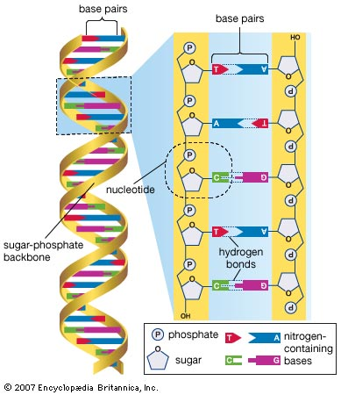

**B. DNA Structure - Chromosomes**

* The DNA is coiled in the __________________ in ___________________
* Chromosomes carry the ________________ of your ancestors

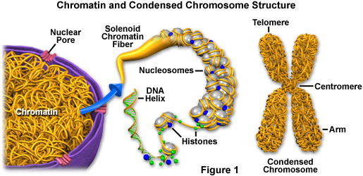

BIOLOGY CORNELL NOTES:

STUDY QUESTIONS

1. What holds DNA together?

__________________________________________________________________________________________________________________

2. What is the X shaped structure that contains DNA?

__________________________________________________________________________________________________________________________________________

3. What type of strands are created from DNA replication? Identical or different?

___________________________________________________________________________________________________________________

**C. DNA Replication**

1. DNA must be _________________ from cell to cell
2. The copying of DNA is called _________________________
3. Once the entire process is complete, two _____________________ strands of DNA are formed

D. Steps of DNA Replication

* STEP 1
  + DNA is _____________ and _______________ bonds are broken apart by the enzyme DNA _______________
* STEP 2
  + Two strands are _____________________ by the enzyme DNA ________________
* STEP 3
  + ____________________________ base pairs are brought to the original strand from the opposite end (___________________)
* STEP 4
  + DNA molecules are one part ____________ strand and one part _________ strand. ________-________________ replication
* STEP 5
  + Two _______________________ strands of DNA are produced

BIOLOGY CORNELL NOTES:

SUMMARY

______________________________________________________________________________________________________________________________________________________________________________________________________________________________________________________________________________________________________________________________________________________________________________________________________________________________________________________________________________________________________________________________________________________________________________________________________________________