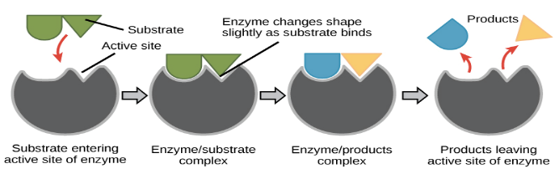
The Effect of Temperature on Enzyme Action
Temperature ºC | Reaction Rate
10 | 1.0
15 | 1.5
20 | 2.5
25 | 3.5
30 | 5.5
35 | 7.5
40 | 9.5
45 | 8.5
50 | 7.0
55 | 4.0
60 | 0.0

TITLE:
Reaction Rate
Temperature ºC
Describe what this graph is indicating. At what temperature is the enzyme working the best? Why doesn’t the enzyme work well at every temperature?
____________________________________________________________________________________________________________________________________________________________________________________________________________________________________________________________________________________________________________________________________________________________________________________

