Name _____________________________________ Date_____________ Period__________
2.4 Chemical Reactions and Enzymes

Directions: Use the textbook to aid you in answering the following questions.
- What happens to chemical bonds during chemical reactions? Why is the melting of ice not a chemical reaction?
________________________________________________________________________________________________________________________________________________________________________________________________________________________________________________________________________________________________________________________________________________________________________
- Describe the two types of energy changes that can occur in a chemical reaction.
____________________________________________________________________________________________________________________________________________________________________________________
- What is activation energy?
____________________________________________________________________________________________________________________________________________________________________________________
- What is a catalyst? Please provide an example of a biological catalyst.
____________________________________________________________________________________________________________________________________________________________________________________
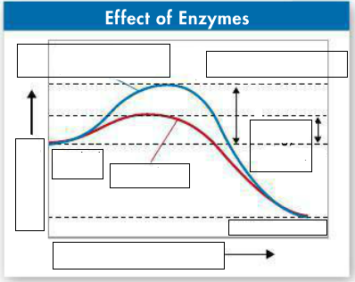
Label the diagram below. Notice how the addition of an enzyme lowers the activation energy in this reaction.
Use the diagram to answer Questions 4-5

Label the enzyme, the active site, and the products in the diagram.
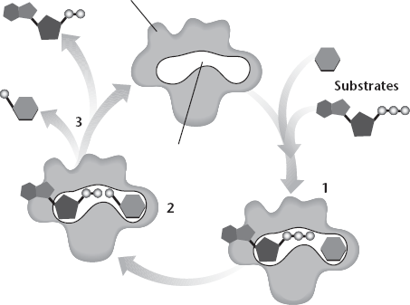
5. Write what is happening at each numbered part of the diagram.
1. _______________________________________ _________________________________________
2. _______________________________________ _________________________________________
3. _______________________________________ _________________________________________

6. Explain how enzymes work, including the role of the enzyme-substrate complex.
____________________________________________________________________________________________________________________________________________________________________________________
7. Describe some factors that may influence enzymes activity.
____________________________________________________________________________________________________________________________________________________________________________________
8. Explain why a lock and key are used to describe the way an enzyme works.
____________________________________________________________________________________________________________________________________________________________________________________
9. Changing the temperature or pH can change an enzyme’s shape. Explain how changing the temperature or pH might affect the function of an enzyme. (Hint: think about the analogy of the lock and key)
______________________________________________________________________________________________________________________________________________________________________________________________________________________________________________________________________________

