Directions: Identify the functions of the following organs/ body parts. Label each diagram appropriately. Be sure to color each picture.
Dorsal View
- Nostril: ____________________________________________________________________________
- Eye: _______________________________________________________________________________
- Nictitating Membrane: ______________________________________________________________
- Tympanic Membrane: _______________________________________________________________
- Head: _____________________________________________________________________________
- Trunk: _____________________________________________________________________________
- Forelimb: __________________________________________________________________________
- Hind limb: _________________________________________________________________________
Oral Cavity
- Vomerine teeth: ____________________________________________________________________
- Maxillary teeth: ____________________________________________________________________
- Internal Nares: _____________________________________________________________________
- Eustachian Tube: ___________________________________________________________________
- Esophagus: ________________________________________________________________________
- Glottis: ____________________________________________________________________________
- Pharynx: __________________________________________________________________________
Digestive System
- Liver: _____________________________________________________________________________
- Gall Bladder: ______________________________________________________________________
- Small Intestine: ____________________________________________________________________
- Stomach: __________________________________________________________________________
- Pancreas: __________________________________________________________________________
- Spleen: ____________________________________________________________________________
- Large Intestine: ____________________________________________________________________
- Cloaca: ____________________________________________________________________________
Urogenital System (Male)
- Testes: ____________________________________________________________________________
- Bladder: ___________________________________________________________________________
- Cloaca: ____________________________________________________________________________
- Kidney: ____________________________________________________________________________
Urogenital System (Female)
- Ovary: _____________________________________________________________________________
- Oviduct: ___________________________________________________________________________
- Ovisac: ____________________________________________________________________________
- Kidney: ____________________________________________________________________________
- Bladder: ___________________________________________________________________________
- Cloaca: ____________________________________________________________________________

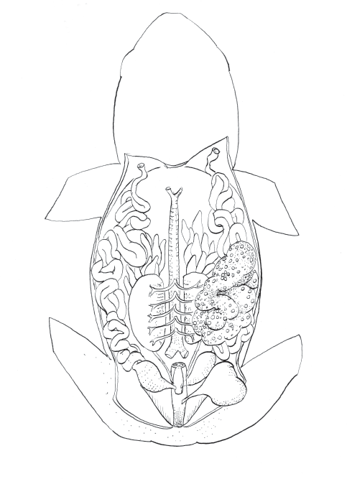

Figure 5. Urogenital System (female)

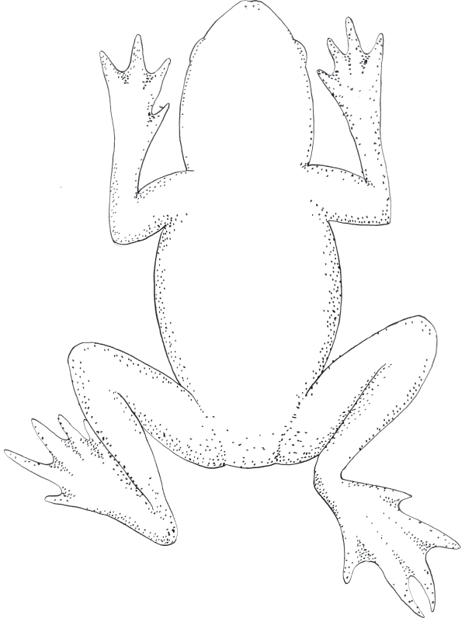

Figure 6. Ventral View

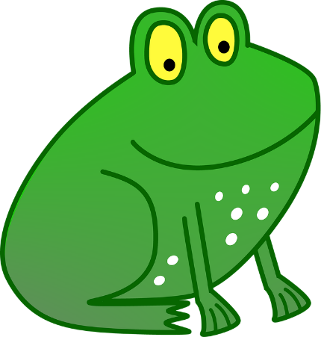

MAKE A FROG SANDWICH

Student Booklet

Student Name : ______________________________________________________

Class Period: ________________________________________________________

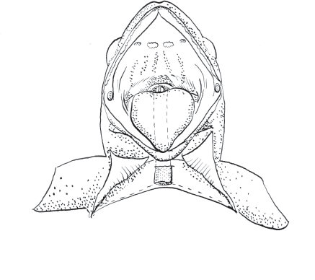

Figure 2. Oral Cavity

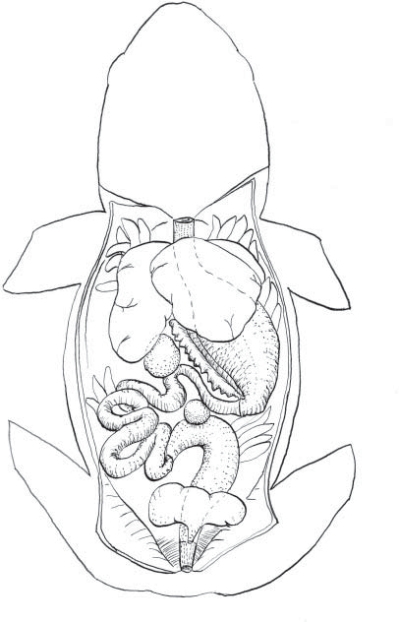
Figure 3. Digestive System

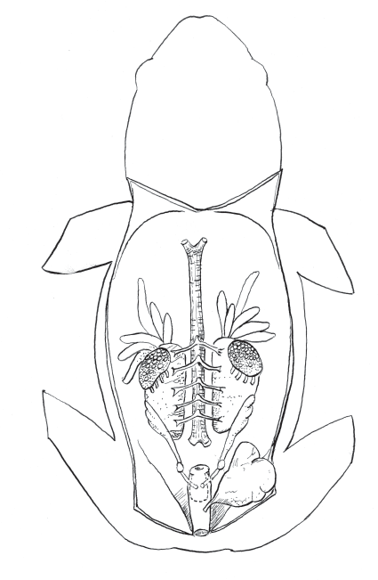
Figure 4. Urogenital System (male)

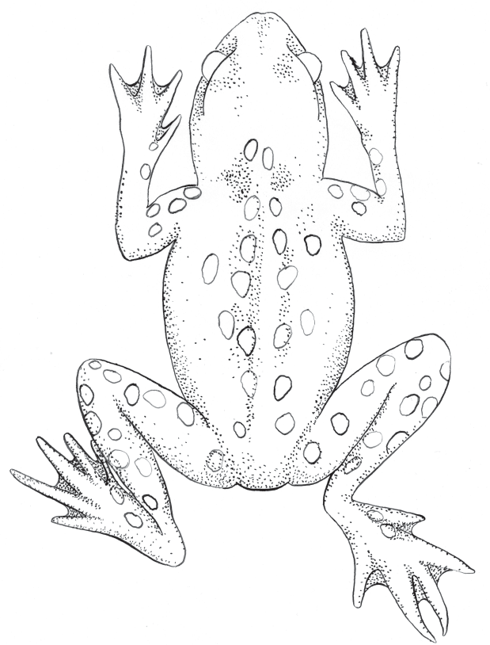

Figure 1. Dorsal View

