Biology Cornell Notes: History of Cell Date:
Study Questions:  1.Why is a cell called a cell? _______________________________________________________________________________________________________________________  2. What is the Cell theory? _________________________________________________________________________________________________________________________________________________________  3. Which two organelles have their own DNA? ____________________________________________________________________  4. Why type of cell is Eukaryotic? ___________________________________________________  Summary:  ____________________________________________________________________________________________________________________________________________________________________________________________________________________________________________________________________________________________________________________________________________________________________________________________________________________________________________________________________________________________________________________________________________________________________________________________________________________________________________________________________________________________________________________________________________________________________________ | I. What Are the Main Characteristics of organisms?  - Made of _______________  - Require ______________ (food)  - ________________ (species)  - Maintain ________________________  - ___________________________  - ____________________ to environment  - ________________ and _______________________  - _______________________materials with surroundings (water, wastes, gases)  II. Levels of Organization  - Nonliving Levels:  - _______________(element)  - _______________________ (compounds like carbohydrates & proteins)  - __________________________ (nucleus, ER, Golgi …)  - Living Levels:  - _____________________ (makes up ALL organisms)  - _________________ (cells working together  - __________________ (heart, brain, stomach …)  - _________________________________ (respiratory, circulatory …)  - ____________________  - ____________________ (one species in an area)  - _____________________________ (several populations in an area  - ECOSYSTEM (forest, prairie …)  - ________________________ (all living and nonliving things on Earth)  III. History of Cells & the Cell Theory  - First to View Cells  In 1665, ____________________________________ used a microscope to examine a thin slice of ______________________ (dead plant cell walls)  Hooke is responsible for ___________________________________. Hooke called them “CELLS” because they looked like the _______________________ _______________________________________ called cells  - First to View Organisms  In 1673, _____________________________________ (a Dutch microscope maker), was __________________________________________ (living things) Leeuwenhoek used a simple, handheld microscope to view ________________________________________________________________________________________________________________________________  Beginning of the Cell Theory  - In 1838, a German botanist named ____________________ _____________________ concluded that all _________________ were made of cells. Schleiden is a _______________________ of the cell theory  - In 1839, a German zoologist named Theodore _______________________ concluded that all ____________________ were made of cells. Schwann also __________________________ the cell theory  - In 1855, a German medical doctor named ______________________ ___________________ observed, under the microscope, cells dividing  He reasoned that all _______________________________________________ ______________________________ cells by cell division  IV. CELL THEORY  - All living things are made of __________________  - Cells are the basic unit of __________________________________ ______________ in an organism (basic unit of life)  - Cells come from the _______________________________________________________________________________________________________________ (cell division)  Discoveries Since the Cell Theory  ENDOSYMBIOTIC THEORY  - In 1970, American biologist, Lynn Margulis, provided evidence that some organelles within cells were at one time ______________living cells themselves  Supporting evidence included organelles with their own _______________ -- Chloroplast and _______________________________ 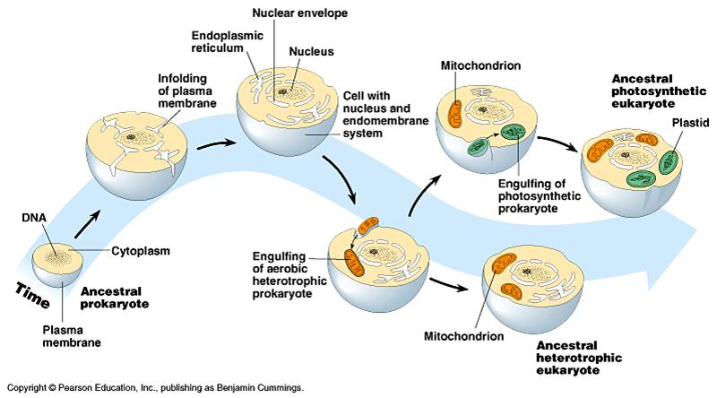  V. Cell Size and Types  - Cells, the basic units of organisms, can only be __________________________ ________________________________________________________________  - Three basic types of cells include:  ANIMAL PLANT BACTERIA

