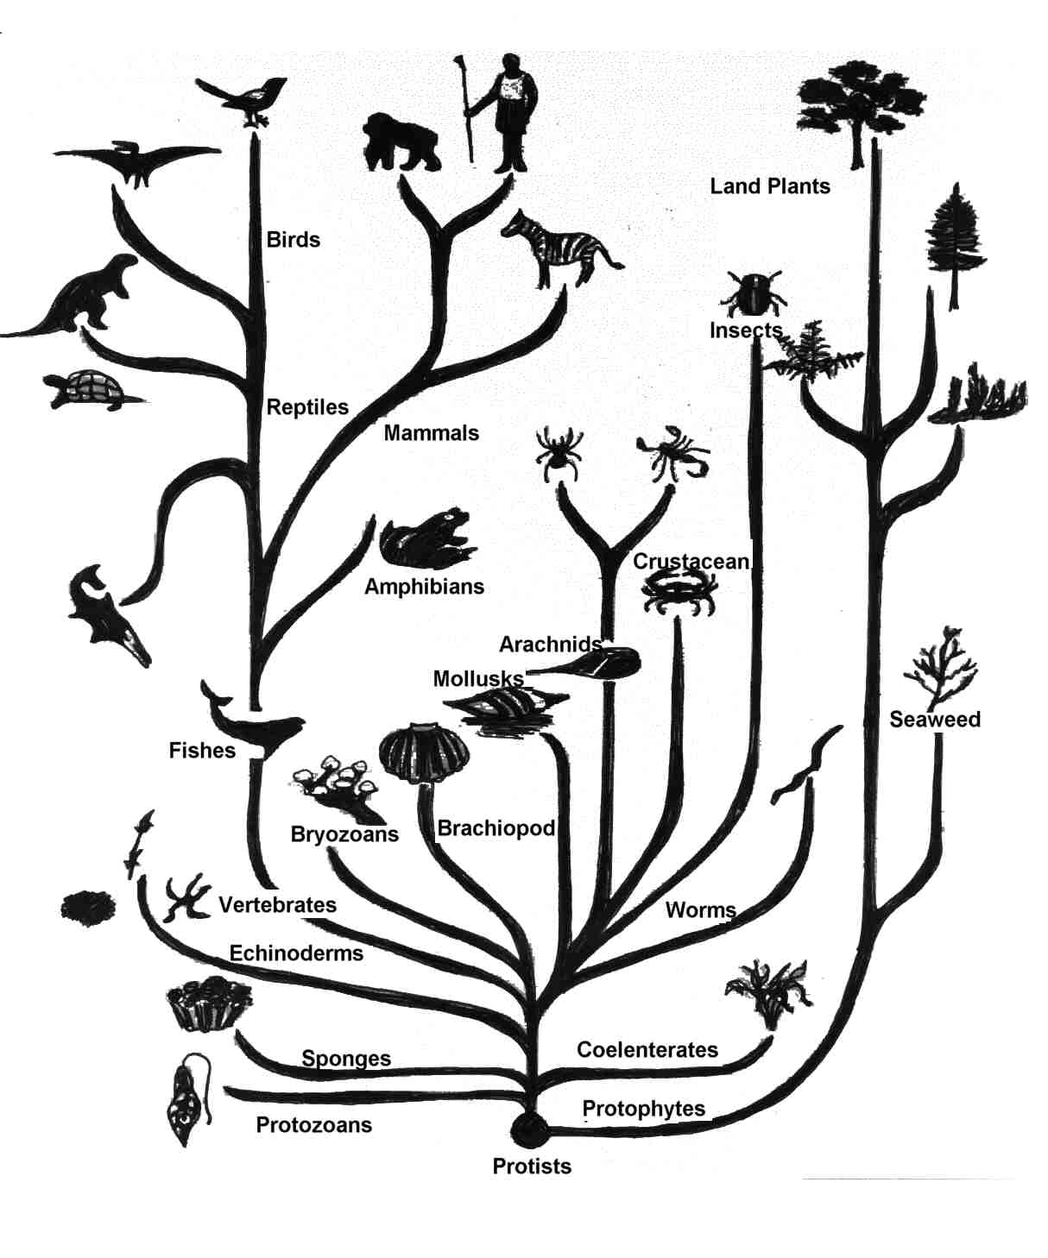C:\Documents and Settings\ferracoa\Local Settings\Temporary Internet Files\Content.IE5\A666645S\MCj04418800000[1].wmfC:\Documents and Settings\ferracoa\Local Settings\Temporary Internet Files\Content.IE5\8KPE1BO5\MCj04298270000[1].wmf

BIG Ideas in Biology

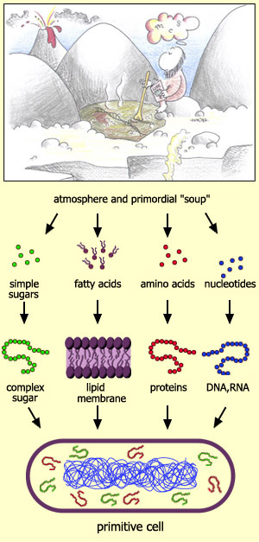#1: Organisms share *common* characteristics of life.

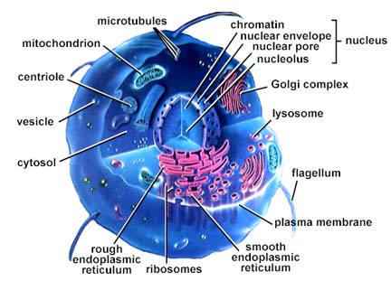#2: Life emerges due to the chemical organization of matter into **cells**.

#3: **Cells** are the basic unit of structure and function for all organisms.

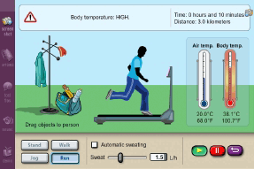

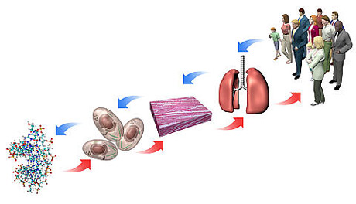#4: Through a variety of mechanisms organisms seek to maintain a biological balance between their internal and external environments (**homeostasis**).

#5: Eukaryotic cells can **differentiate** and organize making it possible for multicellularity.

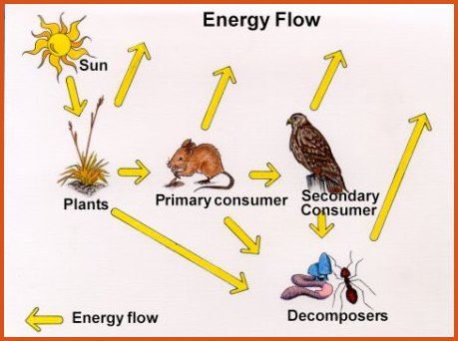

#6: Organisms obtain and use *energy* to carry out their life processes.

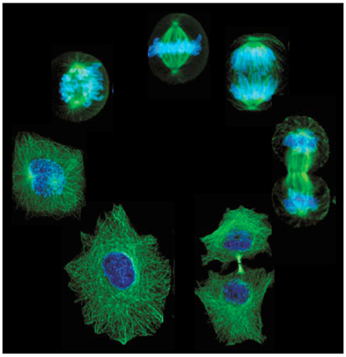#7: New **cells** arise from the division of pre-existing cells.

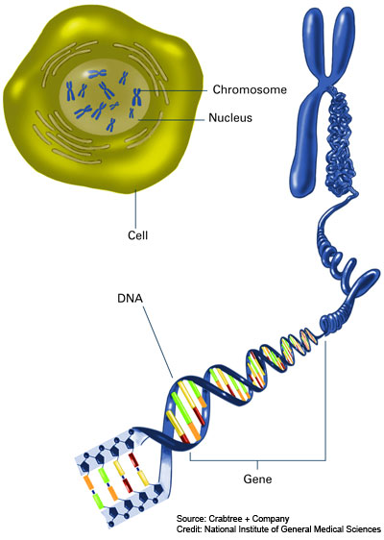

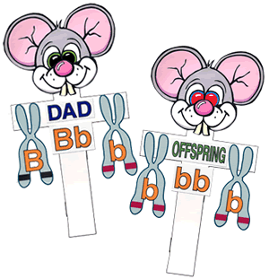

#8: Hereditary information in **genes** is transmitted across generations via **DNA**.

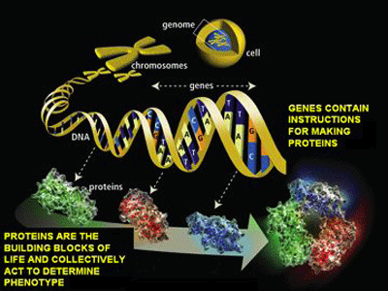

#9: **DNA** segments contain information for the production of **proteins** necessary for growth and function of **cells**.

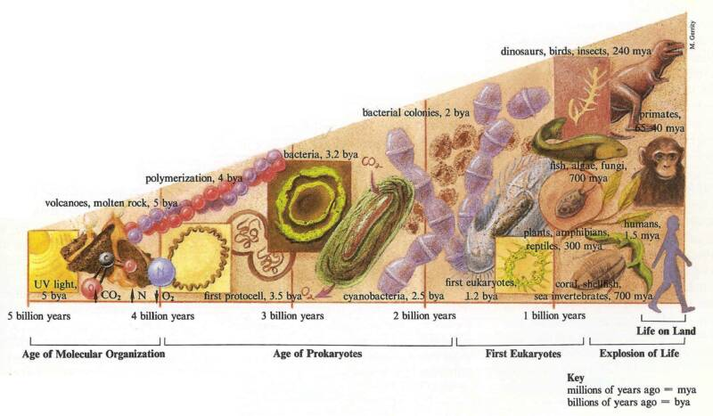

#10: **Evolution** is the result of many random processes selecting for the survival and reproduction of a population.

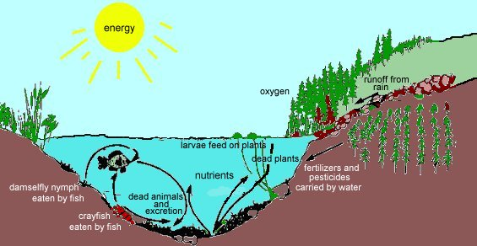

#11: Organisms on Earth interact and depend in a variety of ways on other living and nonliving things in their environments (**ecology**).