Name: ____________________________
TOPIC 1: Biochemistry and the Molecules of Life

- What does it mean for a compound to be organic?
- Water is (circle one) polar / nonpolar because the electrons are not evenly shared.
- What two properties of water are mentioned?

- What is the difference between a monomer and polymer?
- Dehydration synthesis ___________ water to ________ a bond, while hydrolysis ______ water to ___________ a bond.
- Carbohydrates have a ___: ___: ___ ratio of the elements C:H:O. Carbohydrates are the main ______________ source for a cell.
- What are the two monomers of lipids?

- Lipids make up the majority of the cell ______________.
- Nucleic acids have the following elements: ___________________________. Nucleic acids store our ______________ _______________.
- Amino acids (the monomers of a protein are made up of what three parts?

- How do enzymes act as biological catalysts?
Macromolecule | Elements | Monomer and polymer | Roles
Carbohydrates | CHO | Monosaccharide/ polysaccharide | Quick/main source of energy
Lipids | CH and a little O | Glycerol and fatty acid/lipid | Long-term source of energy; cell membrane
Nucleic acids | CHOPN | Nucleotide / nucleic acid | Genetic material
Proteins | CHOSN | Amino acid /polypeptide or protein | Structure and enzymes

Name: _____________________________________

TOPIC 2: Cells and Cellular Organization

- What structure defines a cell? ______________________________
- What do we a call an organism that does have a nucleus? ___________________________
What do we call an organism that does not have a nucleus? _________________________
- What are two examples of prokaryotes? _____________________________ _________________________

- What are three types of eukaryotes? ________________ ___________________ ____________________
- Ribosomes help to make _________________ for the cell
- The fluid in the cells is called the _________________ (aka cytoplasm)
- The Endoplasmic reticulum connects to the _______________ Bodies
- The section of the Endoplasmic Reticulum with attached ribosomes is called the ___________ ER
The section of the Endoplasmic Reticulum without ribosomes is called the ___________ ER
- When a protein leaves the Golgi Bodies, what does it take with it? _____________________
This piece will help it float around in the cell and fuse with the cell membrane.
- What items could be stored in a vesicle? ________________________________________________________
- Lysosomes and lytic vacuoles do what? ______________________________________________
- What is an organelle? _________________________________
- Where do we turn sugars into ATP? ________________________________
- What do plants use for photosynthesis? ________________________________
- What do filaments do? _____________________________________

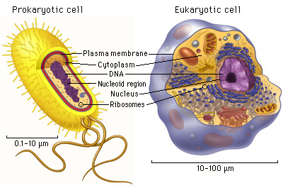

TOPIC 3: Cellular Transport

- What 4 types of organisms have a cell wall?

- Diffusion moves molecules form a ____________ concentration to a _________ concentration.
- True or false: after equilibrium is reached, molecules do not move anymore.
- In a hypotonic solution, there is a low solute / high water concentration outside a cell. Water moves ____ the cell.
- Circle one: Who does better in a hypotonic solution? PLANTS ANIMALS
- In a hypertonic solution, there is a high solute / low water concentration outside a cell. Water moves _____ the cell.
- In an isotonic solution, there is an _________ solute / water concentration outside and inside a cell.
- Circle one: Who does better in an isotonic solution? PLANTS ANIMALS
- Facilitated diffusion needs the help of a __________ to move large/charged molecules across a cell membrane.
- What type of molecule is the “facilitator” in facilitated diffusion? _____________________________
- The only type of cellular transport to go AGAINST the concentration gradient is called _____________________.
- What important energy molecules allows active transport to happen? ____________________
- What happens to the shape of the protein when the ATP binds to it? __________________________________
- What happens to the shape of the protein when the potassium ions bind to it? ___________________________
- In the Na⁺ K⁺ pump, _______ ions of sodium go through first. Then, _____ ions of potassium go through.

TOPIC 4: Cell Division

- What are the three reasons that cells typically divide?

- Circle one: The longest phase of the cell cycle is INTERPHASE / MITOSIS
- G₁ is about cells _______________.
- How does a duplicated strand of DNA end up being identical to the original strand?
- The last stage of Interphase is ________________________.
- In mitosis, the goal is to get cells that are genetically ______________. That is, we want to go 2N2N.
- Match the following Mitosis stages to what happens
___Prophase a. Chromosomes move to opposite ends of cell
___ Metaphase b. Nucleus reforms, DNA loosens, last stage
___ Anaphase c. DNA condenses; nuclear breaks down
___ Telophase d. Chromosomes line up in middle of cell
- What is the difference between plant and animal telophase/cytokinesis?
- What does meiosis do to the number of chromosomes? _______________________
- Meiosis goes from 2N _________, or from diploid ______________
- What is crossing over?
- When does crossing over happen? __________________________
- What is the idea of Independent assortment?
- When chromosomes fail to separate properly, it is known as ____________________________.
  - ___________ syndrome and Patau syndrome are results of nondisjunction.

TOPIC 5: Cellular Energy

- What are examples of autotrophs?
- What are examples of heterotrophs?
- The most instant form of energy is known as ____________.
- Why is ATP a high energy molecule?
- Complete the photosynthesis equation below
__CO₂ + ___ H₂O + _________/enzymes C₆H₁₂O₆ +___6O₂

- If the photosynthesis equation is reversed, then it is the formula for _____________________________.
- The _________ dependent reactions and the light _____________________ reactions make up photosynthesis.
- Place a “D” if the statement refers to the light dependent reactions and an “I” if it refers to the light independent reactions
____ water is split into oxygen, protons, and electrons
____CO₂ is taken in and converted into carbohydrates
____ light energy is not needed
____ light energy is needed
- What initial process splits a molecule of glucose into 2 3-carbon molecules? ________________________
- What is the NET ATP yield from glycolysis? _______

- What are the two different types of fermentation mentioned?

- (Circle one) CO₂ is created during electron transport chain / Kreb’s cycle
- In the electron transport chain, oxygen joins with electrons and protons to make ___________.
- By going through glycolysis, Kreb’s Cycle, and Electron transport chain, a cell can make between _____ and ______ ATP as opposed to just the 2 of glycolysis.

TOPIC 6: DNA and its processes
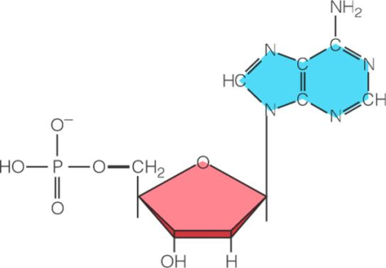
- Label the three parts of a nucleotide to the right.
- DNA has ______ strands and the bases ___denine, ___ymine, ___tosine, and ___uanine.
- RNA has _____ strand and the base ___racil instead of thymine.
- What are the functions of
mRNA? tRNA? rRNA?
- What are the three different processes that nucleic acid can do?

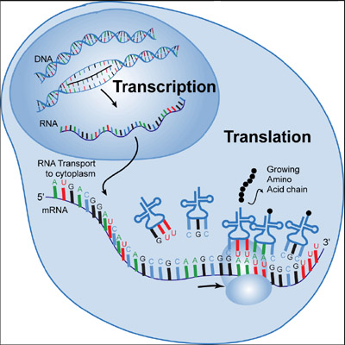

- What happens during replication?
- What happens during transcription?
- What does AUG code for? ____________________
- What do UGA, UAA, and UAG code for? ______________________
- What happens during translation?
- What is the biology definition of a mutation?
- What happens during
  - Substitution mutation
  - Insertion point mutation
  - Deletion point mutation
  - Duplication chromosomal mutation
  - Deletion chromosomal mutation
  - Inversion chromosomal mutation
  - Translocation chromosomal mutation

TOPIC 7: Genetics
- Match the vocab terms to their definitions.
_____ Dominant allele
- Organism with two different alleles for the same trait
- Genetic makeup
- Parental generation
- Physical characteristics
- Organism that has two identical alleles for a trait
- Tool that can predict and compare genetic variation
- Allele that can be masked
- Priest who worked with garden peas
- First offspring generation
- Allele that can mask other alleles
- Second offspring generation
_____ F1 generation
_____ F2 generation
_____ Genotype
_____ Gregor Mendel
_____ Heterozygous
_____ Homozygous
_____ P generation
_____ Phenotype
_____ Punnett Square
_____ Recessive allele
- A monohybrid cross looks at ______ trait, while a dihybrid cross looks at ____ traits at the same time.
- What is Mendel’s idea of
  - Dominance?
  - Segregation?
  - Independent Assortment?
- When the dominant allele does not completely mask the recessive allele, it is called ___________________ dominance.
  - What are two examples?
- When both alleles show up together (one is not really dominant over the other), it is called______________.
  - What are two examples?

- Sex-linked traits are those found on the ______________ chromosome, and show up more in (circle one) males / females

- What is genetic engineering?

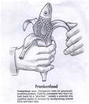
  - Pros?
  - Cons?

TOPIC 8: Evolution

- A process in which new species develop from pre-existing species is known as __________________.
- TRUE or FALSE: There are always enough resources to support all organisms: ___________________
- What happens to the species that have the advantageous traits?
  - b.
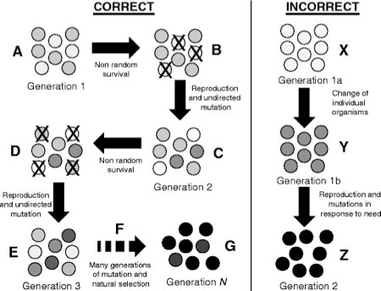
- What happens to the species that do NOT have advantageous traits?
- Explain why the INCORRECT section on the right IS incorrect
- What are the three different types of isolating mechanisms?

- A decrease in genetic variation caused by the formation of a new population by a small number of individuals from a larger population is known as ________________________________________.

- Describe the following pieces of evidence for evolution
  - Fossils:
  - Homologous structures:
  - Analogous structures:
  - Embryology:
  - Biochemistry:

- What happens during gradualism? ___________________________________________________________
- What happens during punctuated equilibrium? _________________________________________________
- Give an example of
  - Selective breeding: ______________________________________________________
  - Inbreeding: ____________________________________________________________
Hybridization: __________________________________________________________

TOPIC 9: Ecology

- Write down the levels of ecosystem organization from smallest to largest
- ________________ make their own food, while ________________________ eat other organisms for food.
- When you move up an energy pyramid, the amount of available energy (circle one) ↑ ↓
- What is the difference between a food chain and a food web?
- What is the difference between abiotic and biotic factors?
- Explain the following organisms interactions
  - Competition
  - Predation
  - Symbiosis
    - Mutualism
    - Commensalism
    - Parasitism
- _____________________ species are those that are naturally found in a location, while _______________ species are accidentally or purposefully introduced to a new area
- Explain the difference between
  - Threatened
  - Endangered
  - Extinct
- What is succession?

