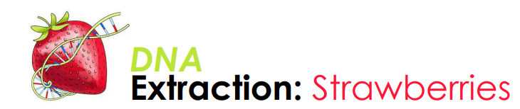 PROCEDURE
PART 1
- Obtain one fresh strawberry from the front desk. Remove the green sepal (top) from the berry.
- Find the initial mass of the strawberry and record it on the data sheet.
- Put on Goggles
- Place the strawberry in a resealable plastic bag
- Close the bag slowly, pushing all of the air out of the bag as you seal it
- Being careful not to break the bag, thoroughly mash the strawberry with your hands for two (2) minutes. Answer Part 1 question 1 on the data sheet
- Pour 10 mL of the extraction buffer into the bag with the mashed up strawberry. Reseal the bag. Answer Part 1 question 2 on the data sheet
- Mash the strawberry for an addition minute
- Place a funnel into a 50 mL centrifuge tube. Fold the cheese cloth in half along the longer side and place it in the funnel to create a filter. The cheesecloth will overlap the edge of the funnel. Answer Part 1 Question 3
- Pour the strawberry mixture into the funnel, filtering the contents through the cheesecloth and into the 50 mL centrifuge tube. As you wait, answer Part 1 Questions 4-8

PART 2
- Carefully pour 2 mL of the filtered contents from the 50mL tube into a clean 15 mL tube. Use the lines on the side of the 15 mL tube to help measure the amount added.
- Hold the 15mL tube at an angle. Using a transfer pipet, carefully add 5mL of cold 95% ethanol by running it down the inside of the tube.
- Add the 95% ethanol until the total volume is 7mL. You should have two distinct layers. ***CAUTION: do not mix the layers!!!
- Watch closely! Answer Part two Questions 1 and 2 on the data sheet
- Find the pre-mass of the skewer. Record this on your data sheet
- Slowly and carefully rotate the wooden stick in the ethanol directly above the extract layer to wind or spool the DNA. Remove the skewer from the tube and observe the DNA.
- Find the post-mass of the skewer. Record this on your data sheet. Proceed to calculate the final yield of the DNA extracted as well as the DNA % of strawberry mass.
- Share your date with two other groups and graph the results.
- Wash and return all objects to your lab station. **It should look exactly as you found it!
- Complete pages four and five of the data sheet.

